**AWS Cloud Assignment**

Step 1: Create an AWS account and login to the AWS account.

This is the Home Page visible after logging to the AWS account.

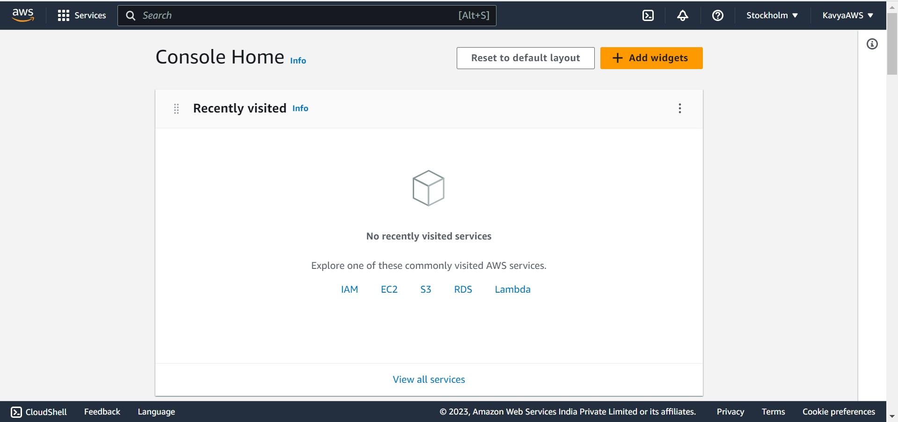

Q1. Create a virtual network with 2 subnets. Each subnet should have 16 Ips only.

**Virtual private clouds (VPC)**

A VPC is a logically isolated virtual network in AWS cloud that closely resembles a traditional network. After we create a VPC, we can add subnets.

**Subnets**

A subnet is a range of IP addresses in the VPC. A subnet must reside in a single Availability Zone. After we add subnets, we can deploy AWS resources in your VPC.

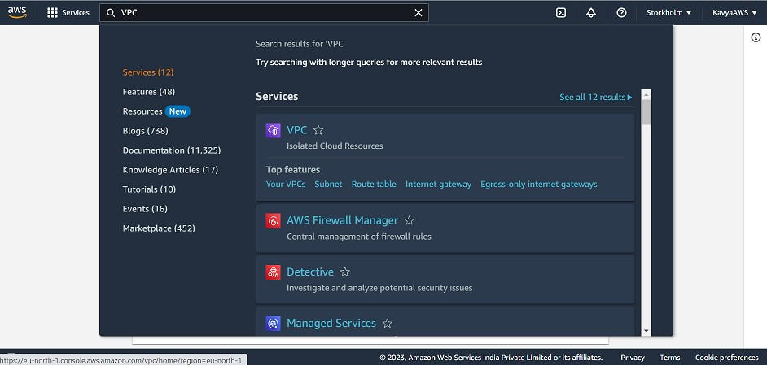

The below page is visible after clicking on VPC.

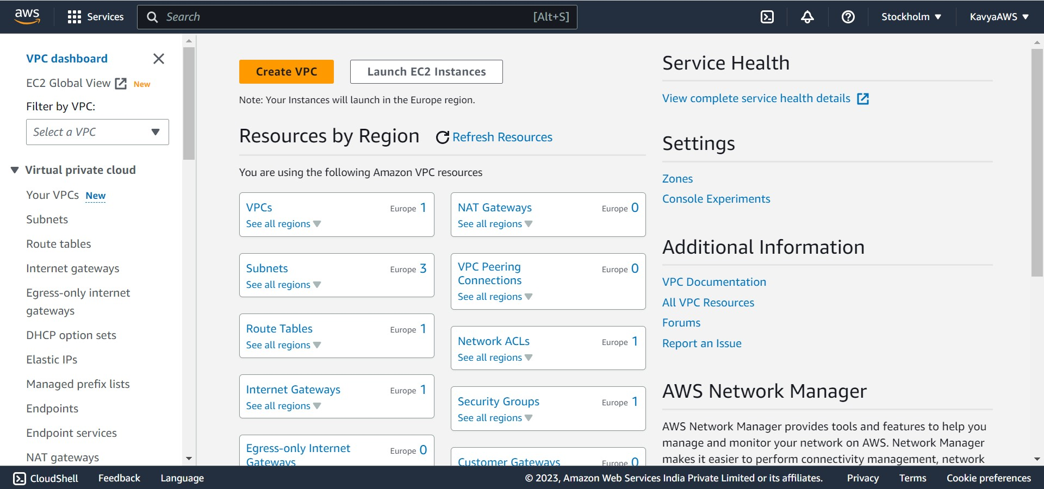

On clicking on “Your VPCs” from the left navigation bar, we can see the default Virtual Private Cloud. When we start using Amazon VPC, we have a default VPC in each AWS Region. A default VPC comes with a public subnet in each Availability Zone, an internet gateway, and settings to enable DNS resolution.

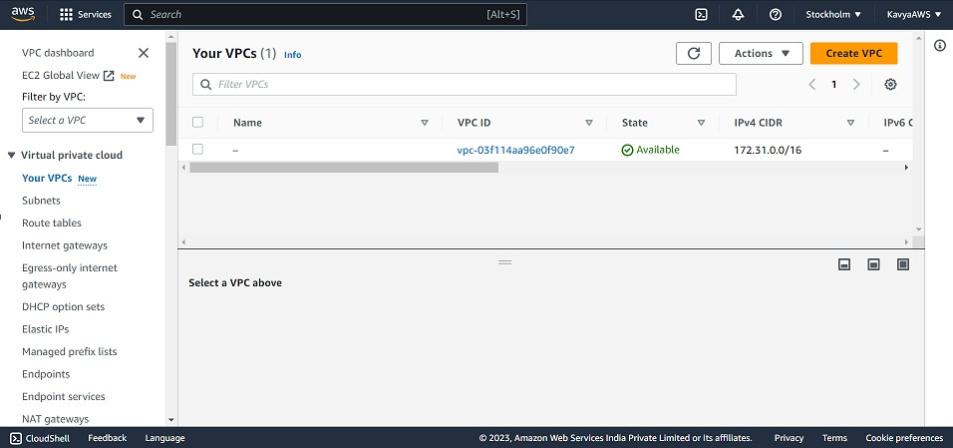

On clicking on “Subnets” from the left navigation bar, we can see he default subnets which are present.

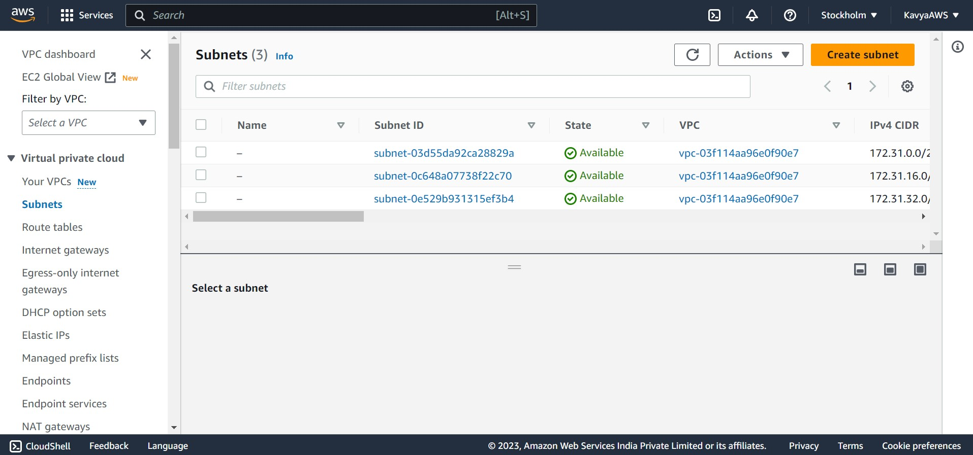

Go to Your VPCs from the left navigation bar, on the VPC dashboard, click on **Create VPC**.

Under **Resources to create**, choose **VPC and more**.

For **Name tag**, enter a name for VPC.

For **IPv4 CIDR block**, enter an IPv4 address range for the VPC. A VPC must have an IPv4 address range.

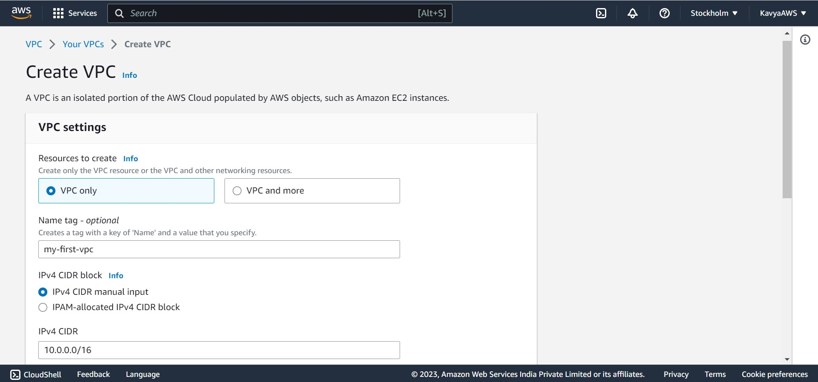

To support IPv6 traffic, choose **IPv6 CIDR block**, **Amazon-provided IPv6 CIDR block**.

Choose the Default option from the Tenancy dropdown, as we are using free tier.

Choose **Create VPC**.

After you create a VPC, you can add subnets.

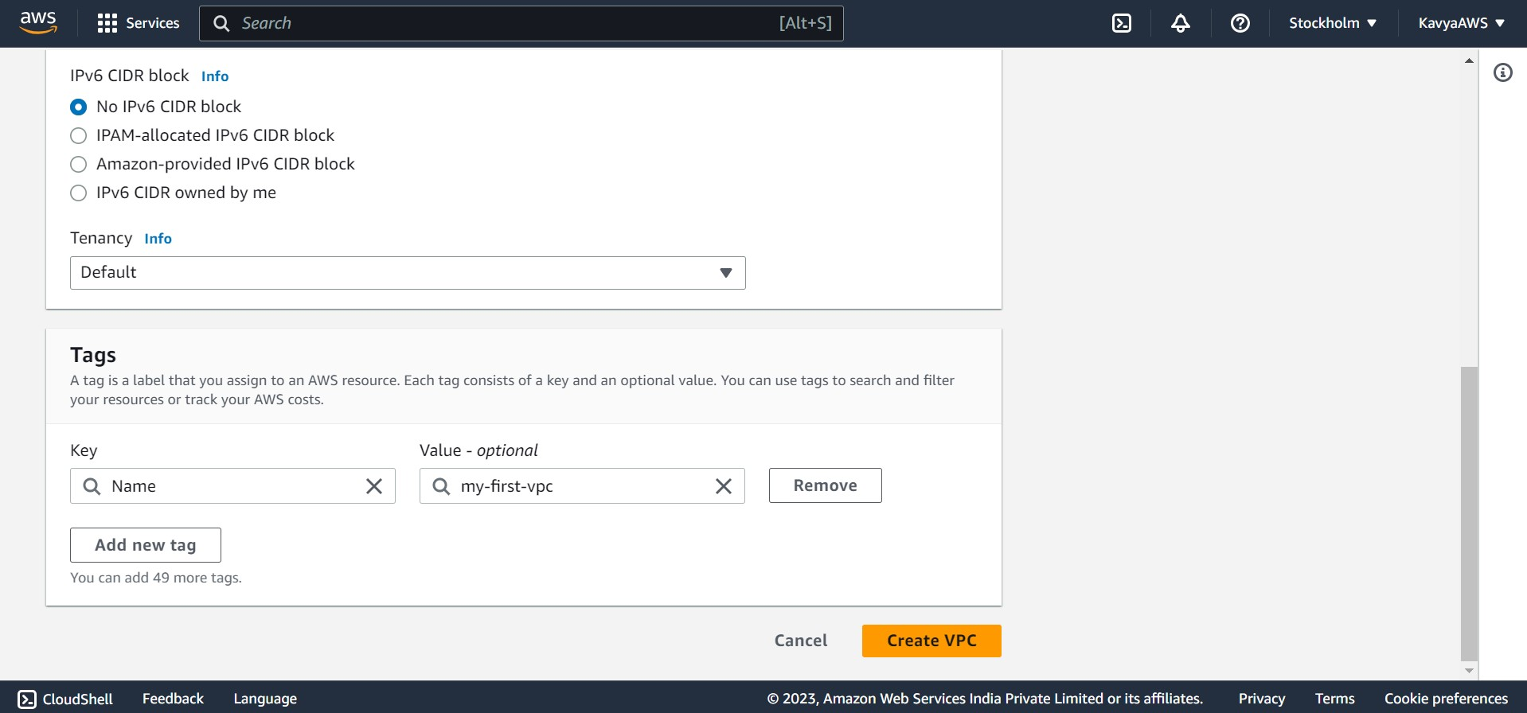

We have successfully created our first VPC “my-first-vpc”. After we create a VPC, we can add subnets.

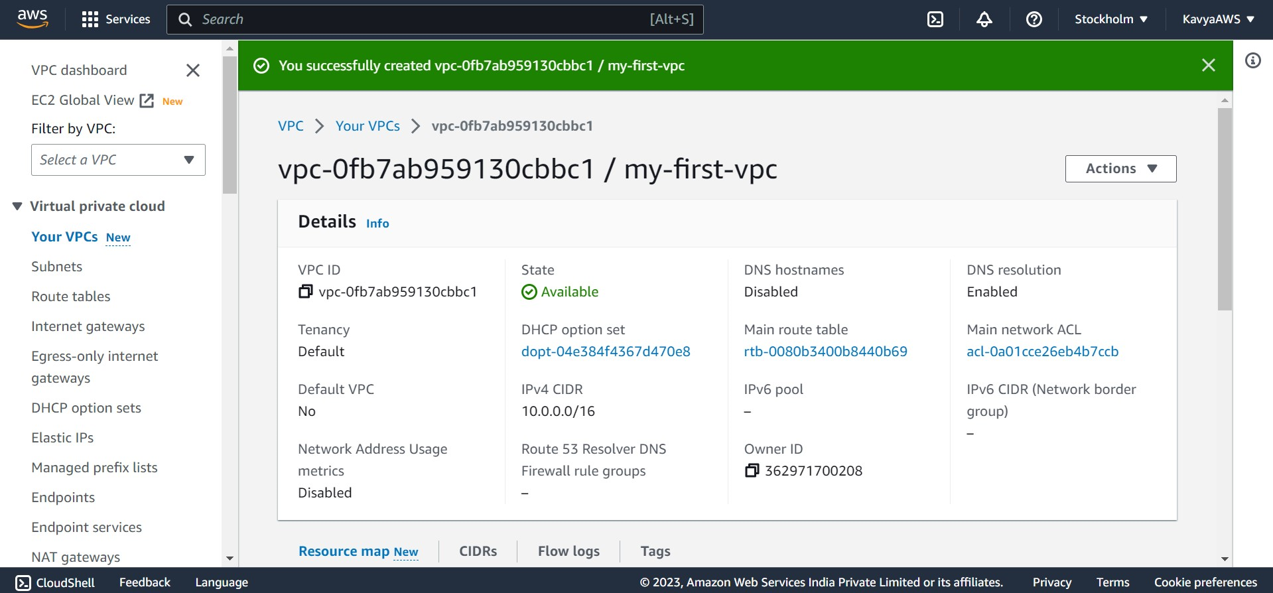

**To add a subnet to your VPC**

Go to Subnets from the left navigation bar.

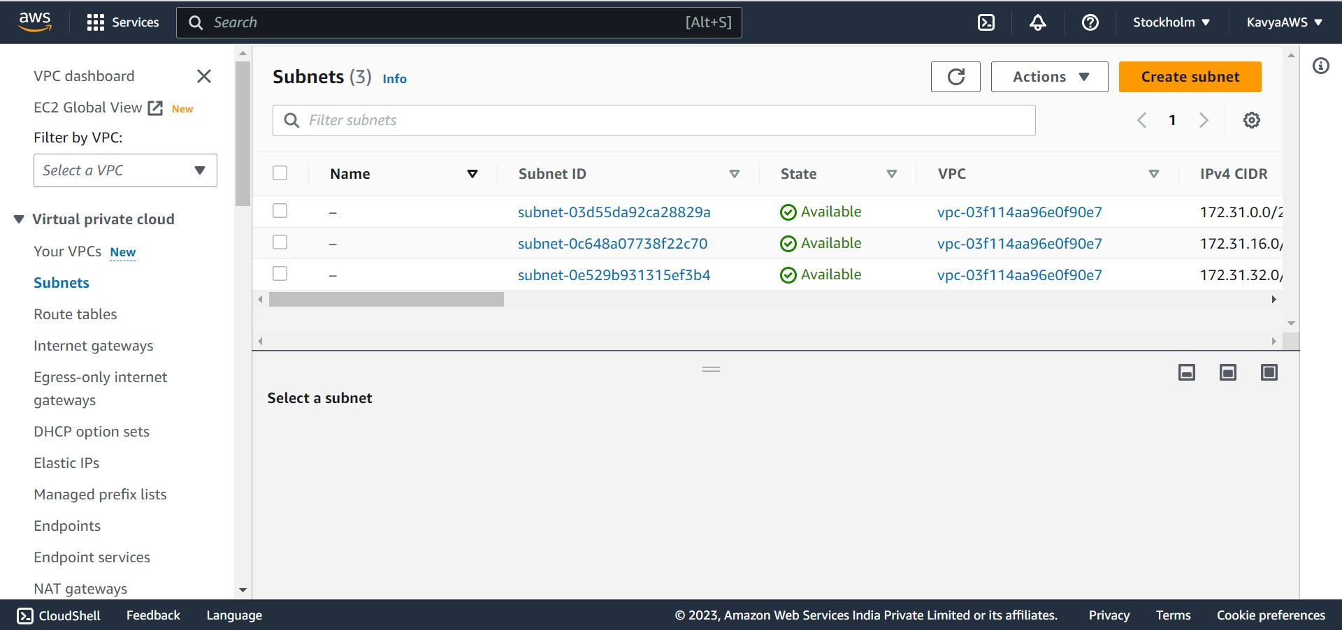

In the left navigation click on Filter by VPC dropdown and choose the VPC which we created (my-first-vpc). So that the subnet will be created inside that VPC.

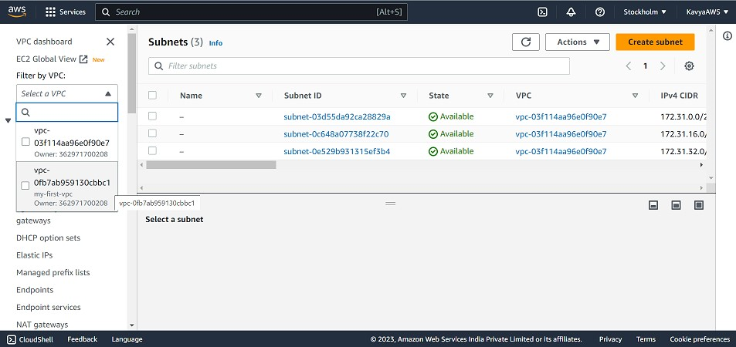

After selecting the VPC, click on Create subnet.

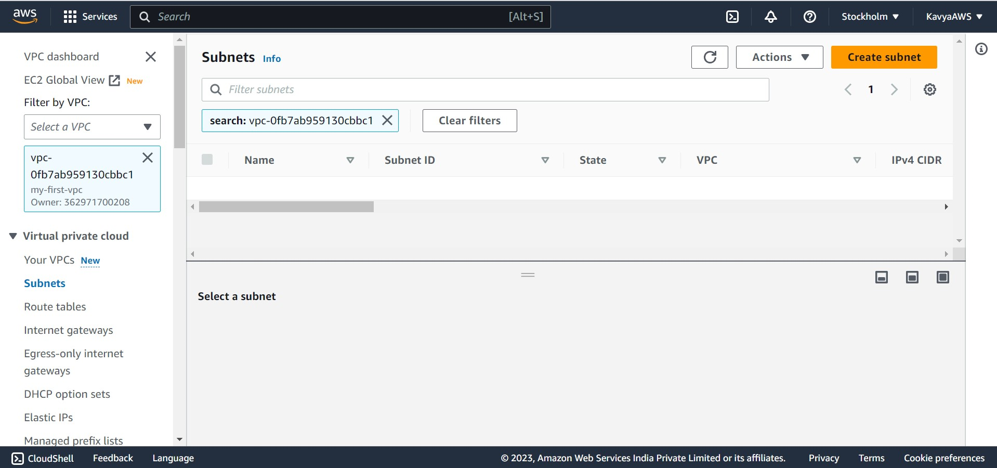

For **VPC ID**: Choose the VPC for the subnet.

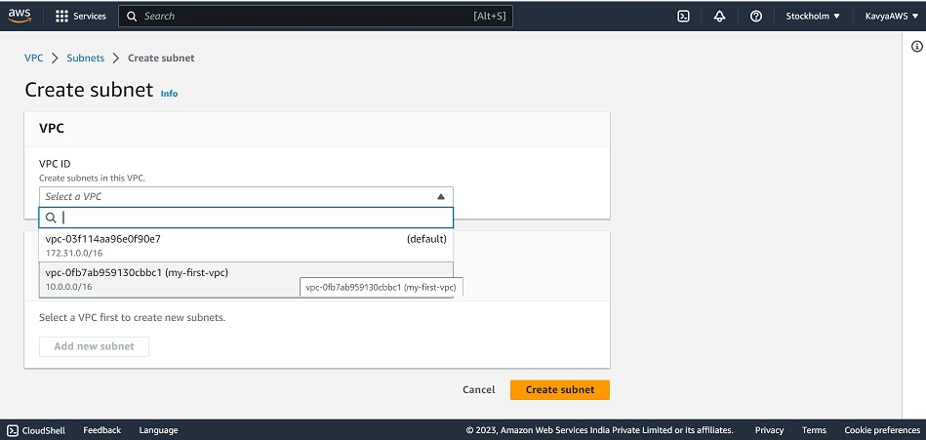

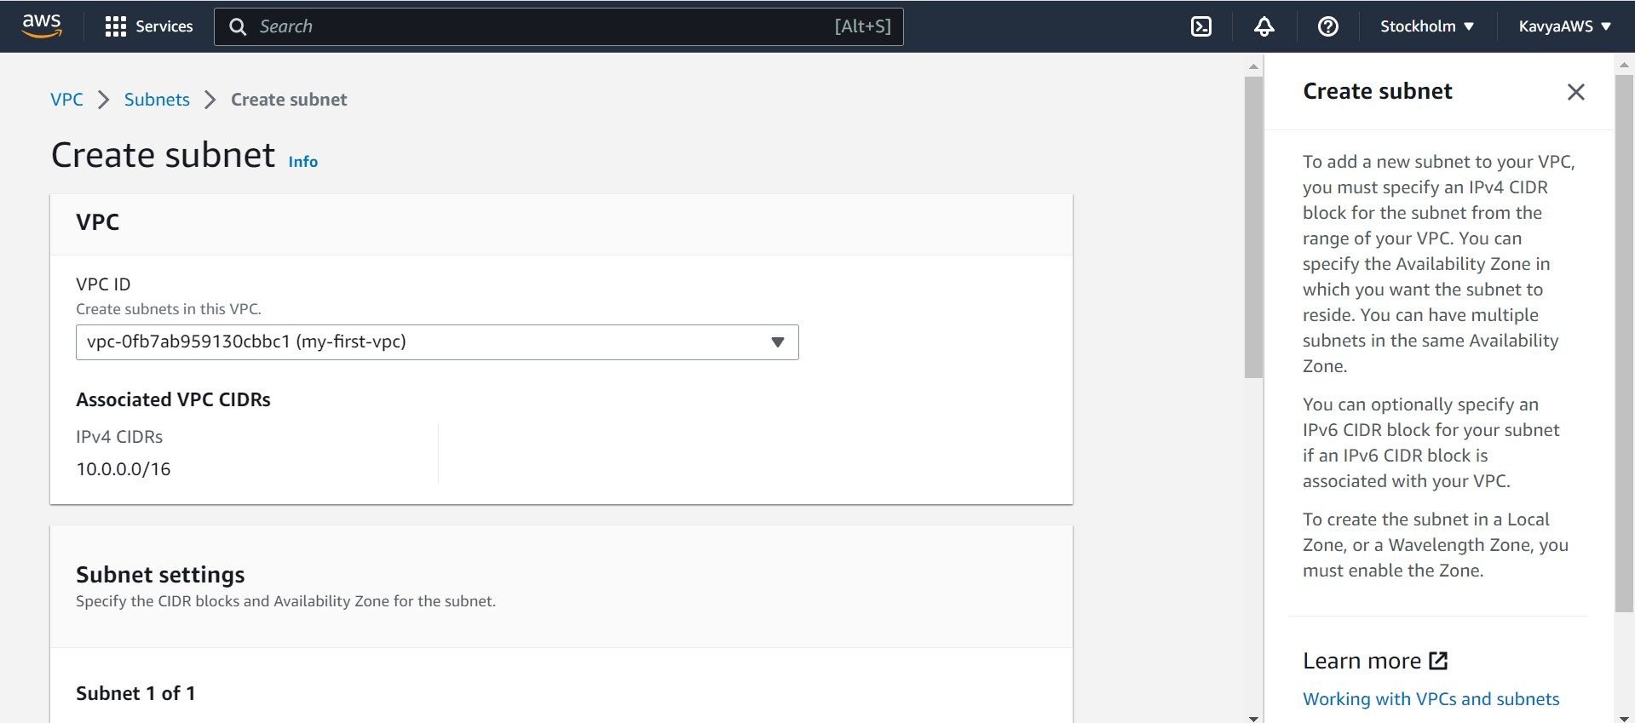

For **Subnet name**, enter a name for your subnet.

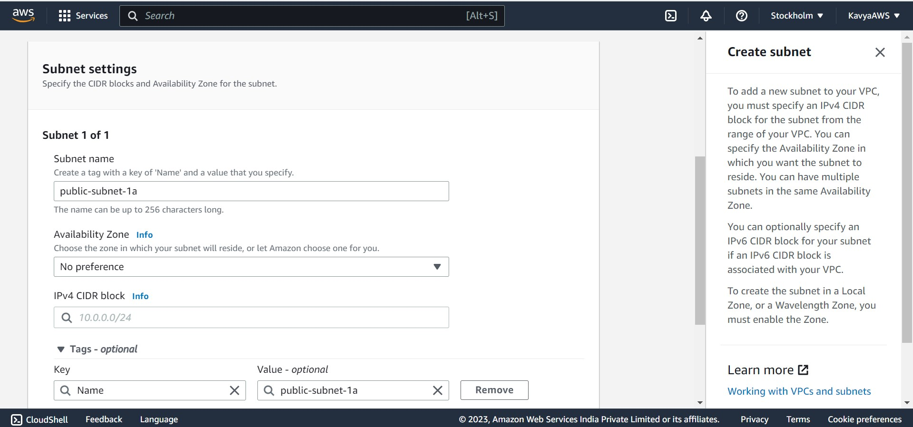

For **Availability Zone**, choose a Zone for the subnet.

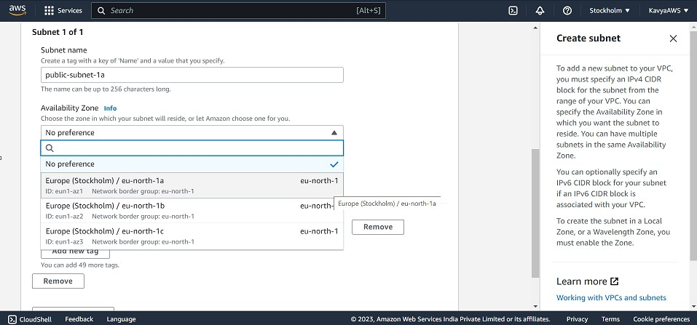

For **IPv4 CIDR block**, enter an IPv4 CIDR block for your subnet. I added 10.0.0.0/28 as I need a subnet with only 16IPs. And click on **Create subnet**.

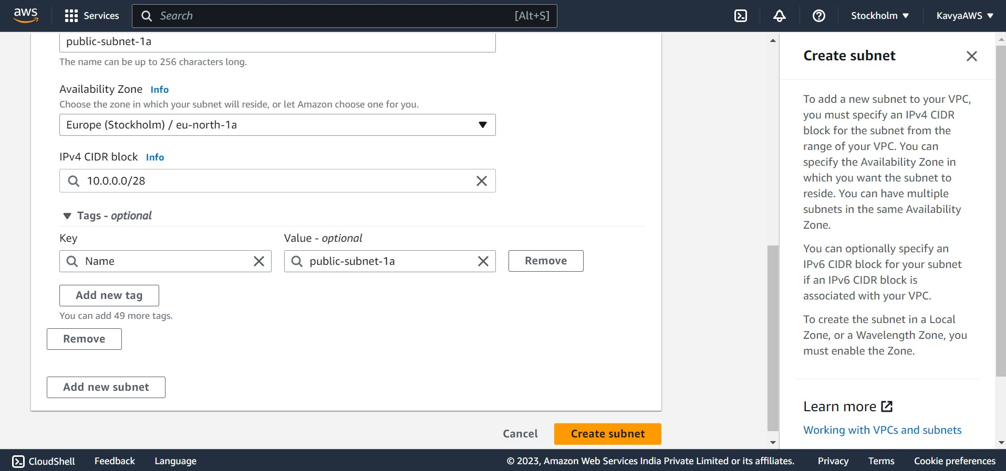

We have successfully created a Subnet with 16Ips under the VPC we created.

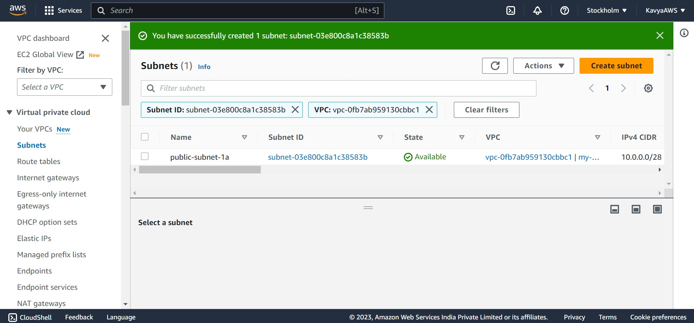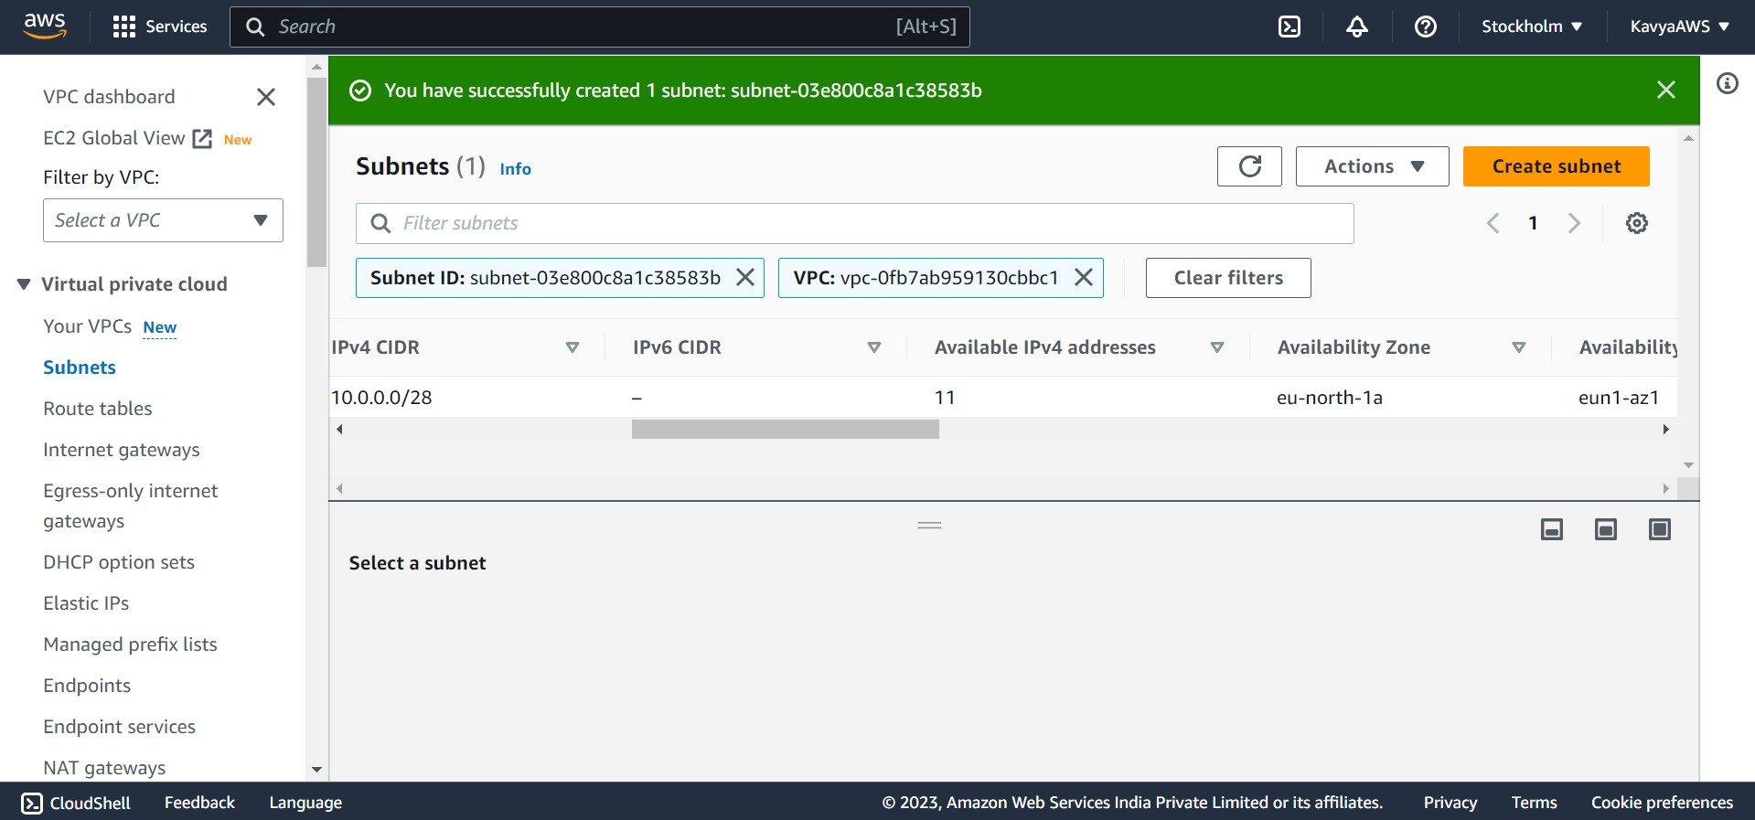

We need to create a 2nd subnet, following the previous steps.

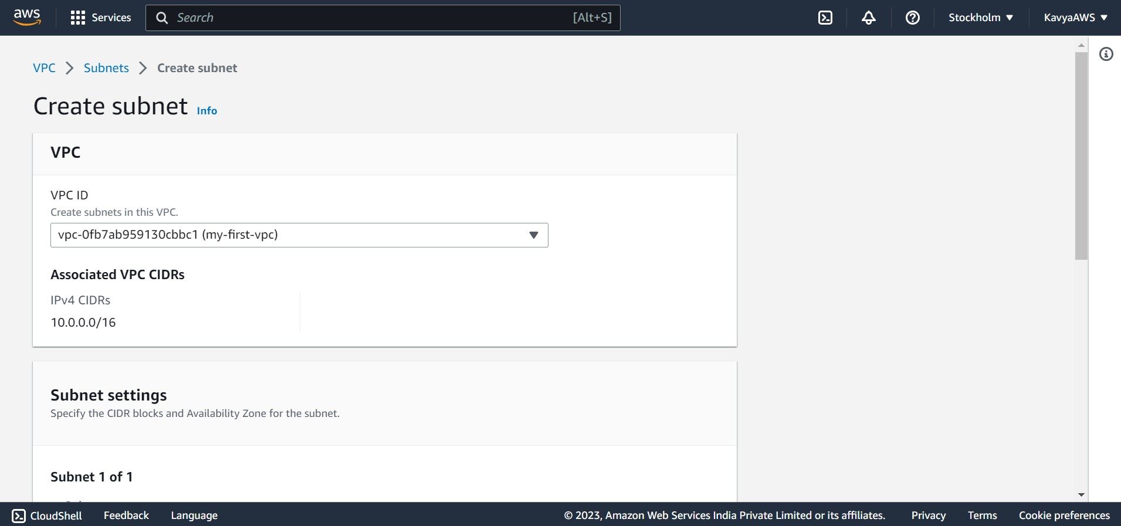

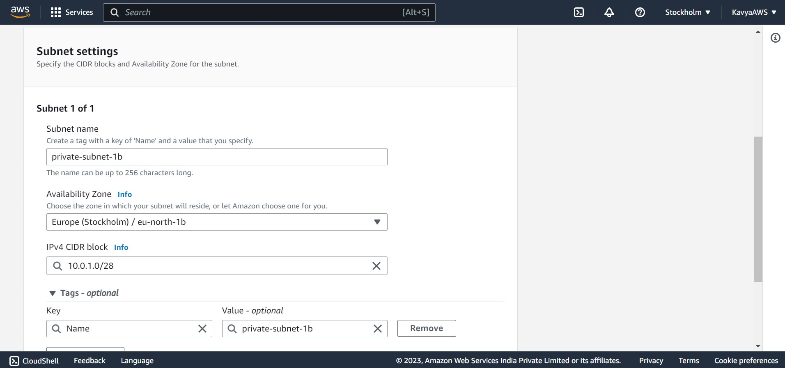

The IPv4 block range should not overlap, So here the IPv4 range is 10.0.1.0/28.

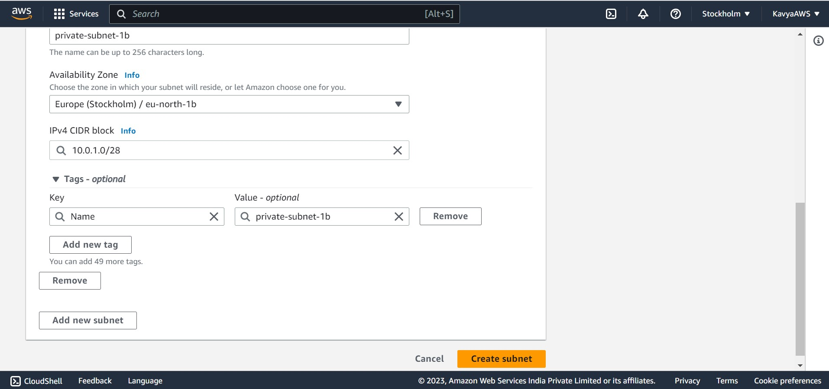

Successfully created the two subnets with 16Ips inside the VPC we created.

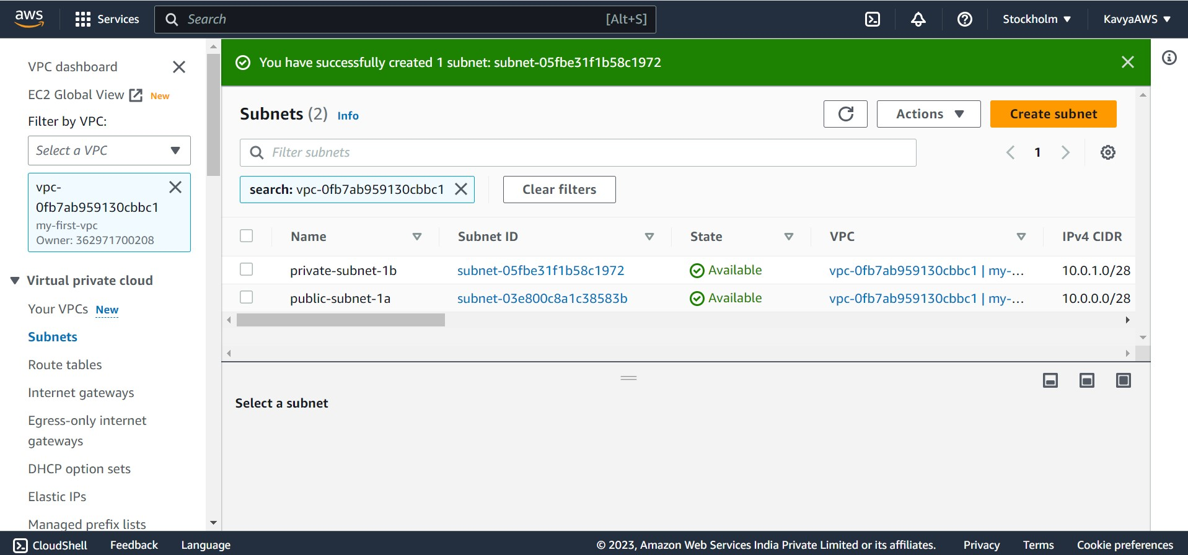

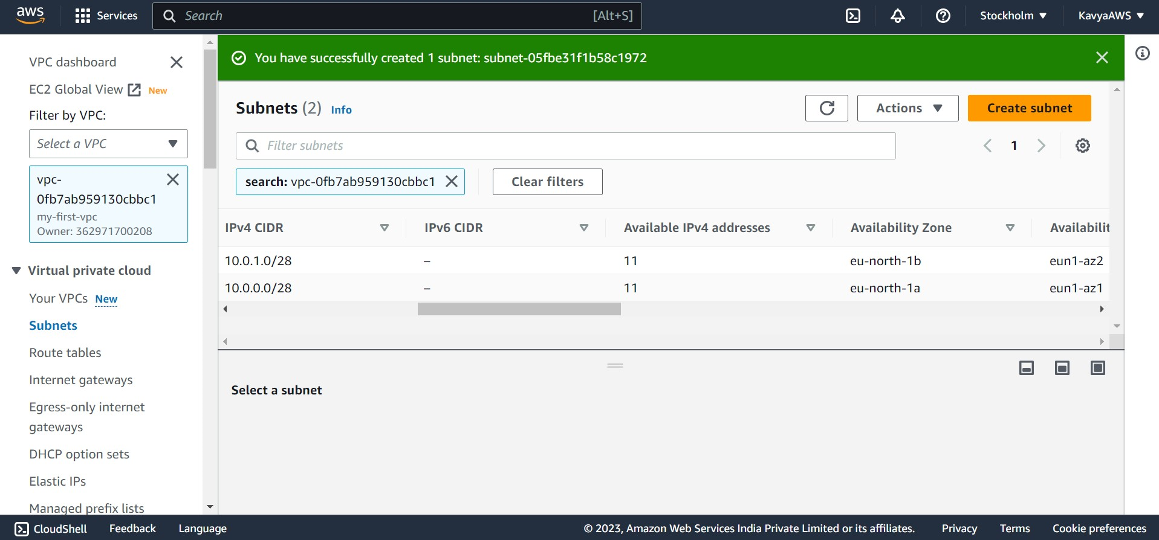

Q2. Inside one of the subnets, create a VM and deploy an application code inside it (any existing application created by you before). Make sure to use appropriate NACLs and SGs.

**To launch an instance**

To create EC2 instance, Search for EC2 in the search bar on the home page.

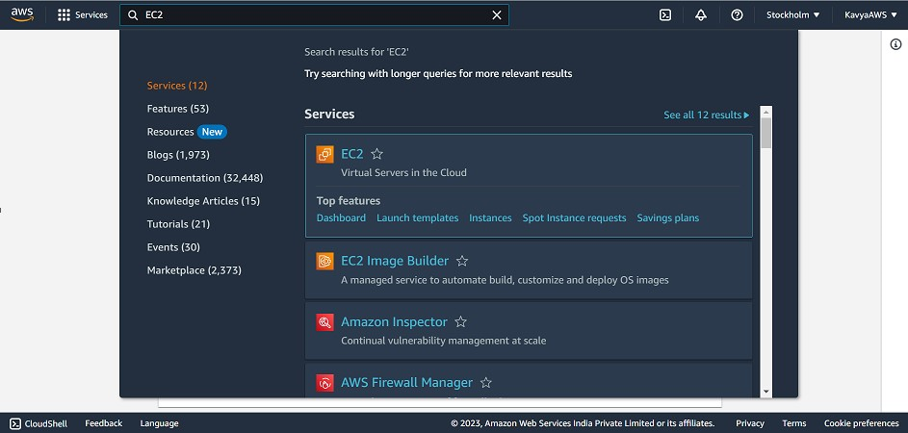

From the EC2 console dashboard, in the **Launch instance** box, choose **Launch instance**, and then choose **Launch instance** from the options that appear.

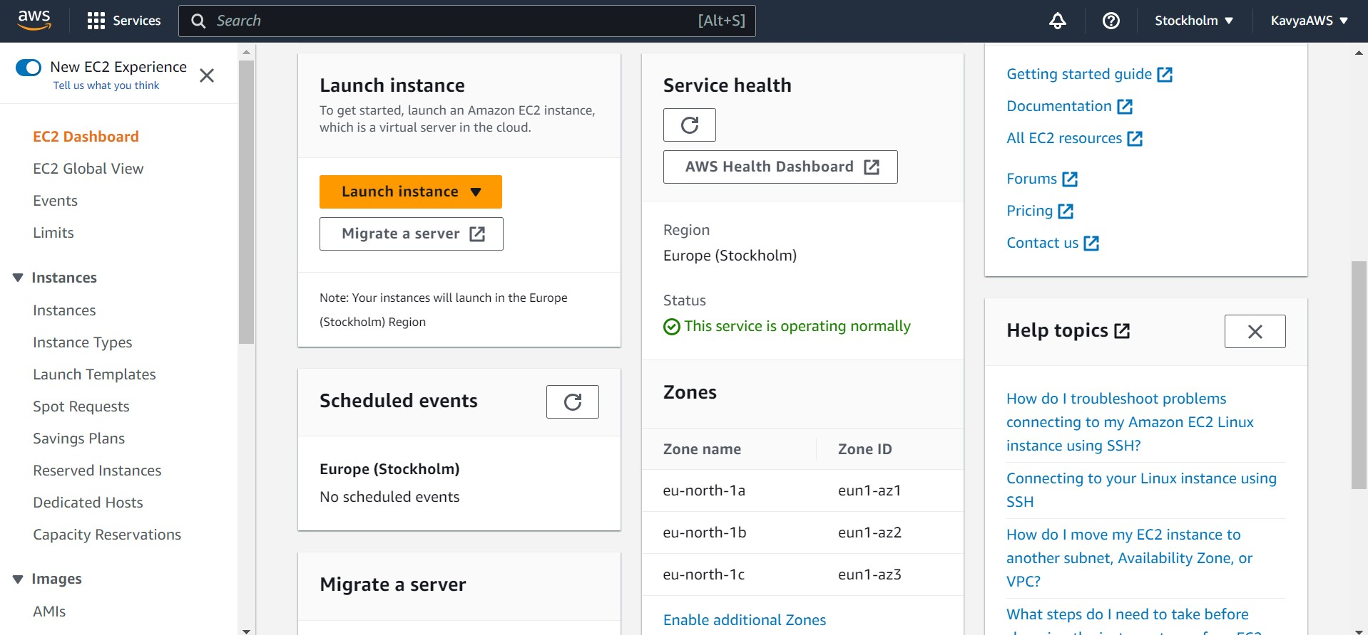

Under **Name and tags**, for **Name**, enter a descriptive name for your instance.

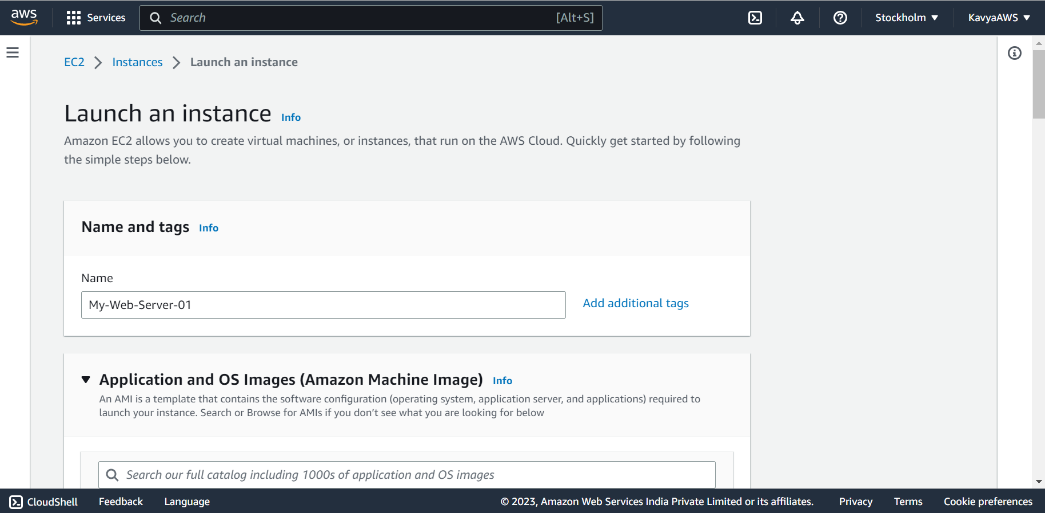

Under **Application and OS Images (Amazon Machine Image)**:

* 1. Choose **Quick Start**, and then choose Windows.
  2. From **Amazon Machine Image (AMI)**, select the AMI for Windows Server 2016 Base or later. Notice that these AMIs are marked **Free tier eligible**. An Amazon Machine Image (AMI) is a basic configuration that serves as a template for your instance.

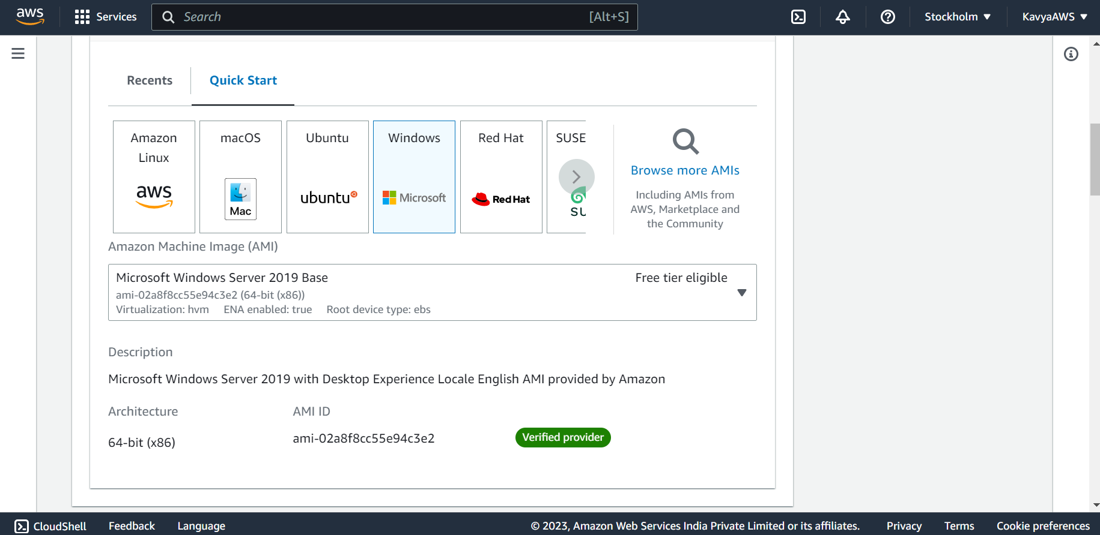

Under **Instance type**, from the **Instance type** list, you can select t3.micro. Under **Key pair (login)** choose the key we created or create a new key pair.

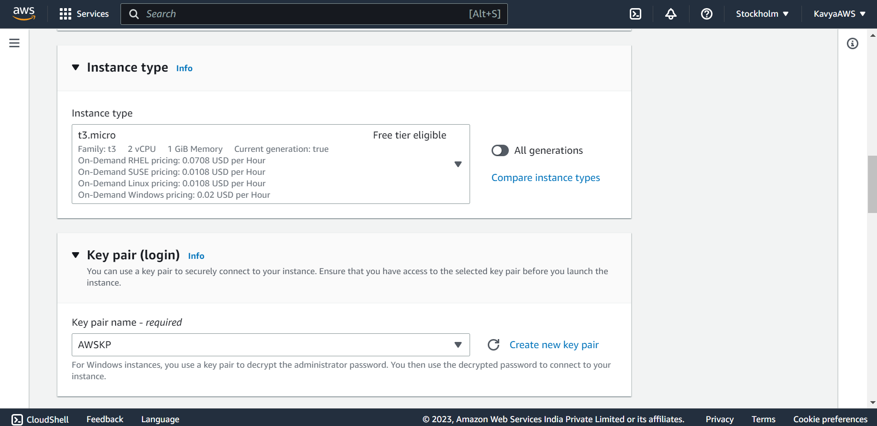

Clicking on **Create new key pair,** the below page is visible. Enter the Key pair name and select .pem in the private key file format.

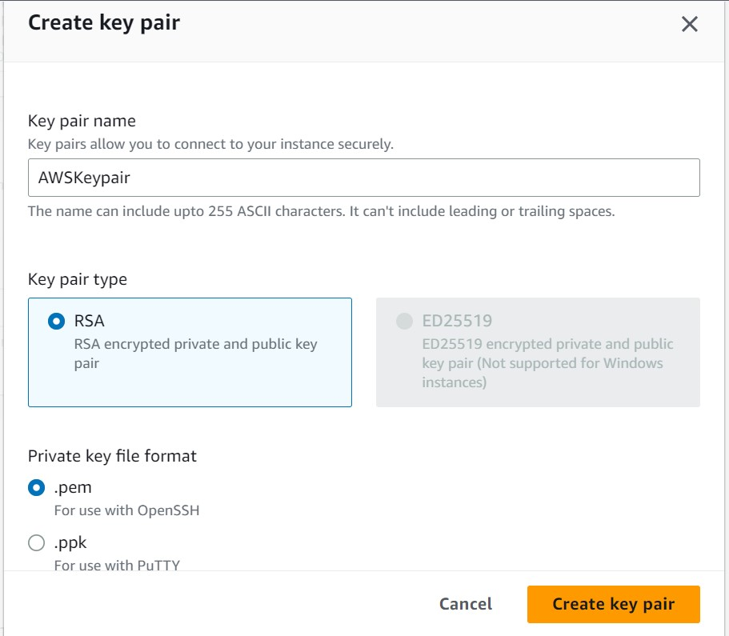

Clicking on create Key Pair the .pem file will be downloaded.

Next to **Network settings**:

* 1. Choose **Select existing security group**.
  2. From **Common security groups**, choose your security group from the list of existing security groups.

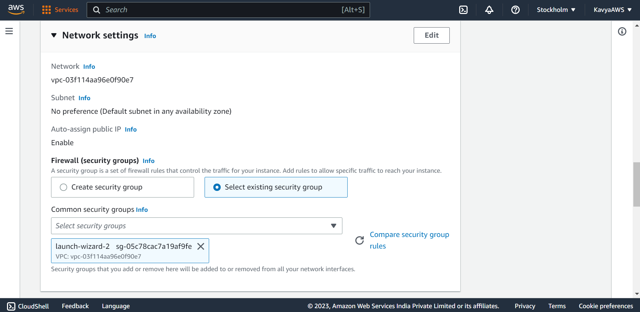 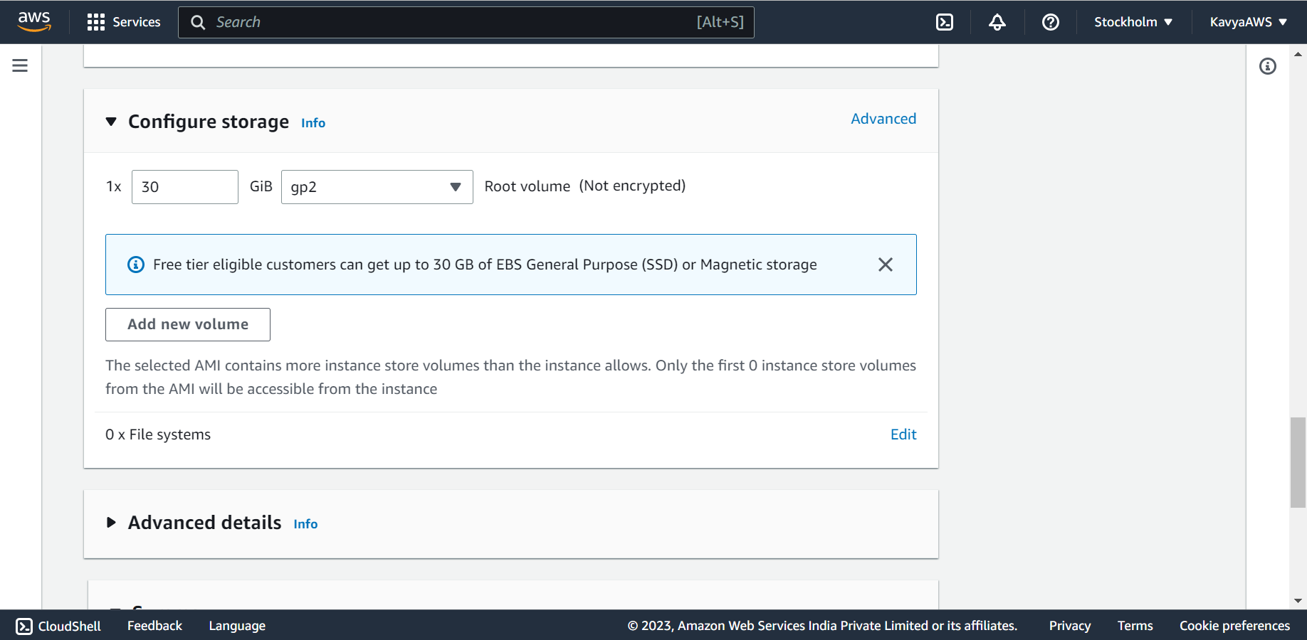

Review a summary in the **Summary** panel and click on **Launch instance**.

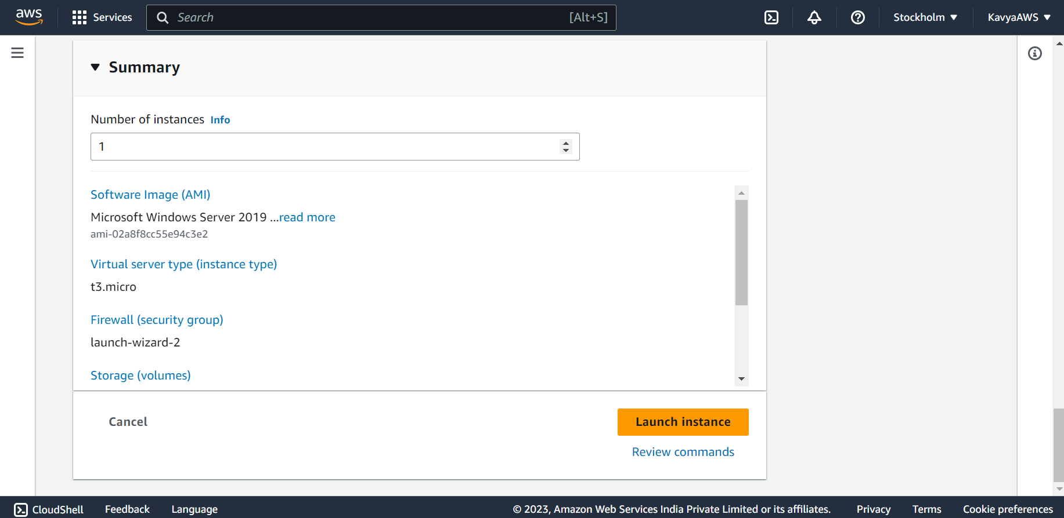

EC2 instance is successfully launched.

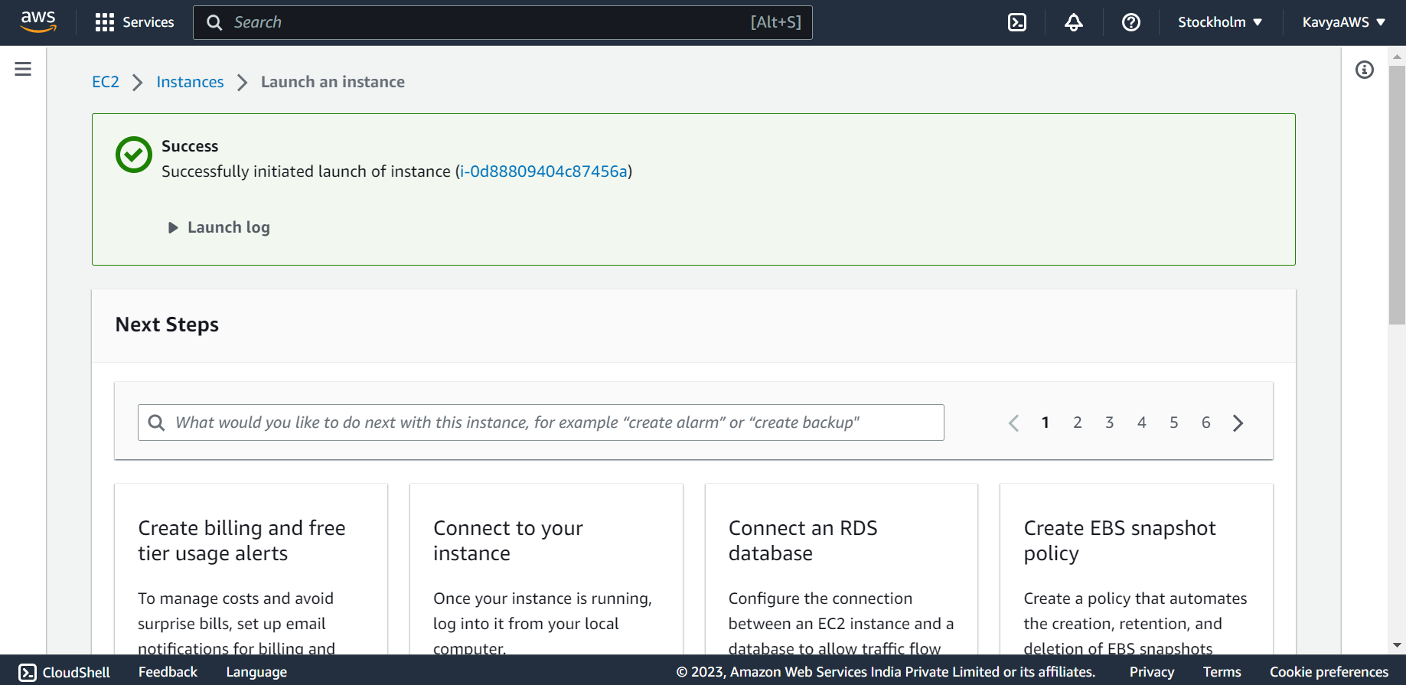

To view all instances, Click on the **Instances** in the top navigation bar.

It can take a few minutes for the instance to be ready for you to connect to it. Check that the instance has passed its status checks, we can view this information in the **Status check** column.

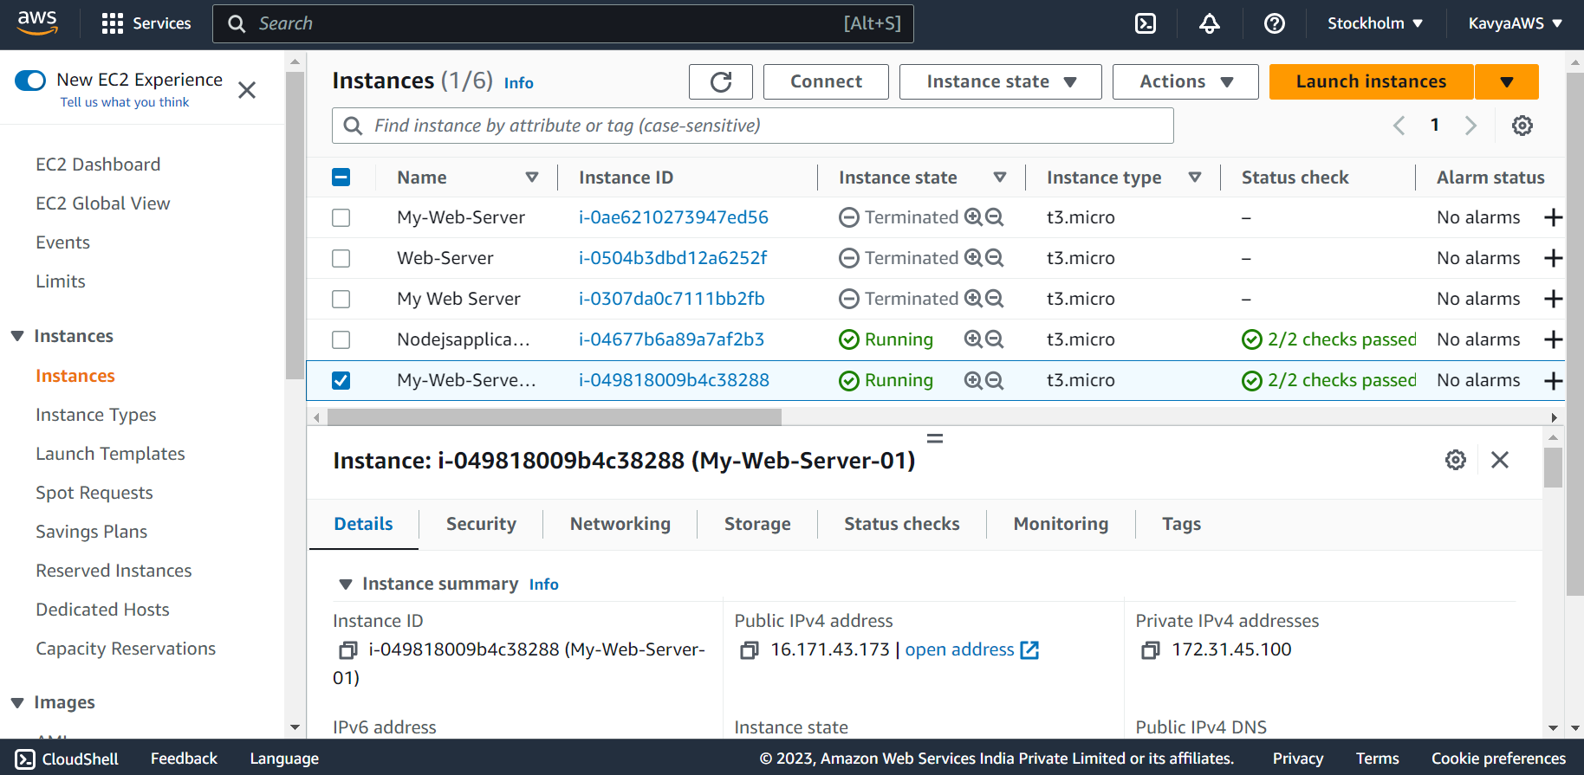 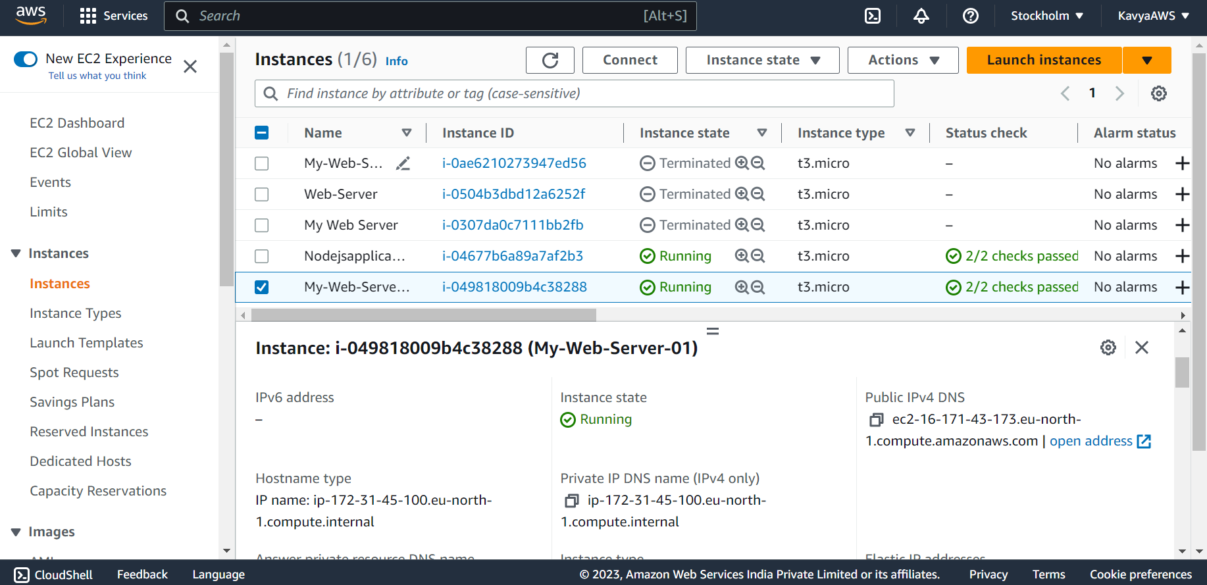

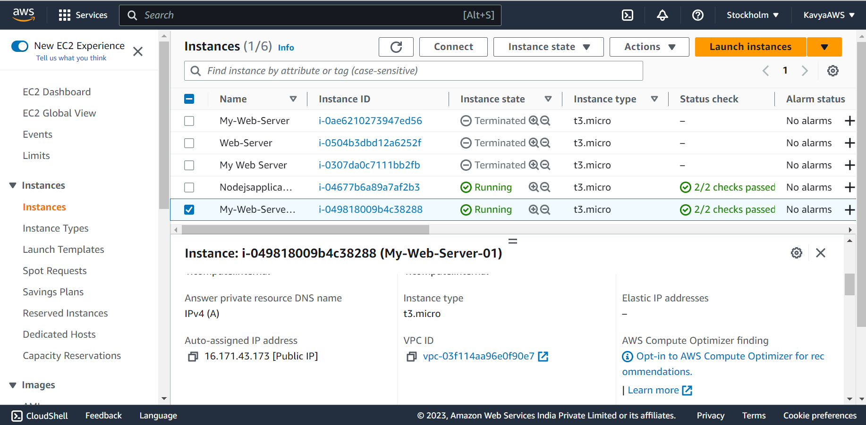 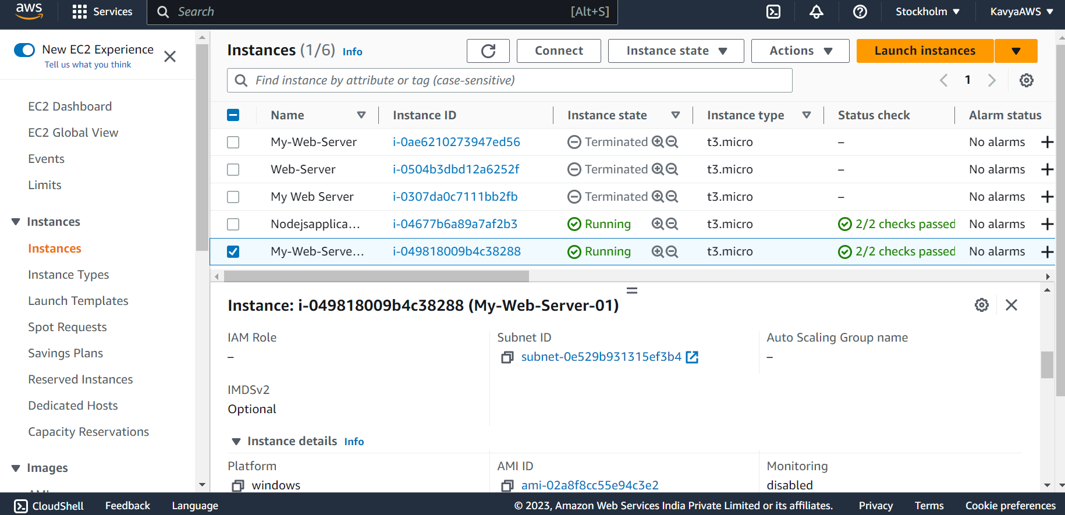

Platform is Windows

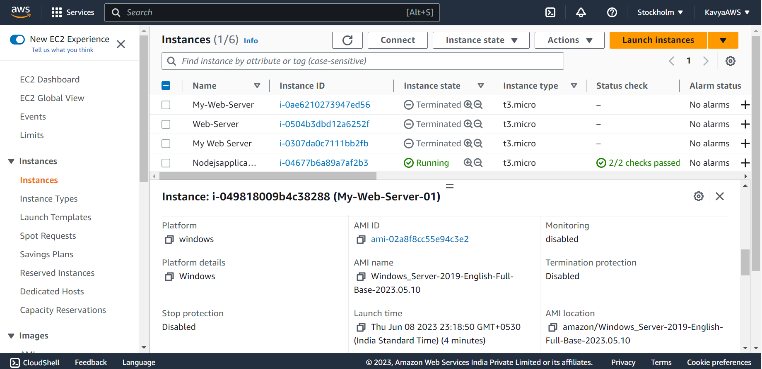

To connect to windows instance, Select the instance we created and click on **Connect.**

On the **Connect to instance** page, choose the **RDP client** tab, and then click on **Get password**.

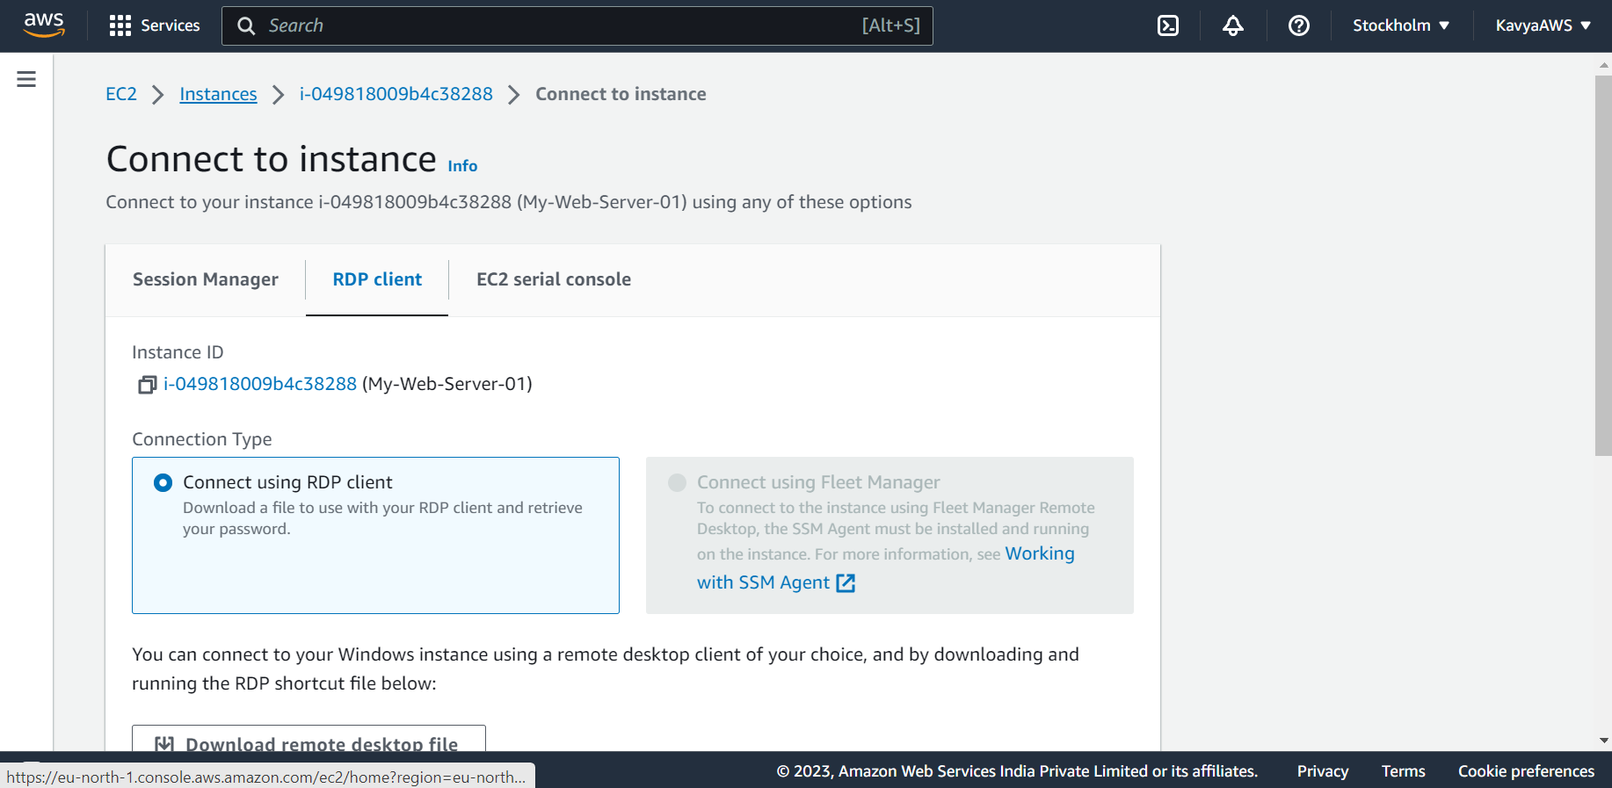 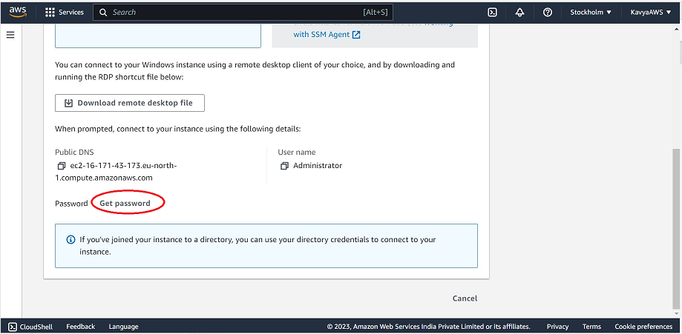

On the **Get Windows password,** click on **Upload private key file,** and browse the **.pem file** which we downloaded while creating the EC2 instance**.**

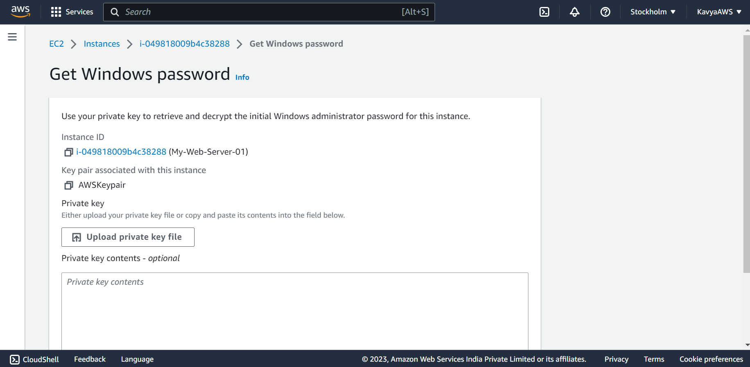 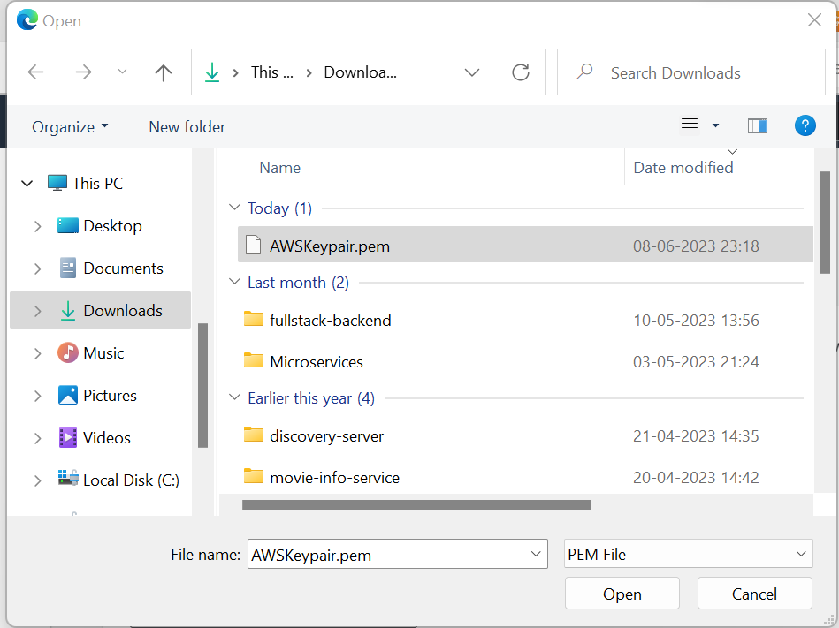

Click on **Decrypt Password**. The console will display the default administrator password for the instance under **Password**, replacing the **Get password** link shown previously. Save the password as it will be required to connect to the instance.

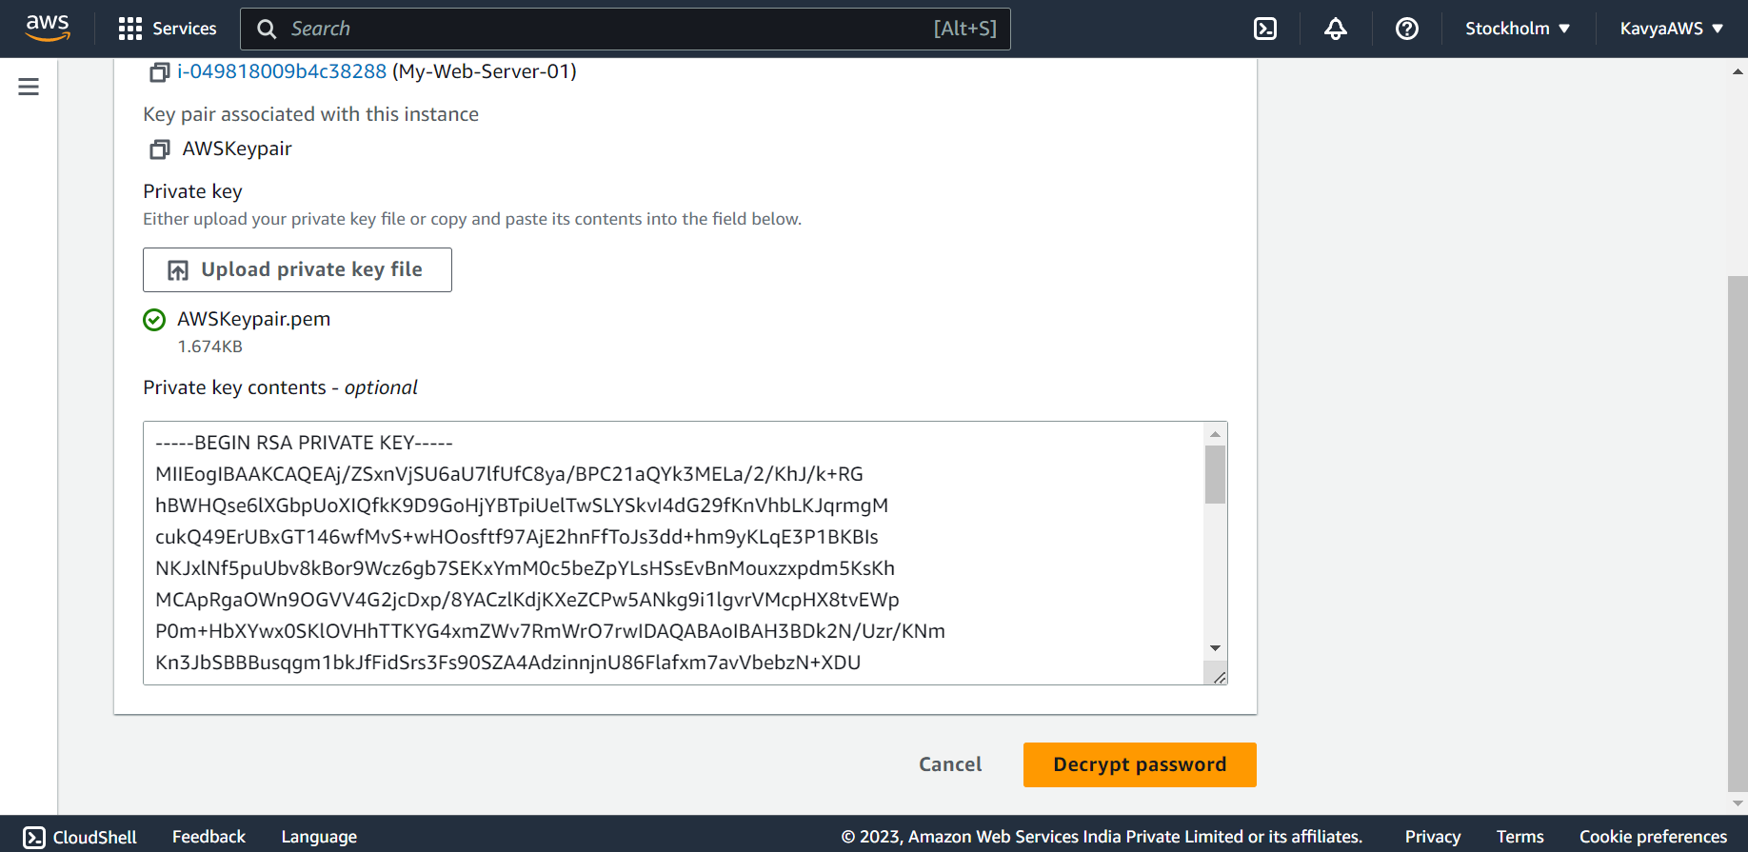 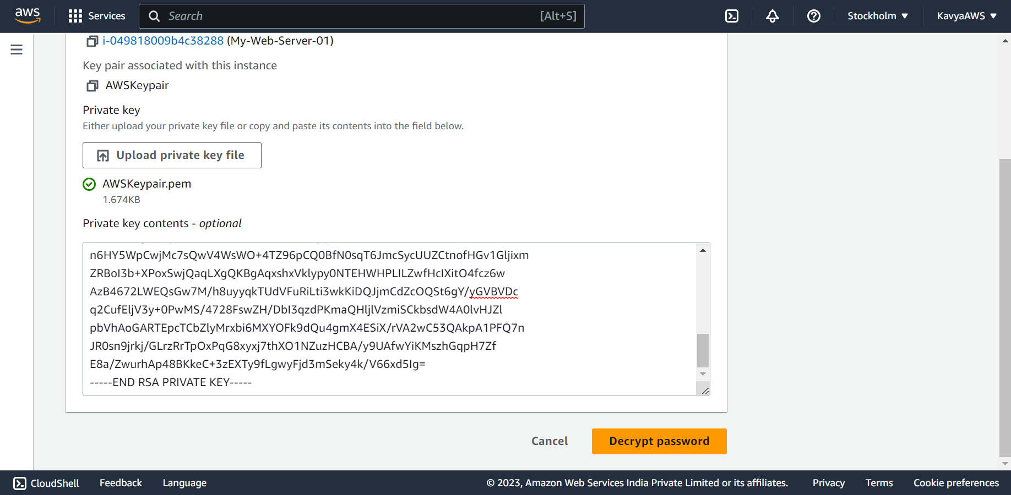

Click on **Download remote desktop file**

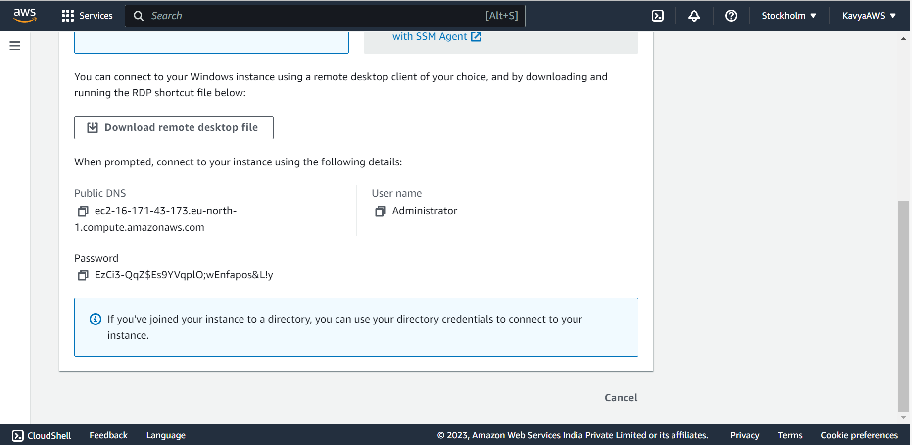

A Remote Desktop Connection file will be downloaded. Double click on the **Remote Desktop Connection file** to connect to the instance.

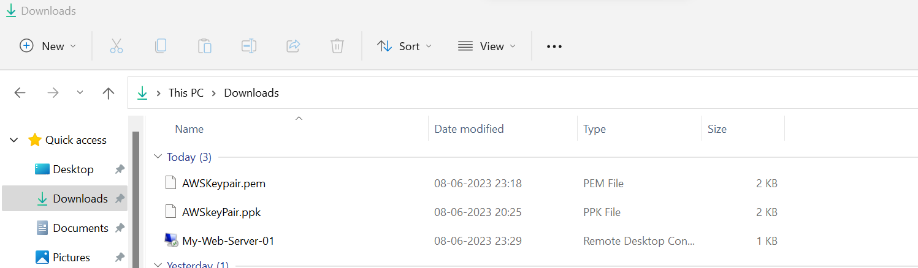

After clicking on the Remote Desktop Connection file, the below pop-up will be displayed. Click on **Connect**.

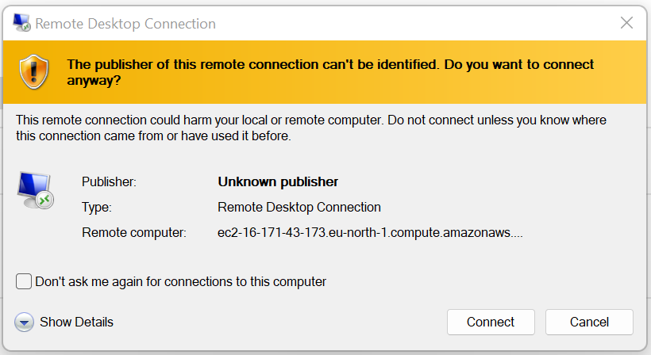

After clicking on connect, we ned to enter the password that we saved earlier through Get Password link.

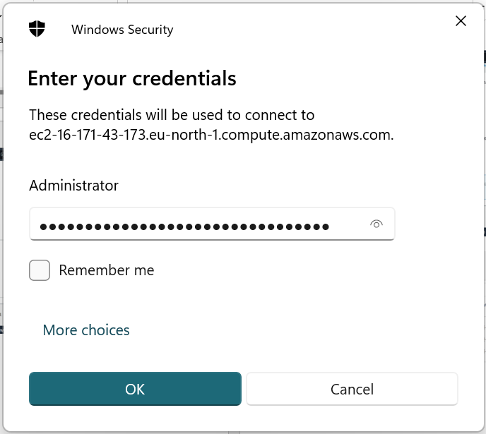

After adding the password and clicking on the **OK** **button**, the below pop-up will appear.

Choose **Yes** in the **Remote Desktop Connection** window to connect to your instance.

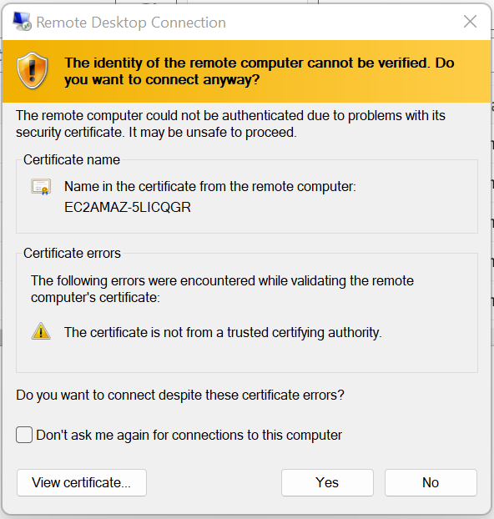

Connected to the instance successfully.

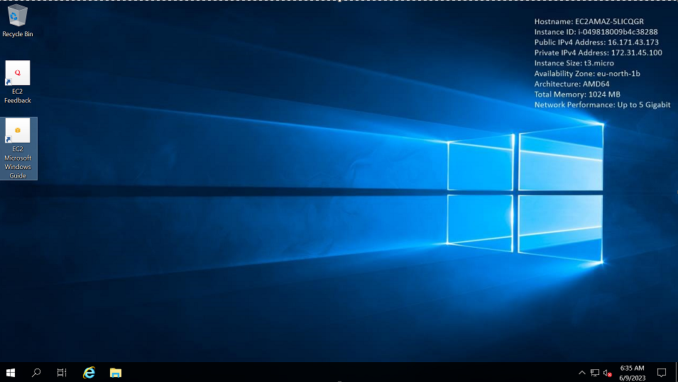

Q3. Deploy the same application to Elastic beanstalk Service.

Let’s create an Elastic Beanstalk application and launch an environment within it. An environment is the collection of AWS resources required to run your application code.

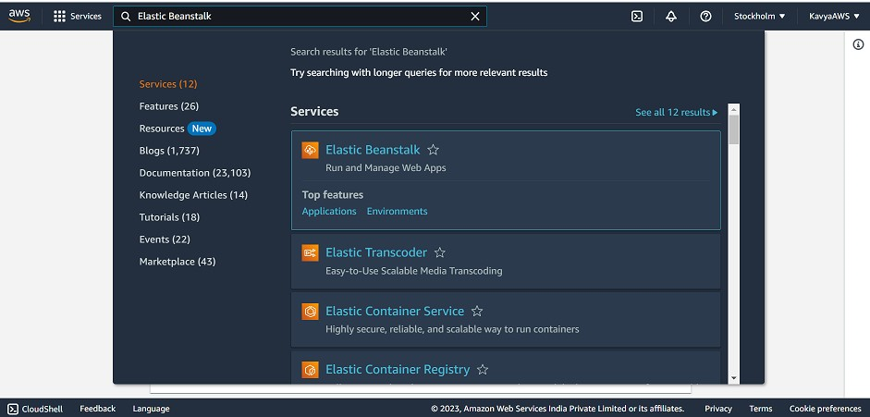

Open Elastic Beanstalk console and choose **Create application.**

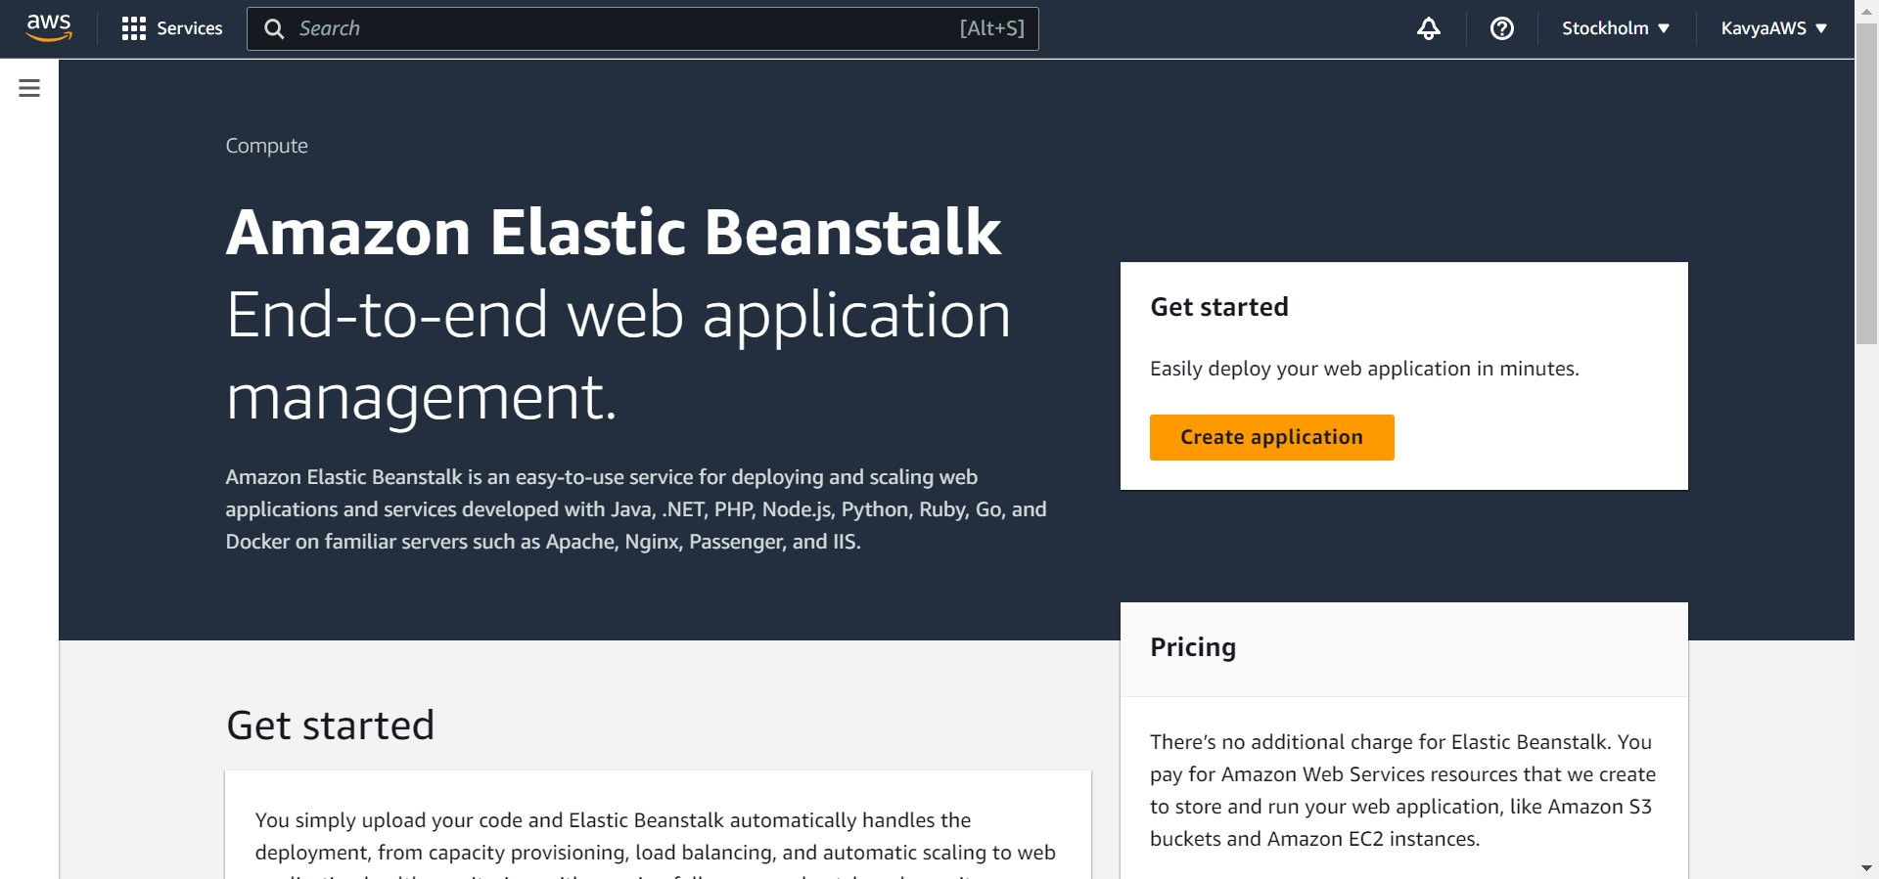

In the environment tier choose **Web server environment**. For **Application name** enter a unique name.

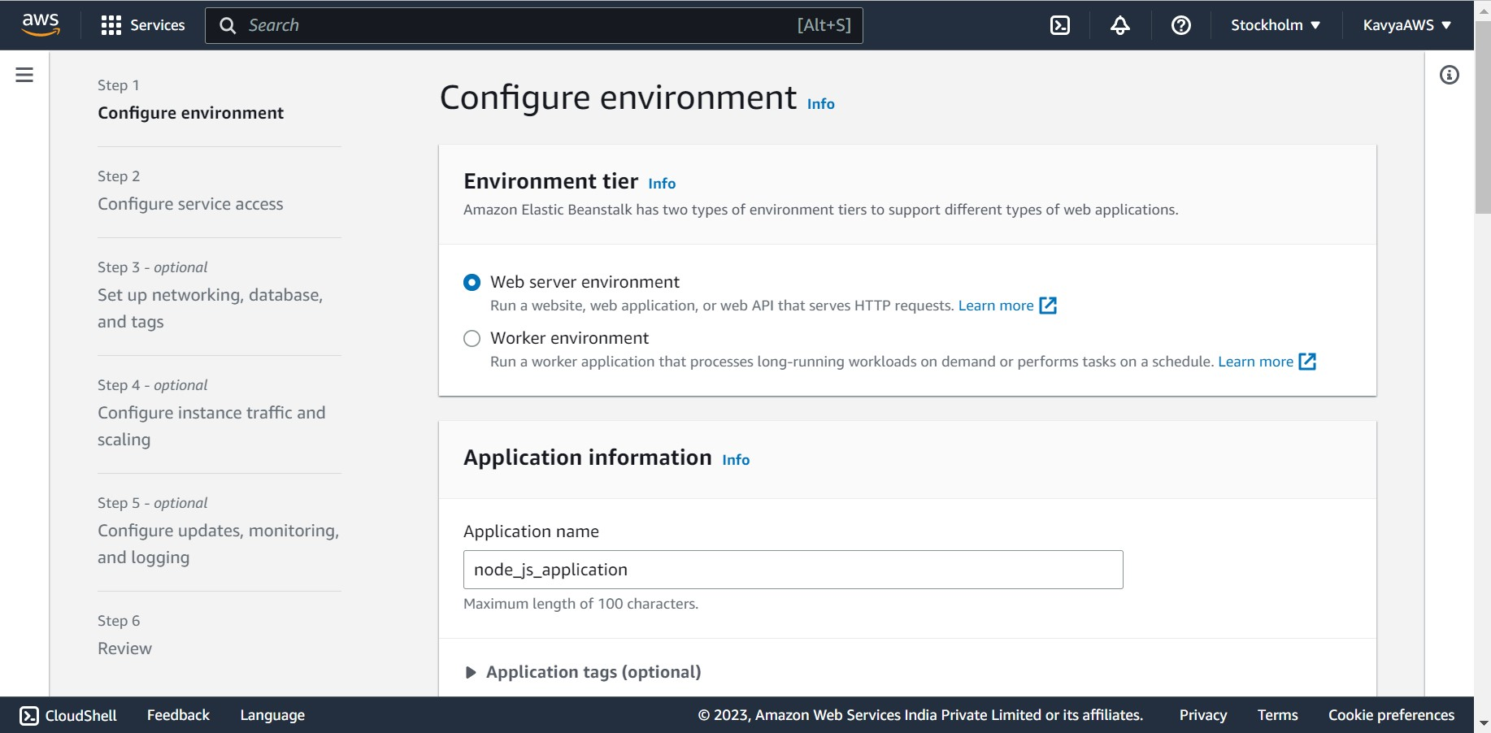

For **Platform**, choose a platform.

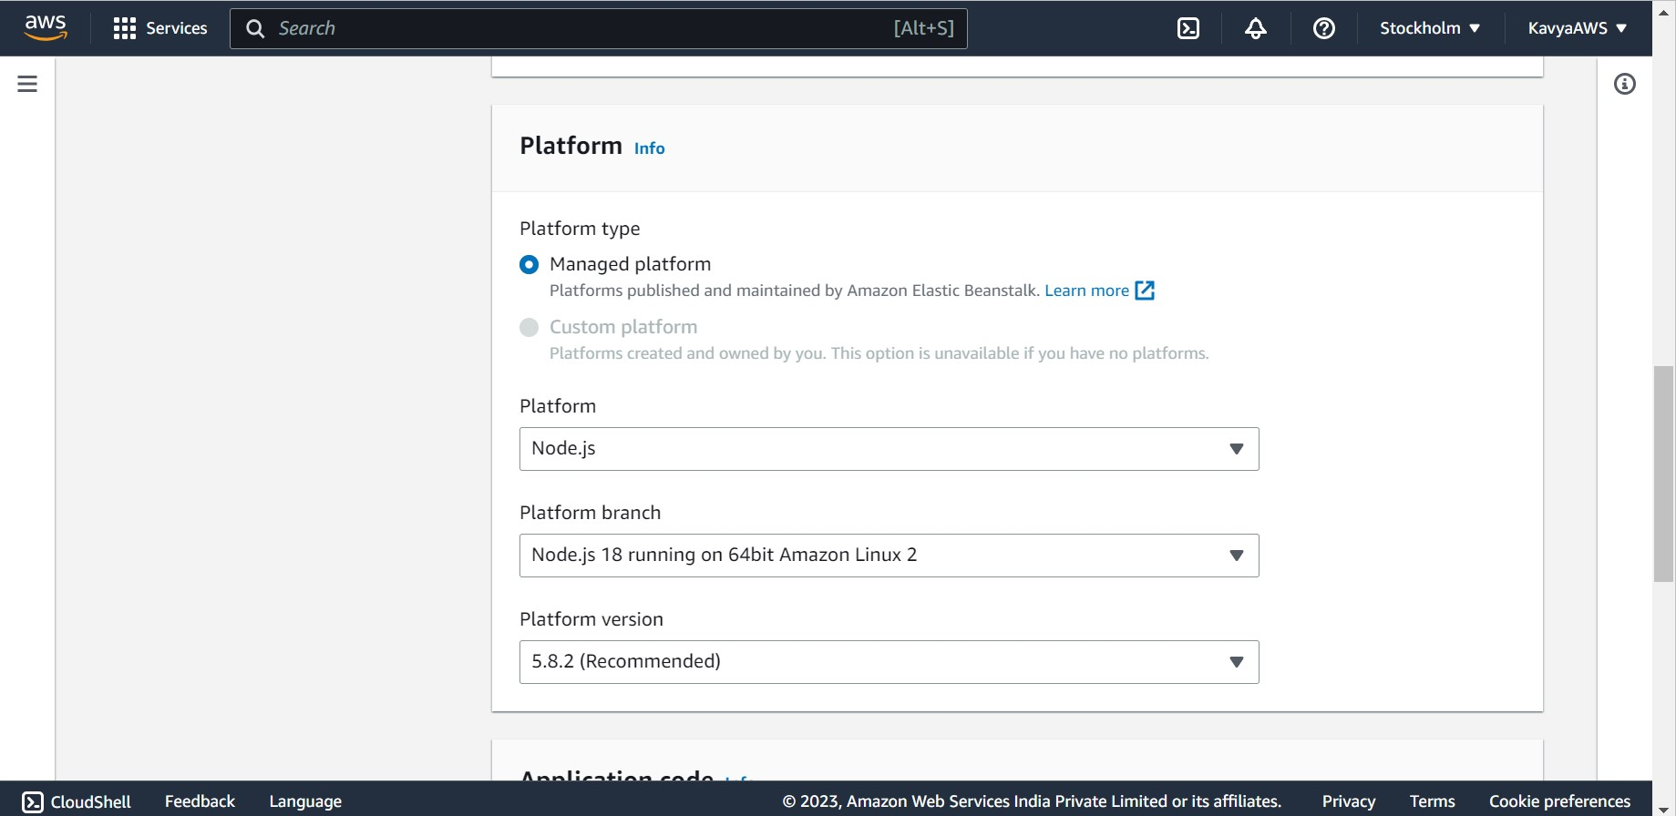

Choose **Next**.

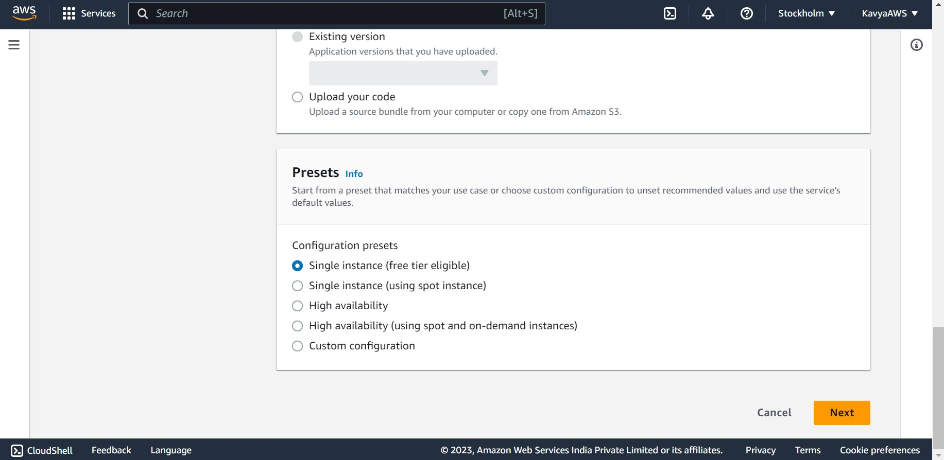

The **Configure service access** page displays. Choose **Create and use a new service role** for **Service Role**.

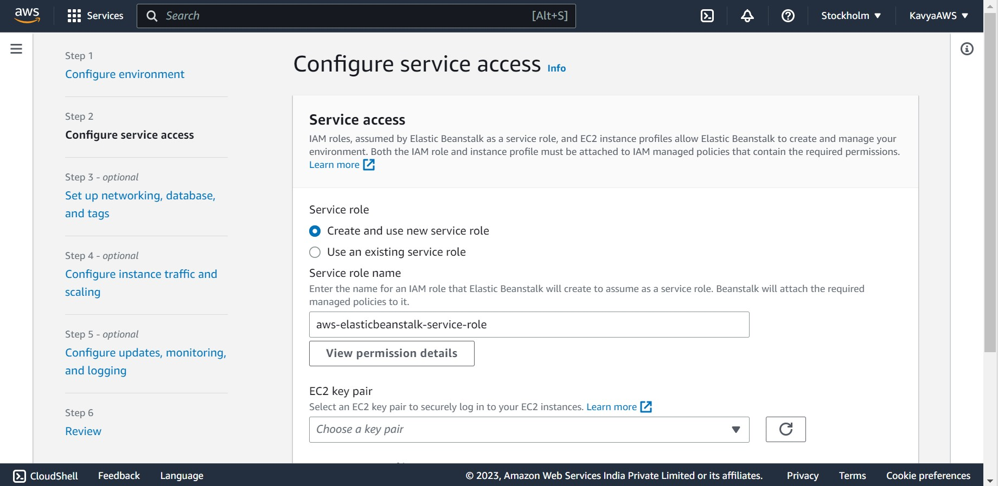

If the **EC2 instance profile** dropdown list doesn't list any values to choose from.

**Create an IAM Role for EC2 instance profile selection.** Choose **View permission details**. This displays under the **EC2 instance profile** dropdown list.

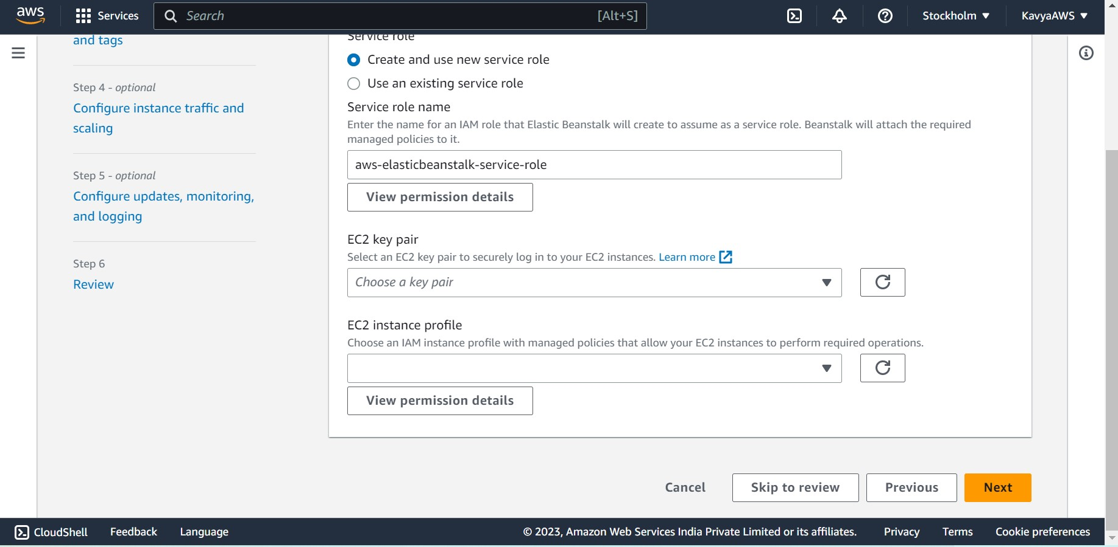

A modal window titled **View instance profile permissions** displays. This window lists the managed profiles that you'll need to attach to the new EC2 instance profile that you create. It also provides a link to launch the IAM console.

Click on the **IAM console** link displayed at the top of the window.

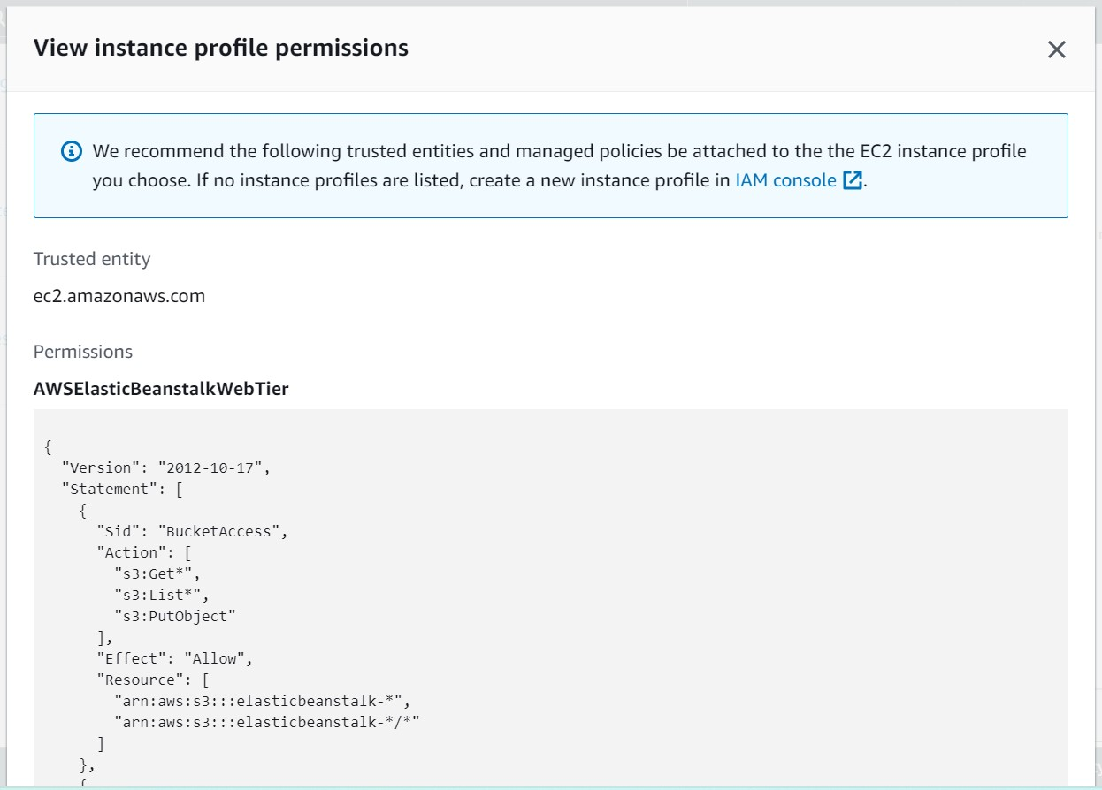

In the IAM console, in the left navigation panel, choose **Roles**. Click on **Create role**.

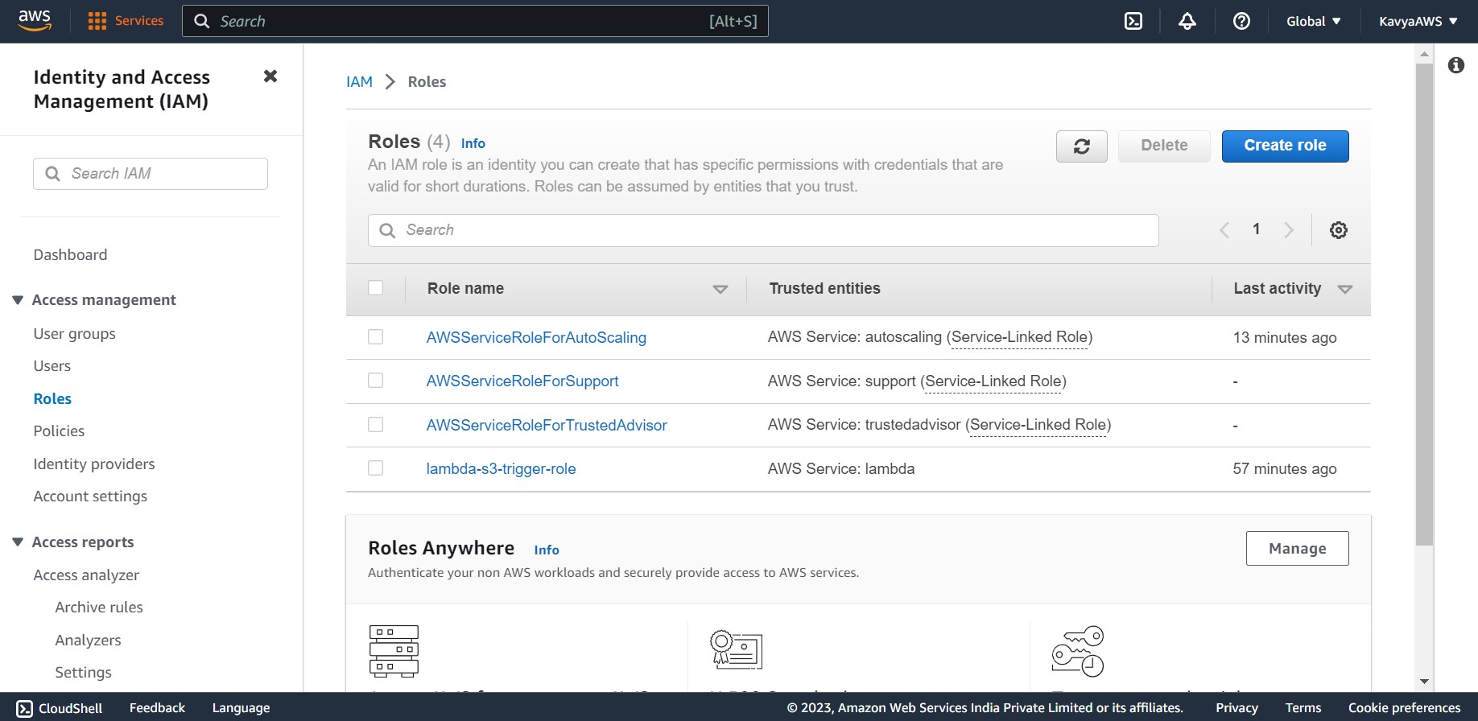

Under **Trusted entity type**, select **AWS service**.

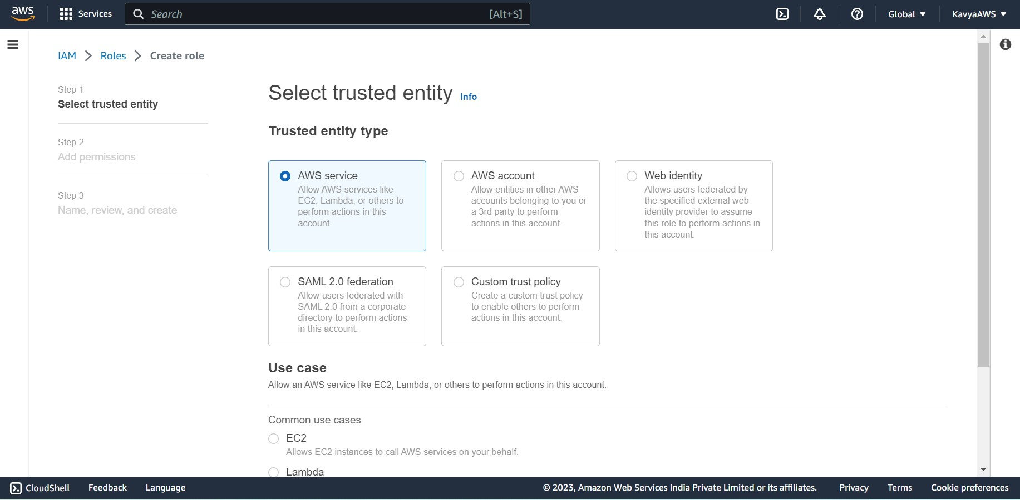

Under **Use case**, choose **EC2**. Click on **Next**.

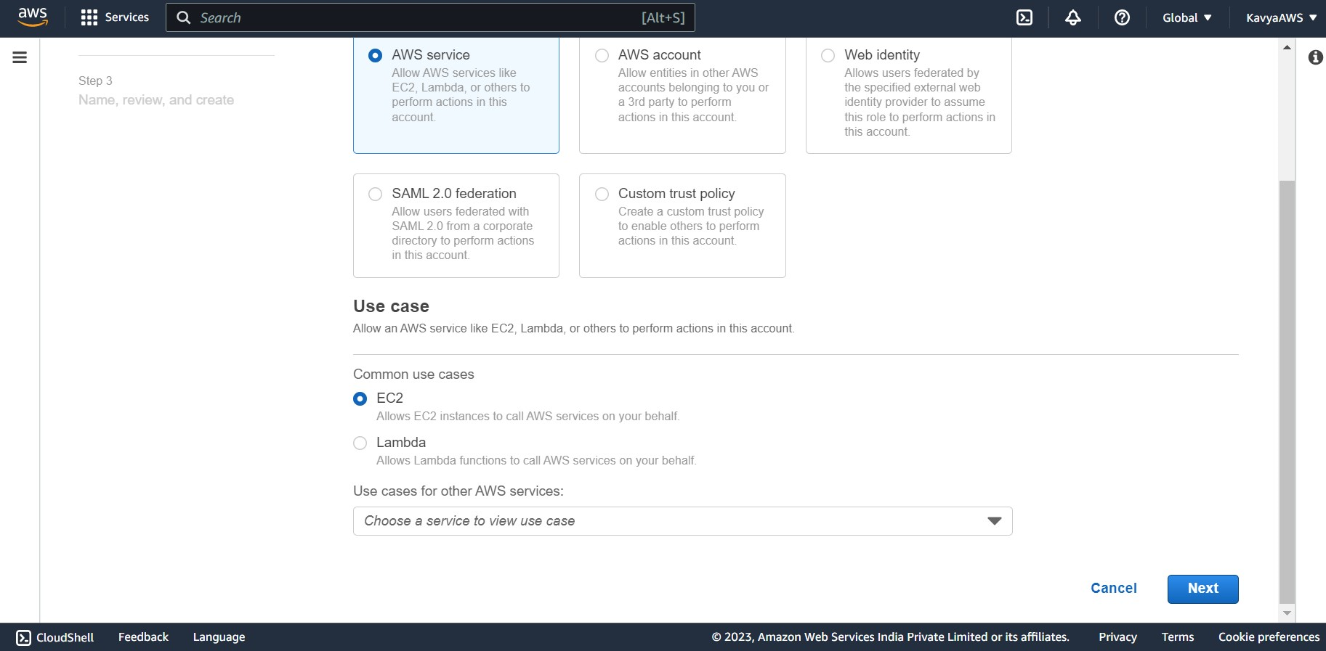

Attach the appropriate managed policies. And click on **Next.** The policies are listed below:

1. AWSElasticBeanstalkWebTier
2. AWSElasticBeanstalkWorkerTier
3. AWSElasticBeanstalkMulticontainerDocker

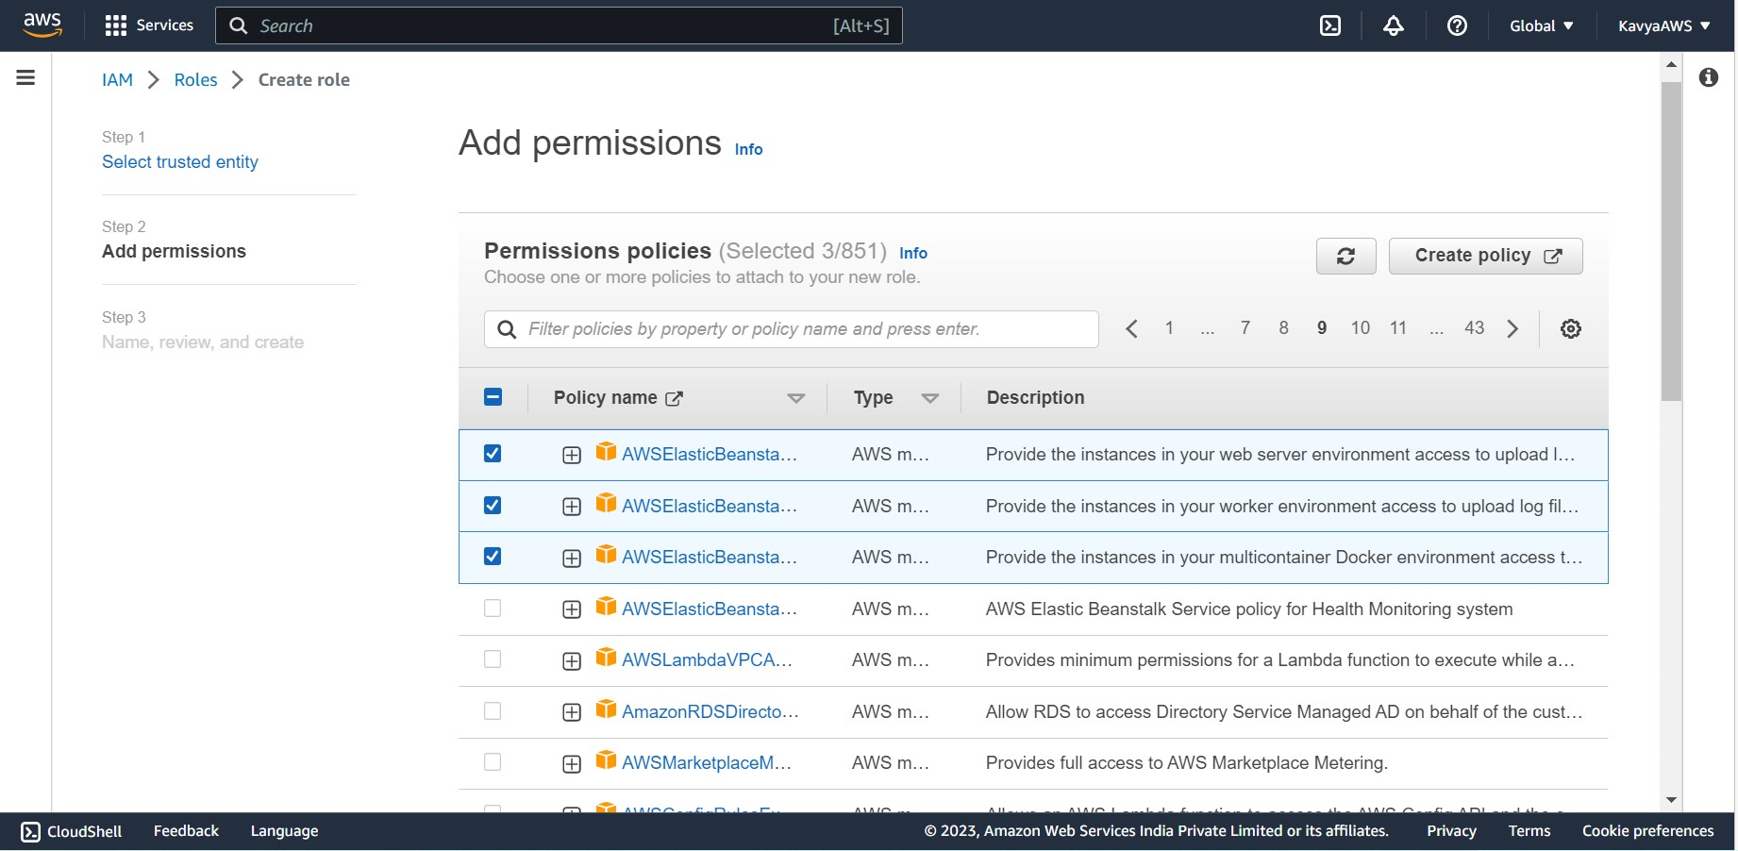

Enter a name for the role.

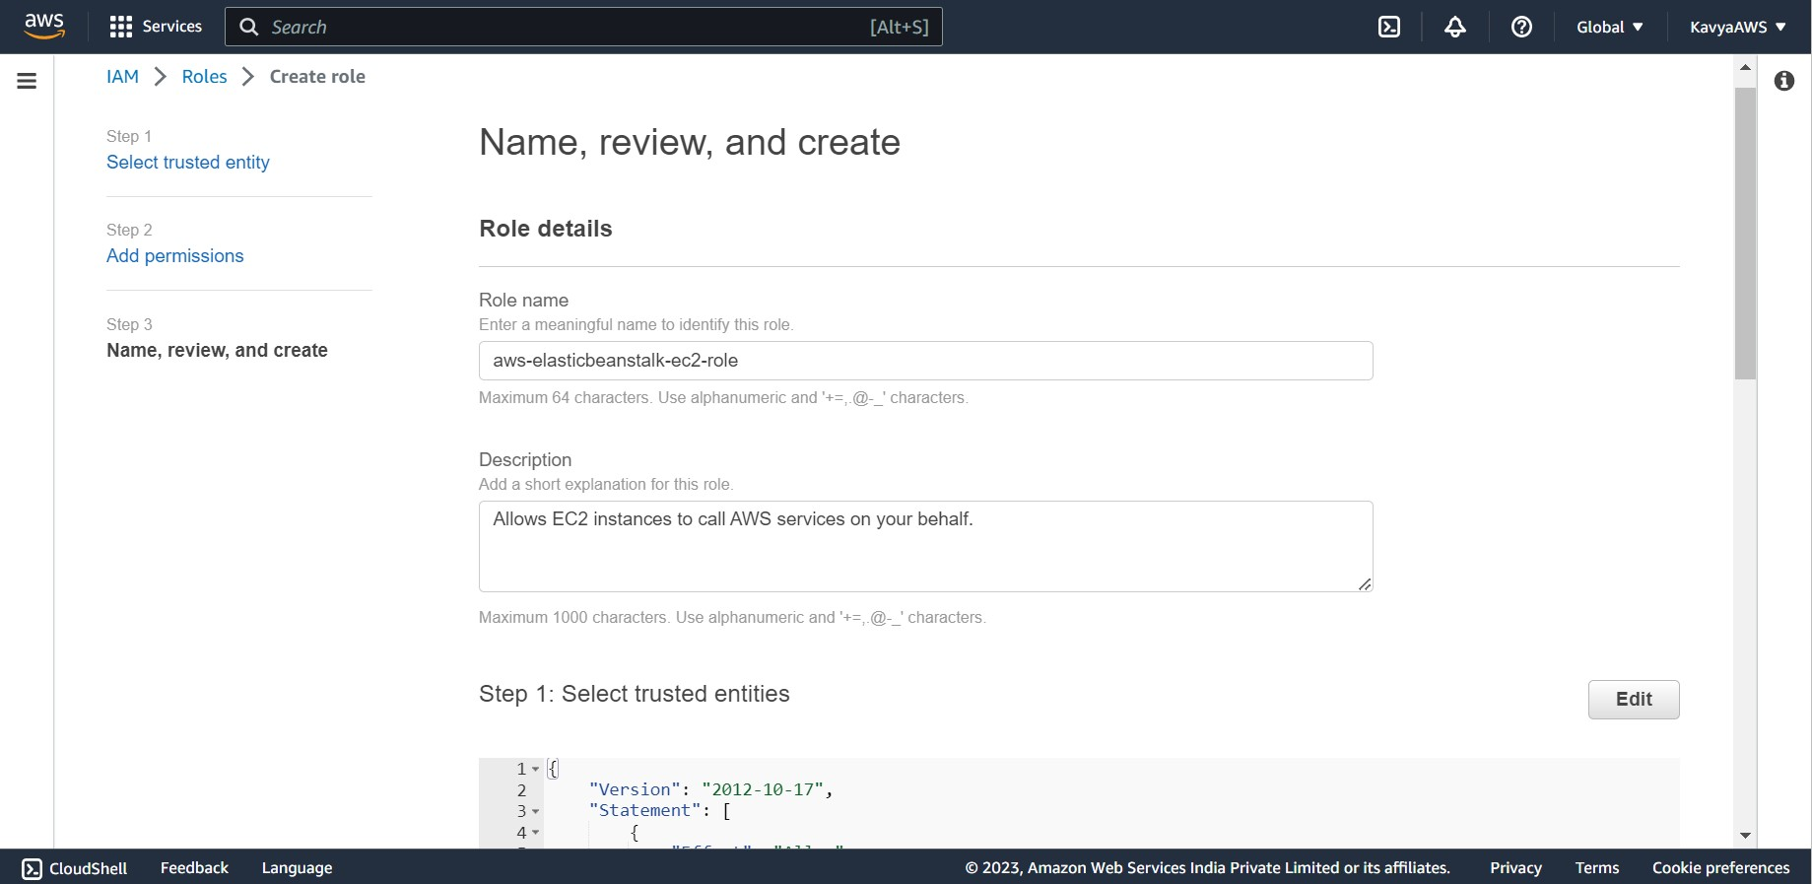

Click on **Create role.**

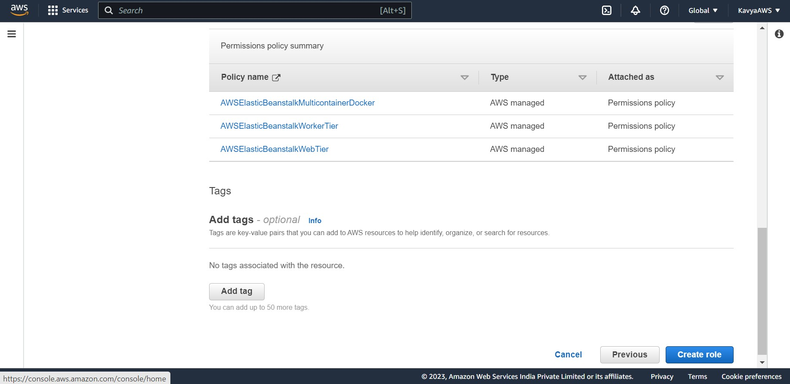

Role is successfully created. Return to the Elastic Beanstalk console window that is open.

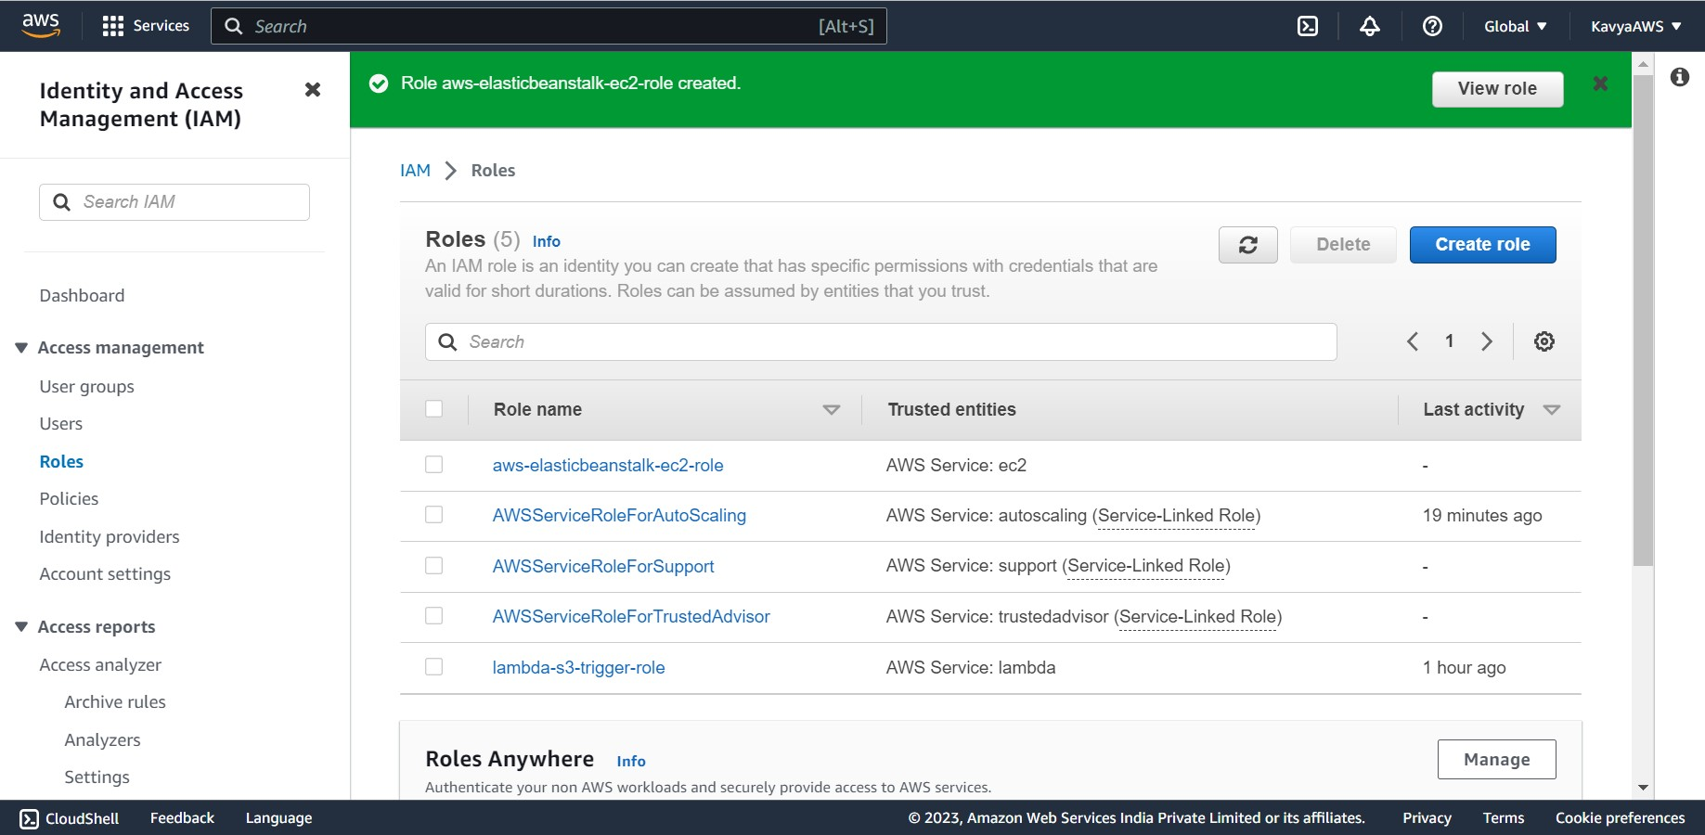

Click on refresh, next to the **EC2 instance profile** dropdown list. This refreshes the dropdown list, so that the Role you just created will display in the dropdown list. Choose **Skip to Review** on the **Configure service access** page. This skips the optional steps.

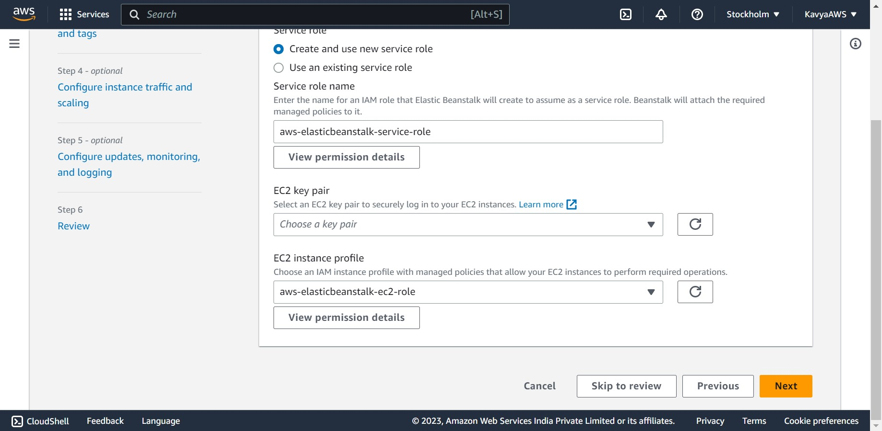

The **Review** page displays a summary of all your choices.

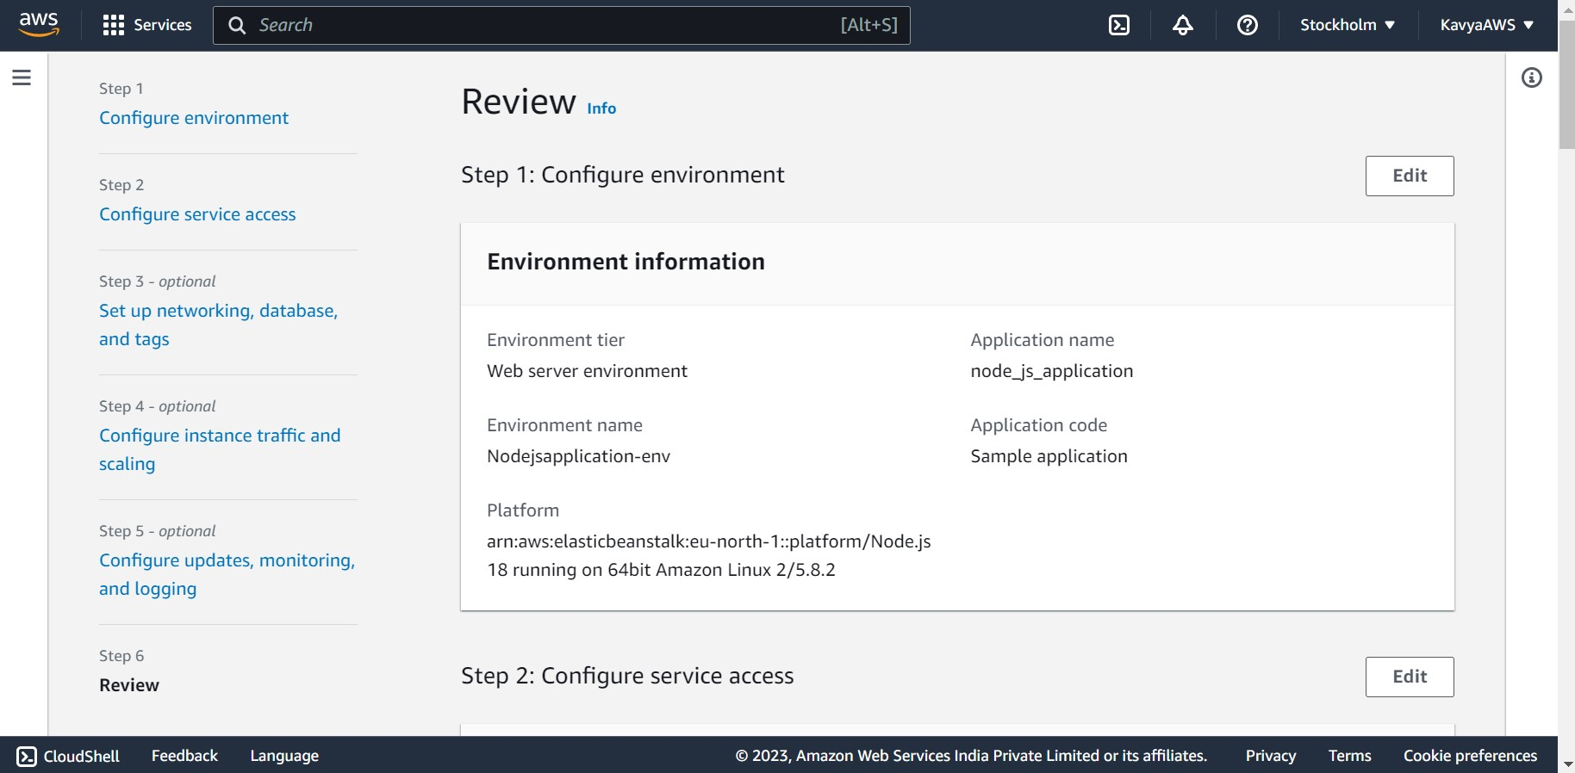

Click on **Submit** at the bottom of the page.

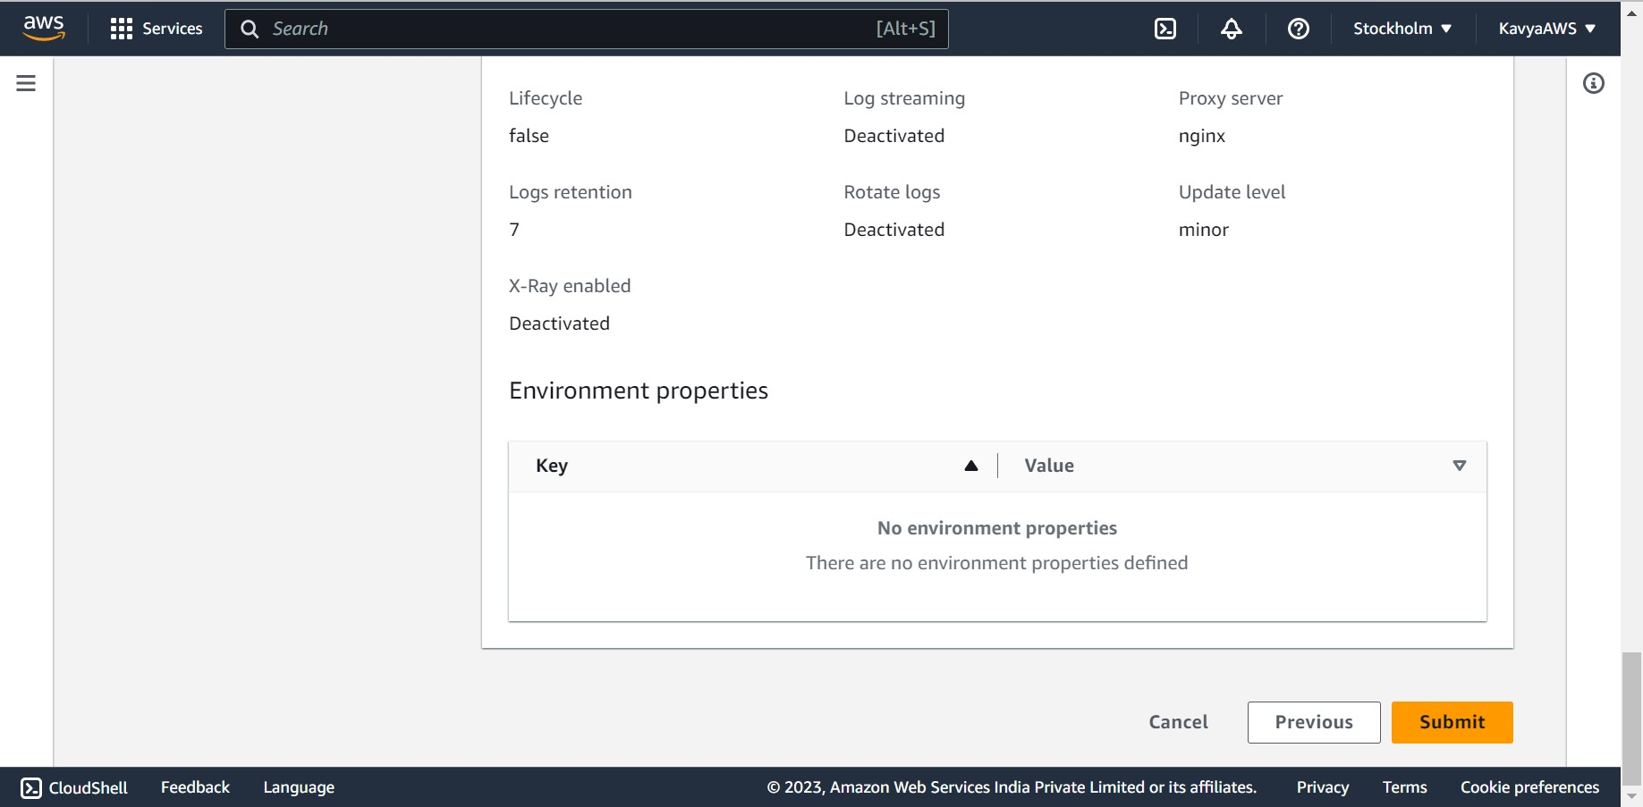

Elastic Beanstalk Environment launched successfully.

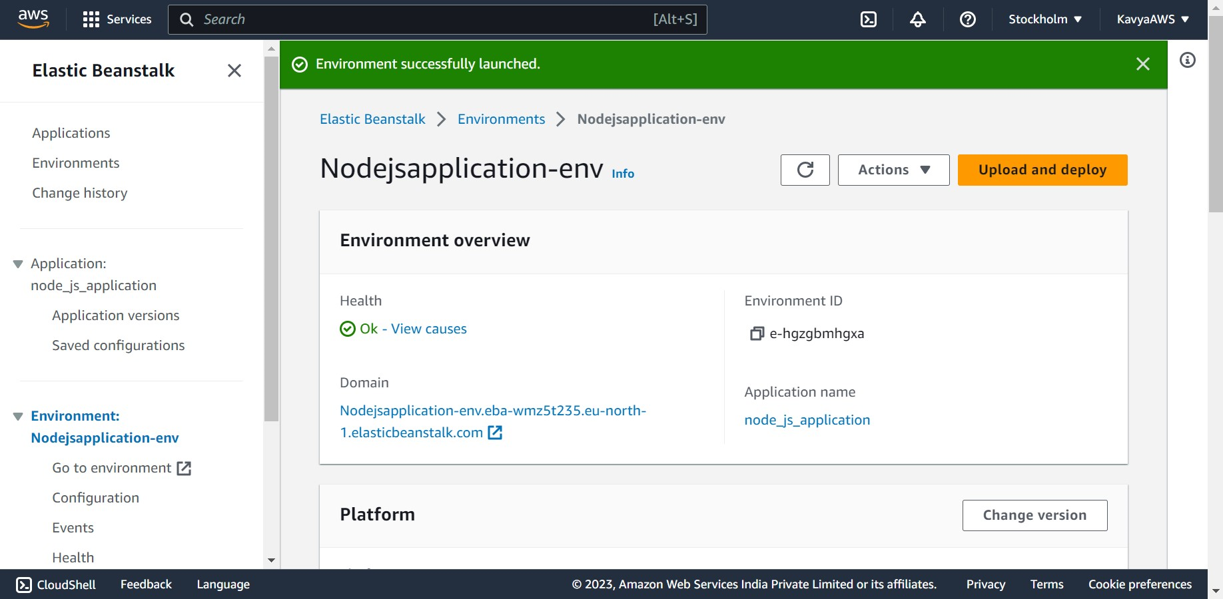

Open the Elastic Beanstalk console, and in the **Regions** list, select your AWS Region. and then choose the name of your environment we created.

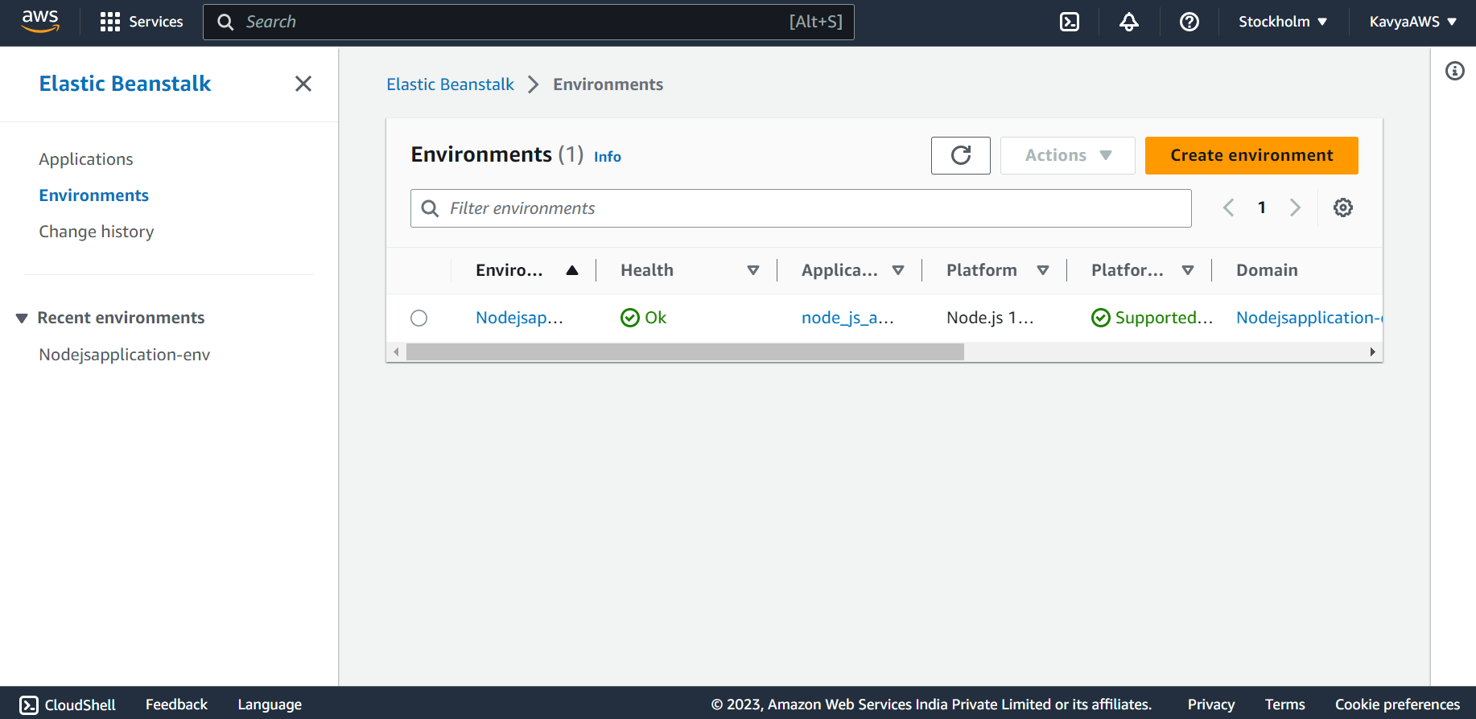

On clicking on the navigation link.

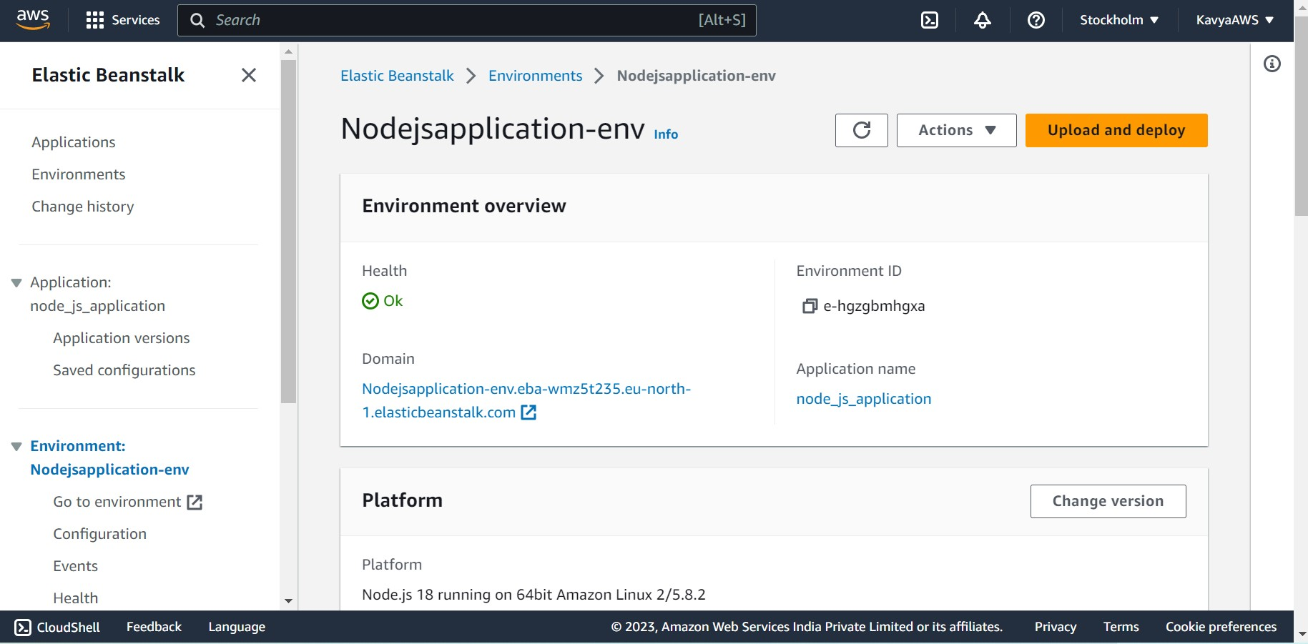

This page is displayed.

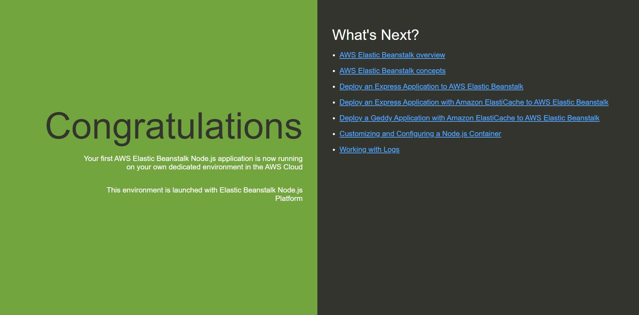

To upload other project to the environment overview page, choose **Upload and deploy**.



**Choose file**, and then upload the zip file.  And click on **Deploy**.

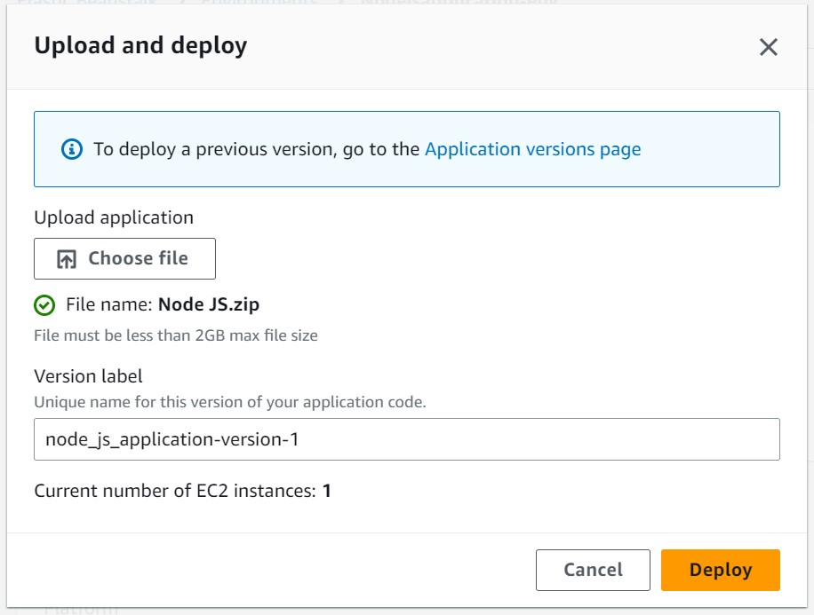

Successfully uploaded the zip file of the project and updated the environment as well.

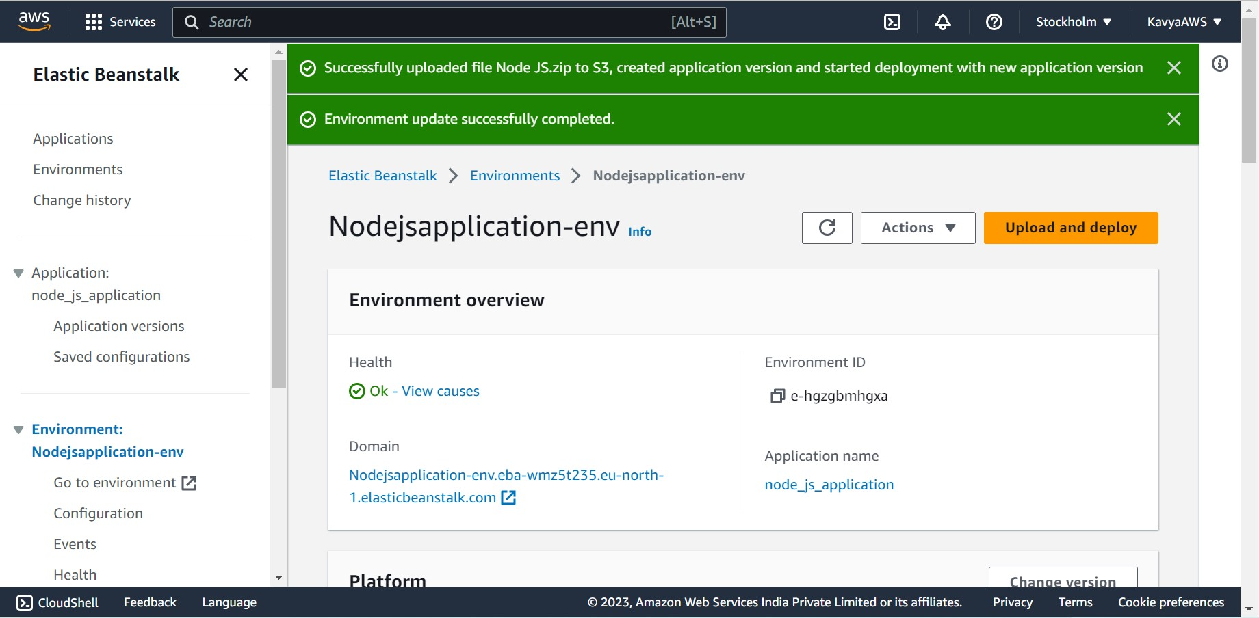

After clicking on the navigation, I’m getting Bad Gateway, Tried to change the port name and re-upload the project but got the same error.

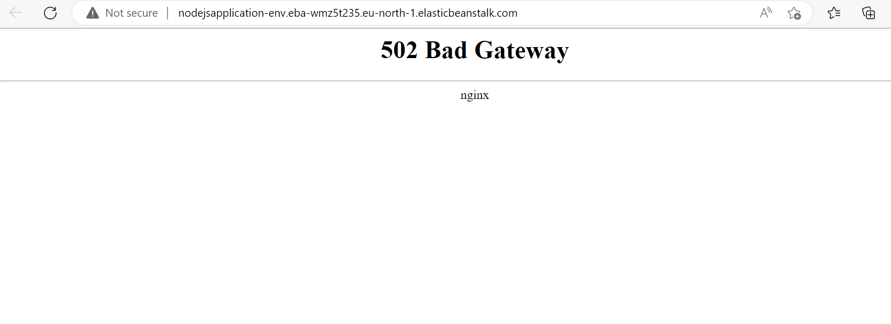

Q4. Create a Lambda that should trigger as soon as you upload a file in the S3 bucket.

Function should be able to print the name of the file uploaded in the function.

1. **We need to create an Amazon S3 bucket.**

Search for S3 in the Search bar on the home page

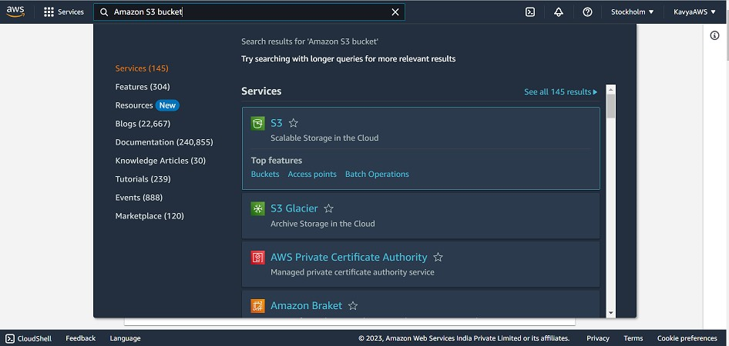

Open Amazon S3 console and select the Buckets page.

Click on Crete Bucket

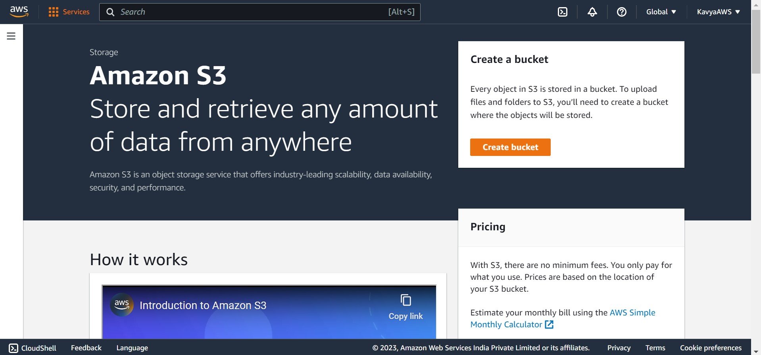

Under General configuration:

1. For Bucket name, enter a globally unique name that meets the Amazon S3 bucket naming rules. Bucket names can contain only lowercase letters, numbers, dots(.), and hyphens (-).
2. For AWS Region, choose a Region, we must create a Lambda function in the same Region.

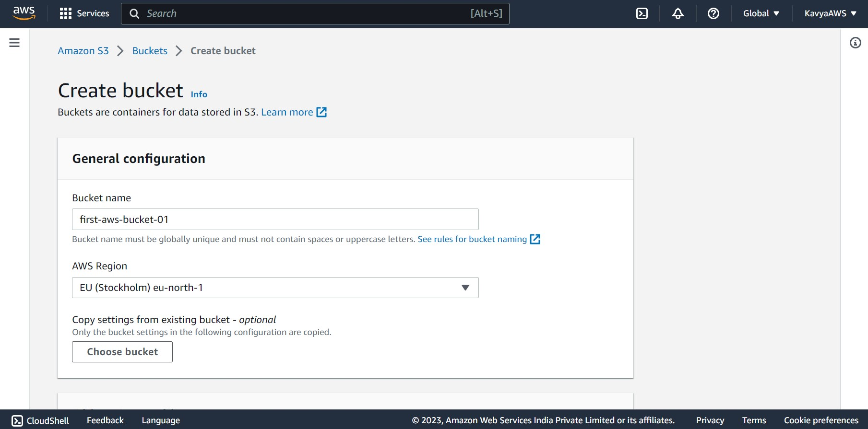

Leave all other options set to their default values and choose **Create bucket**.

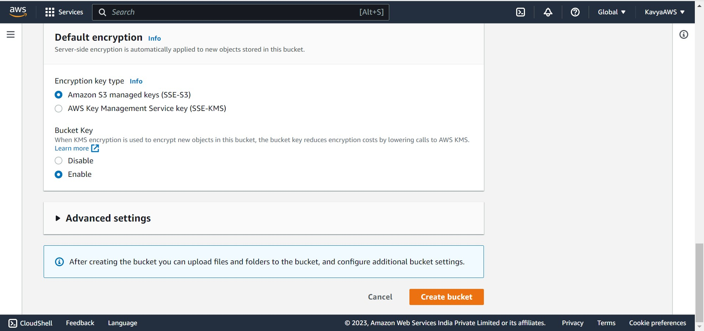

Amazon S3 Bucket “first-aws-bucket-01” is successfully created.

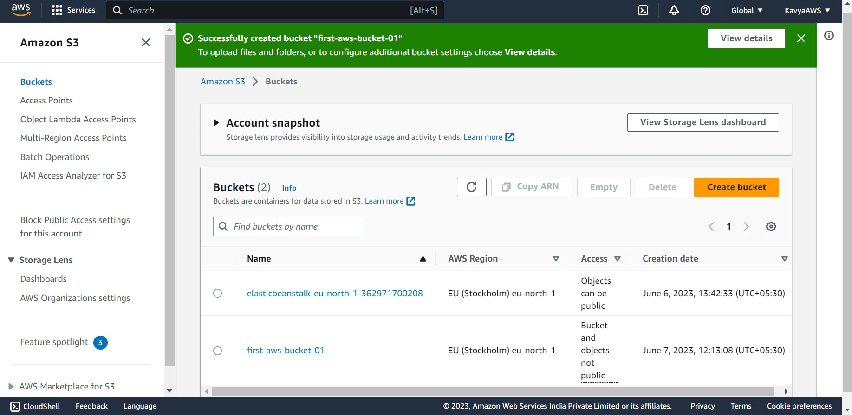

1. **Upload Test object to the bucket**

Open the buckets page of the Amazon S3 console and choose the bucket created in the previous steps. Click on **Upload**.

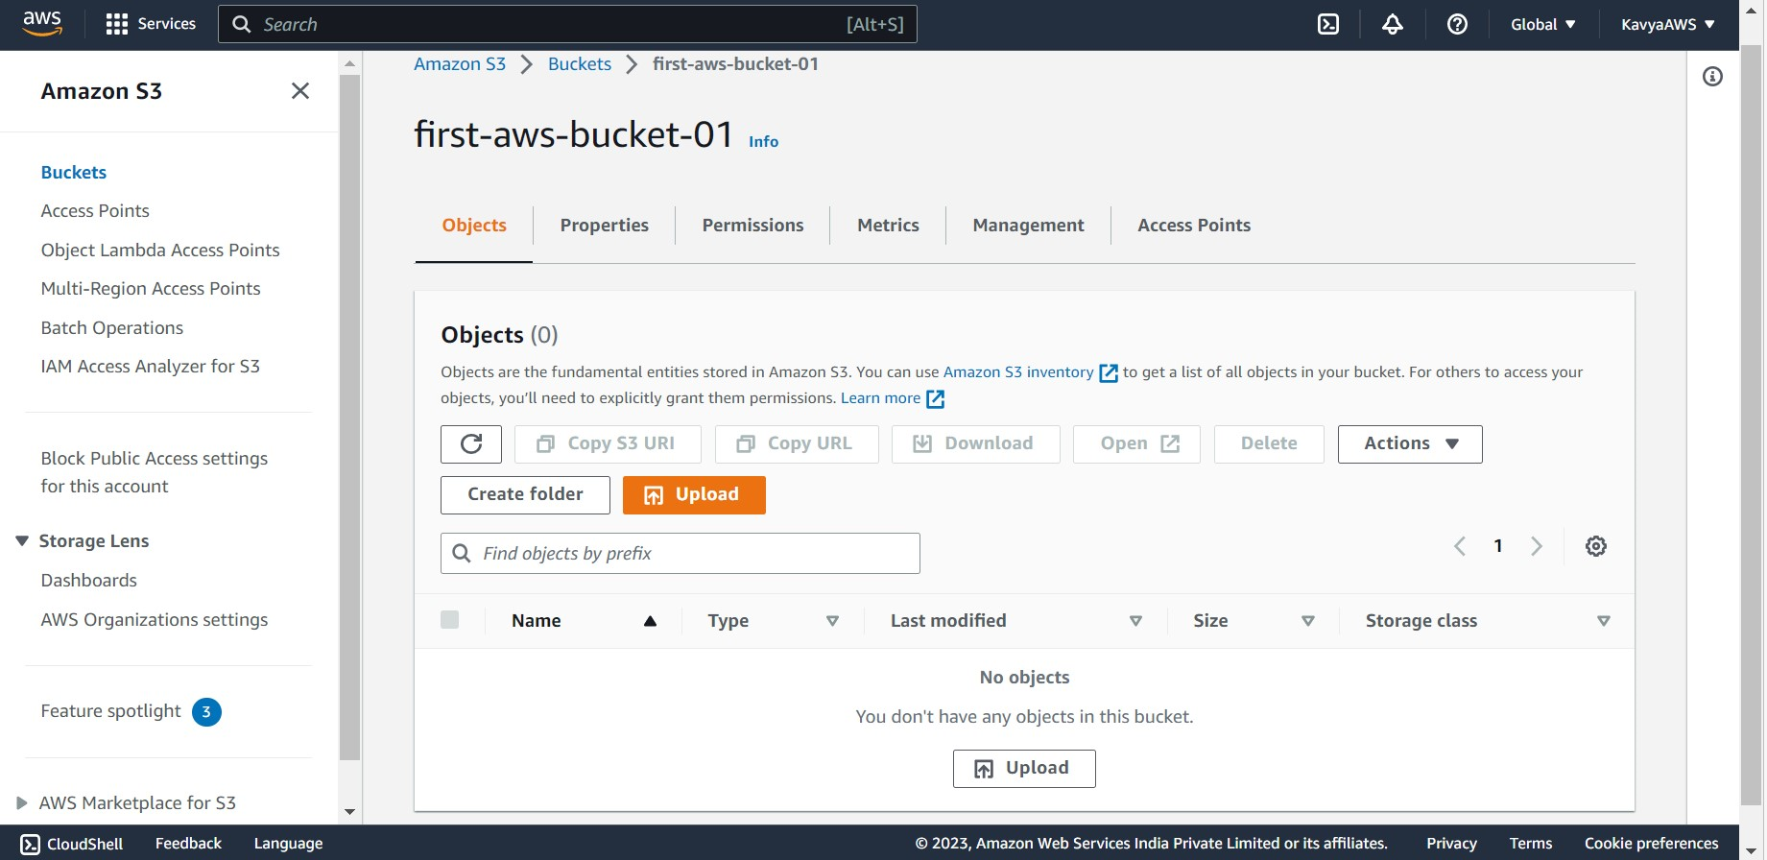

Click on **Add files** and use the file selector to choose the object to upload.

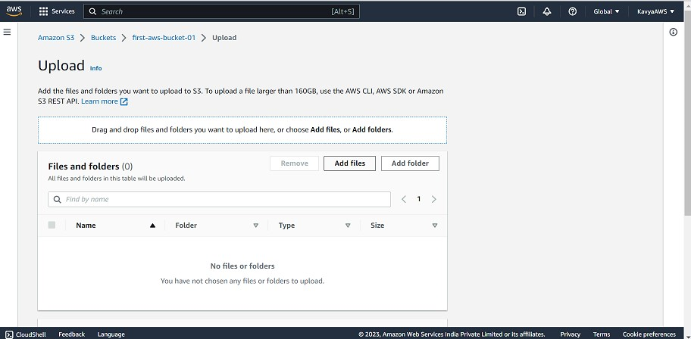

Choose Open and then click on Upload at the bottom of the page.

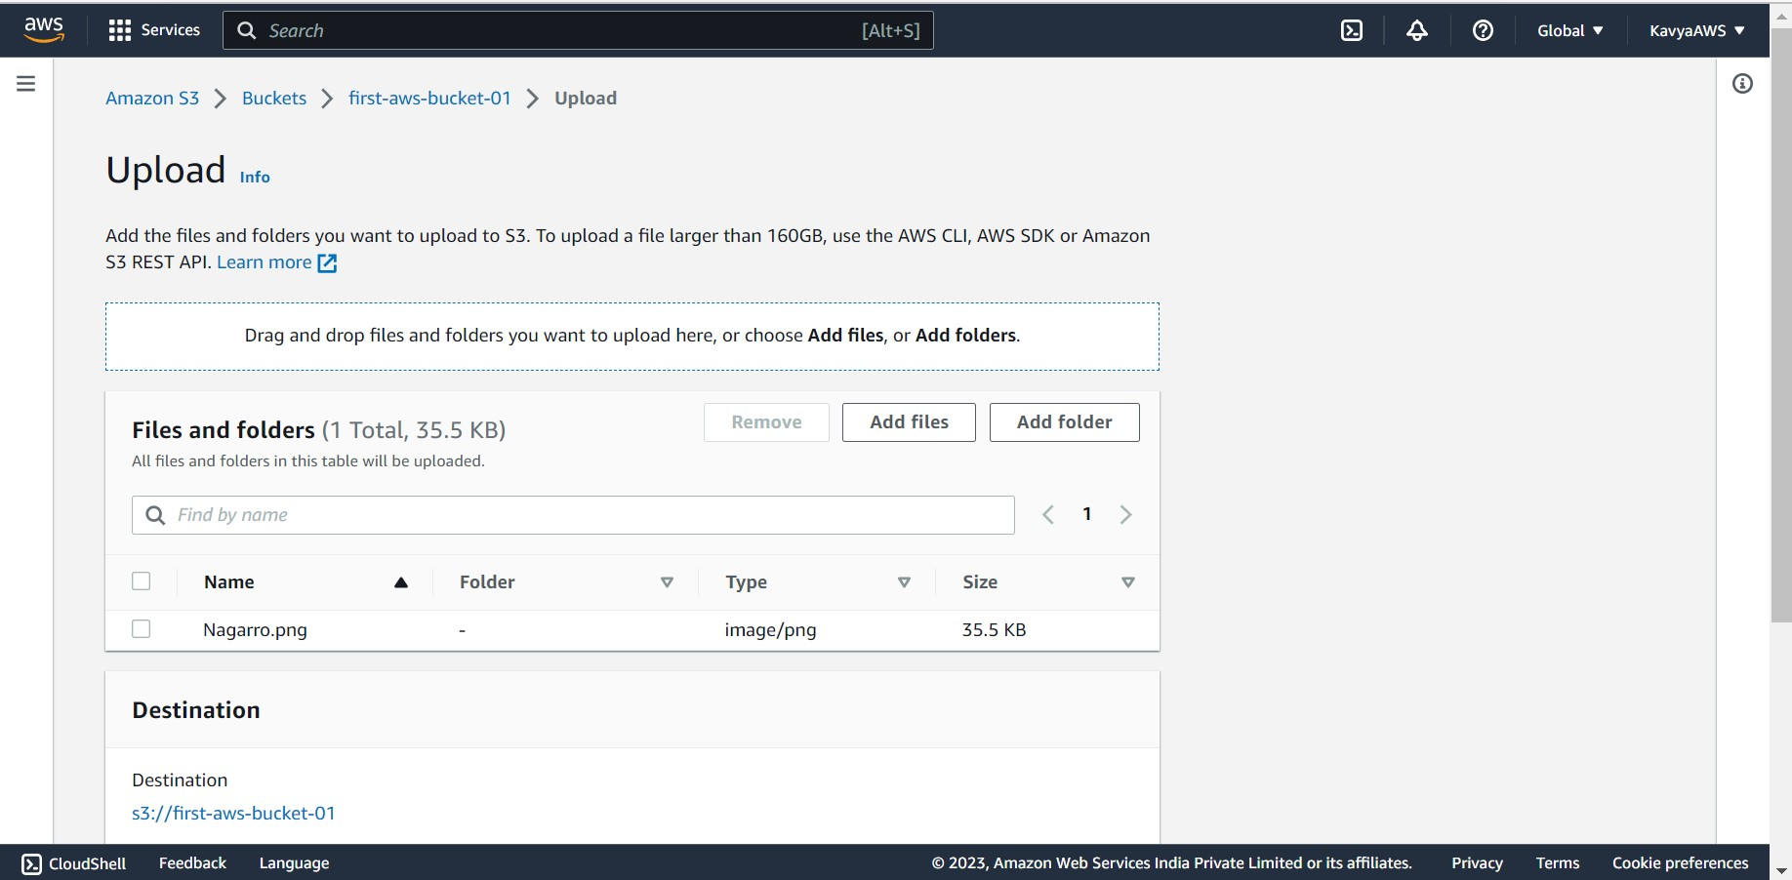 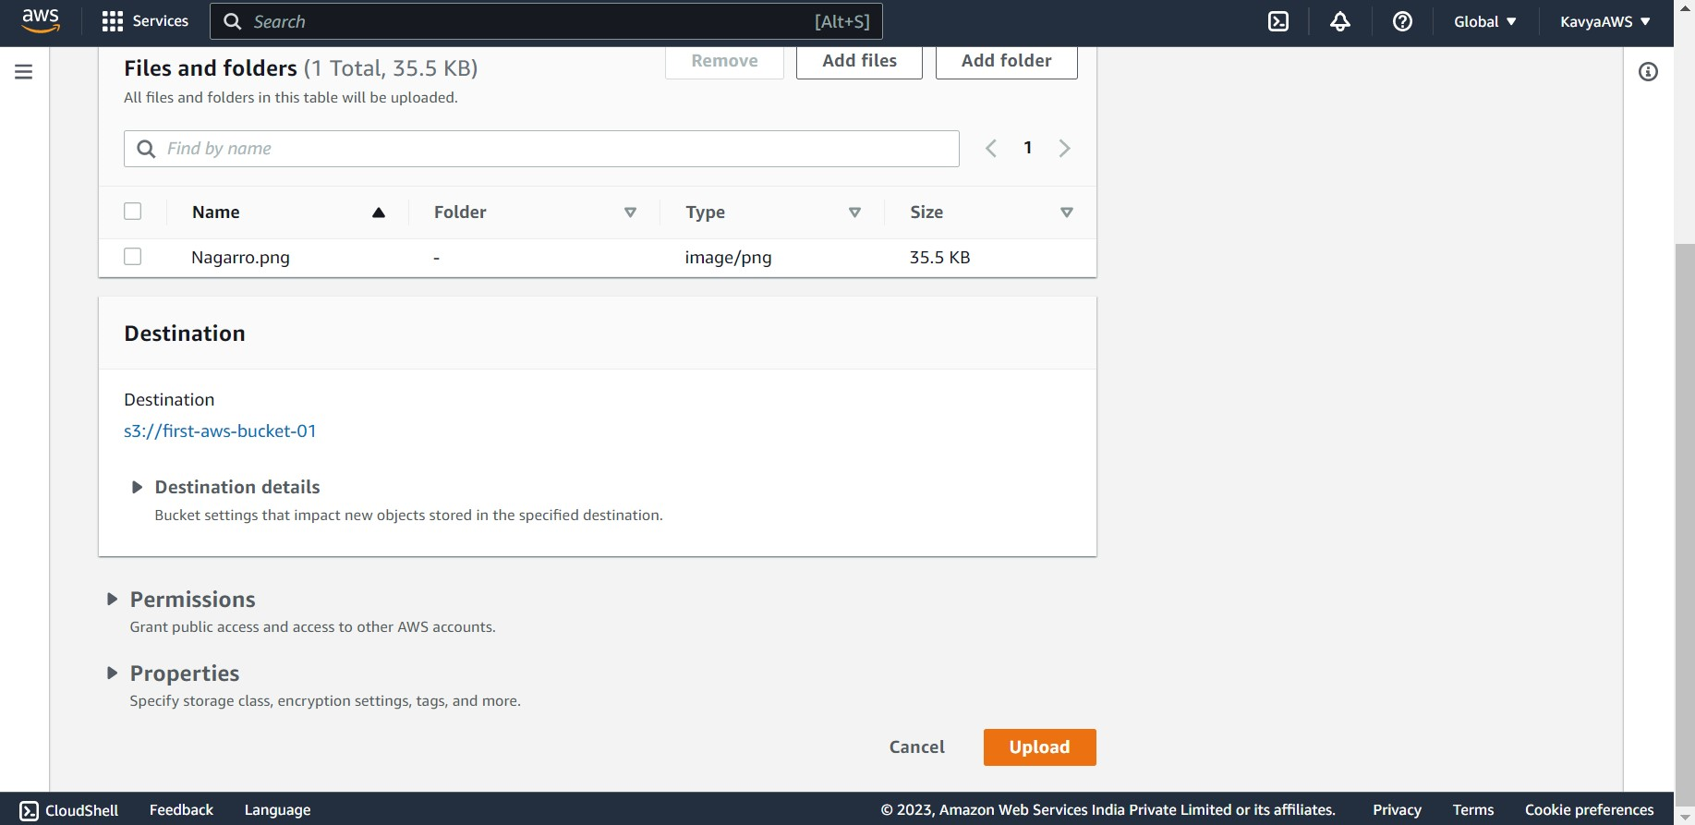

Object is uploaded successfully.

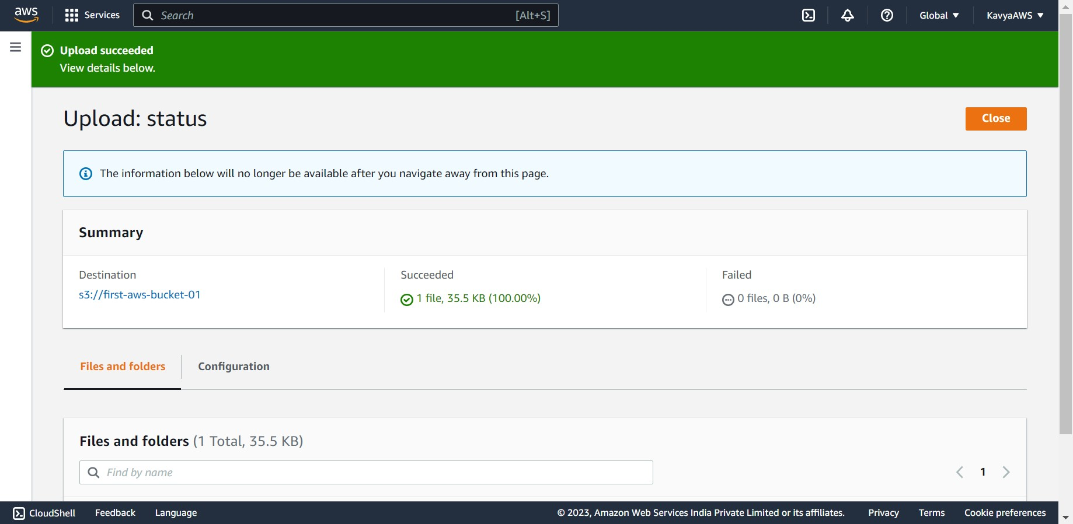 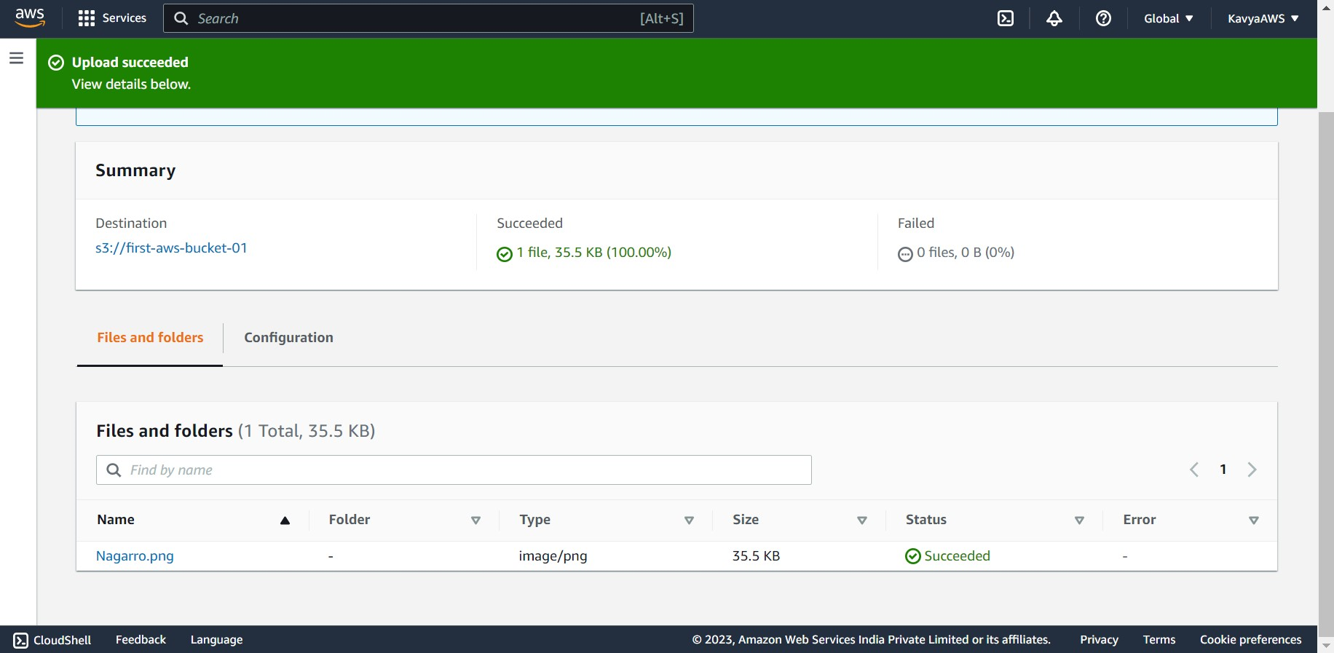

1. **Create Permission Policy**

From the IAM console, open the **Policies** page. And click on **Create policy**.

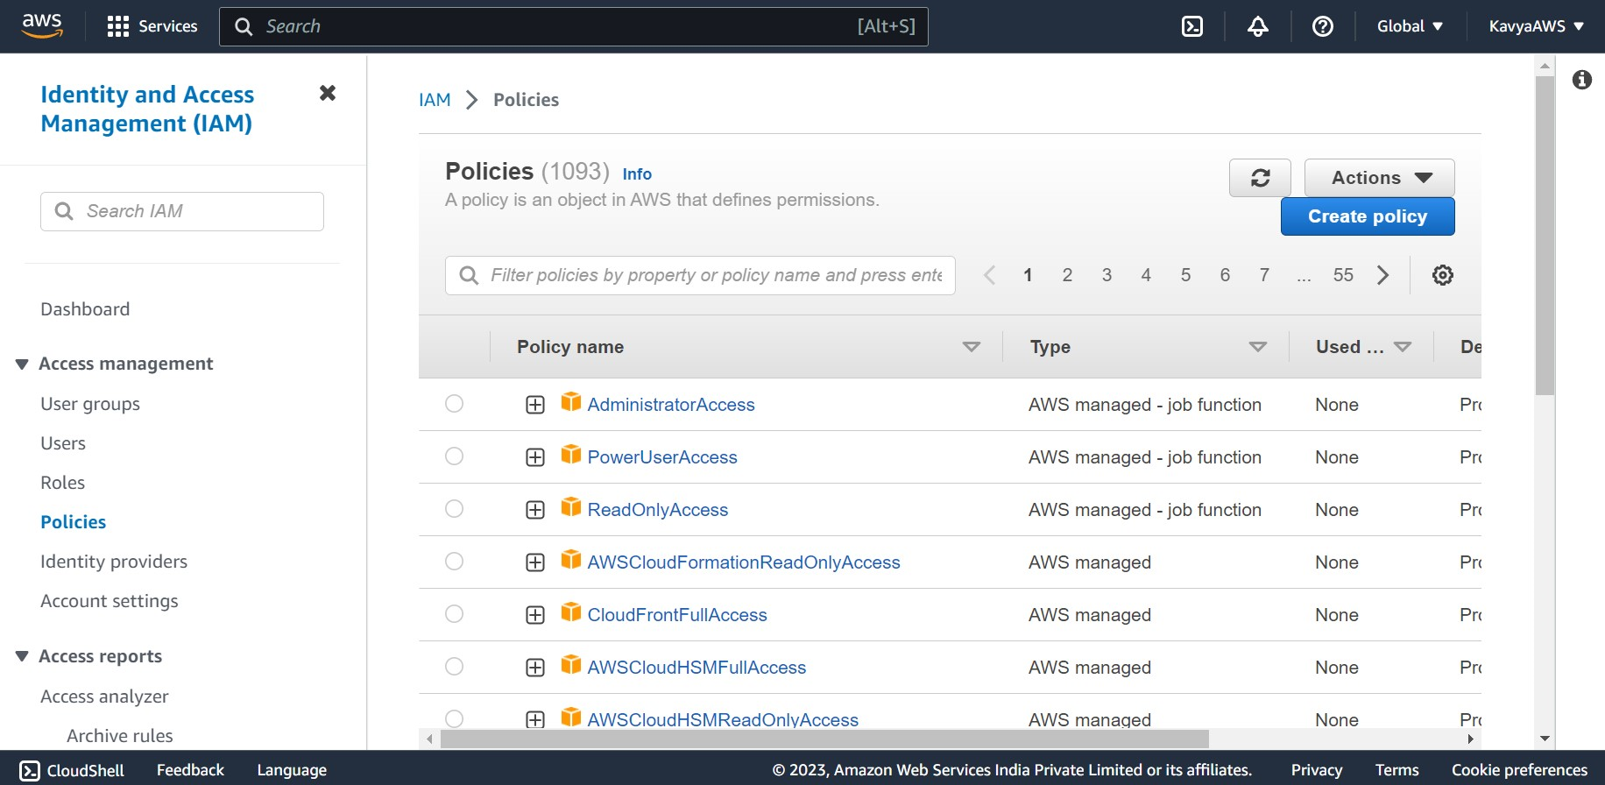

Choose the **JSON tab** and add the code. And Click on **Next** at the bottom of the page.

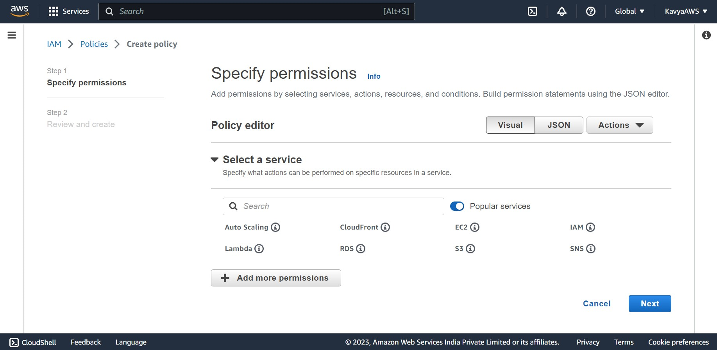 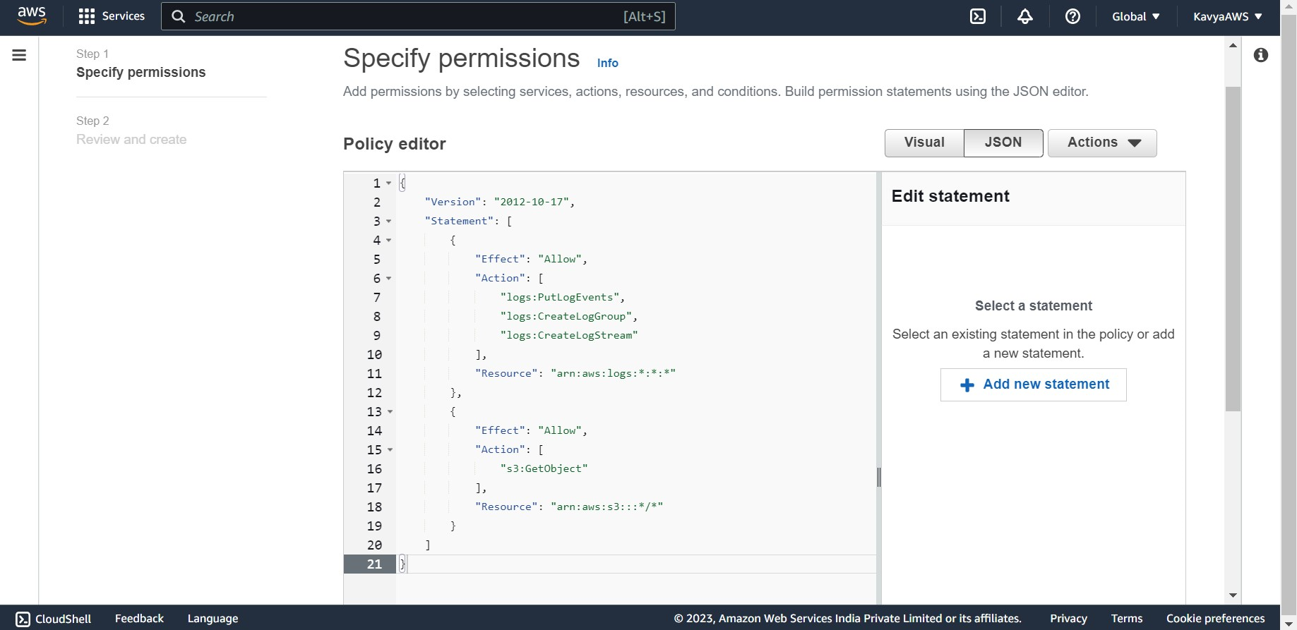

Under Policy details, for the **Policy name** enter **s3-trigger.**

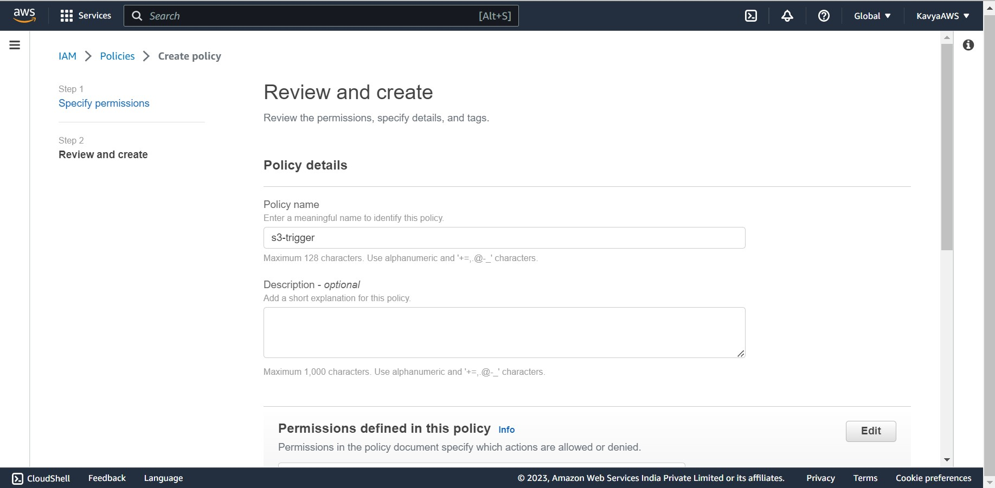

Click on **Create policy.**

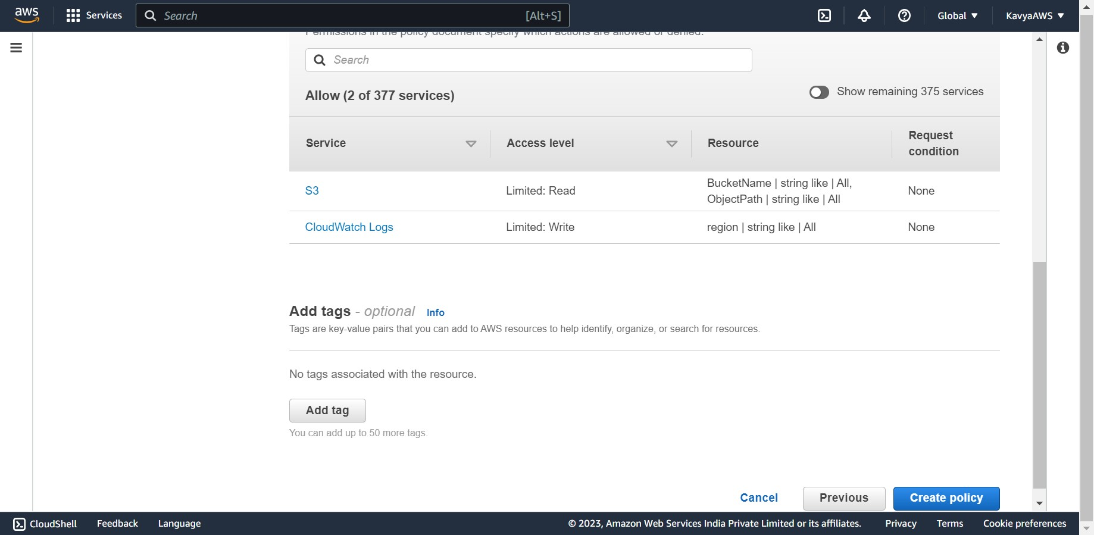

Policy s3-trigger is created successfully.

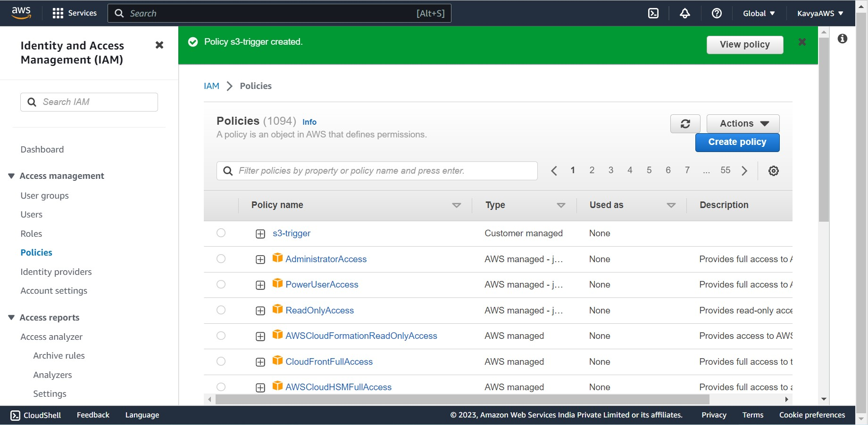

1. **Create an execution role.**

Open the Role page of the IAM console. And click on **Create role.**

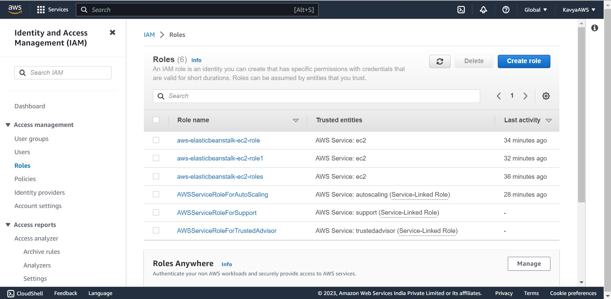

For the type of trusted entity, select **AWS service**.

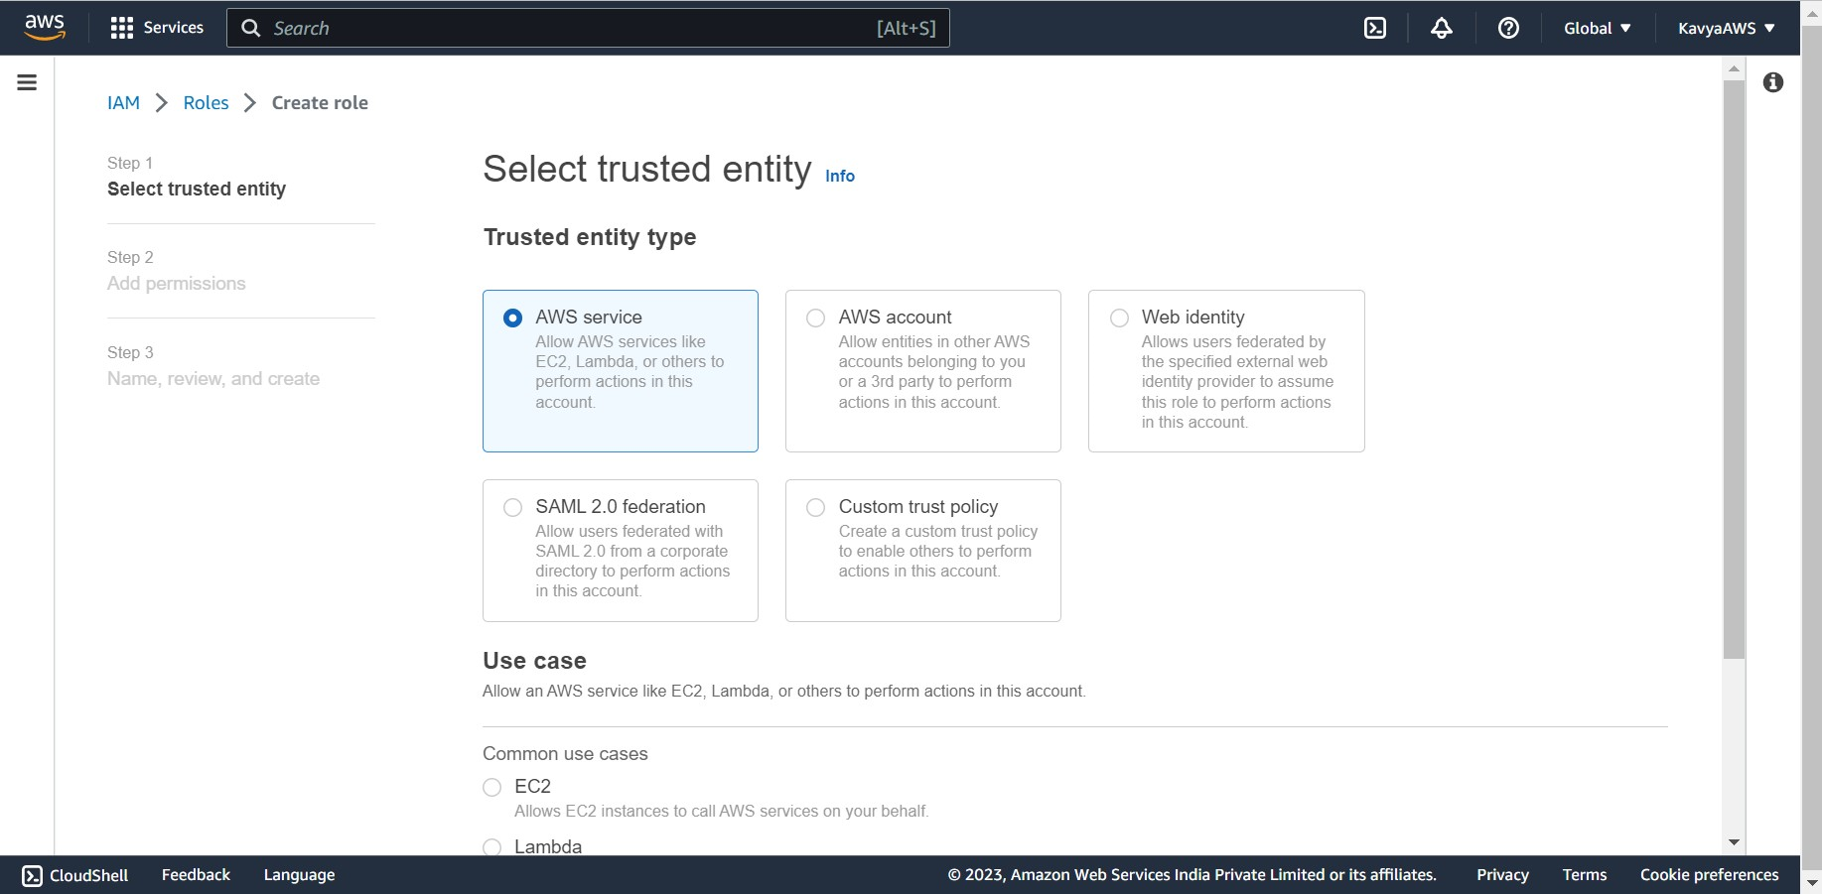

For the use case, choose **Lambda**. And click on **Next.**

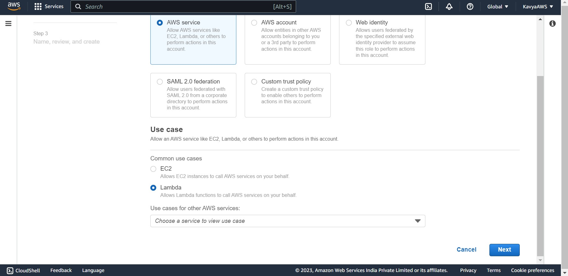

In the policy search box, select the policy that we created (s3-trigger) and click on **Next** at the bottom of the page.

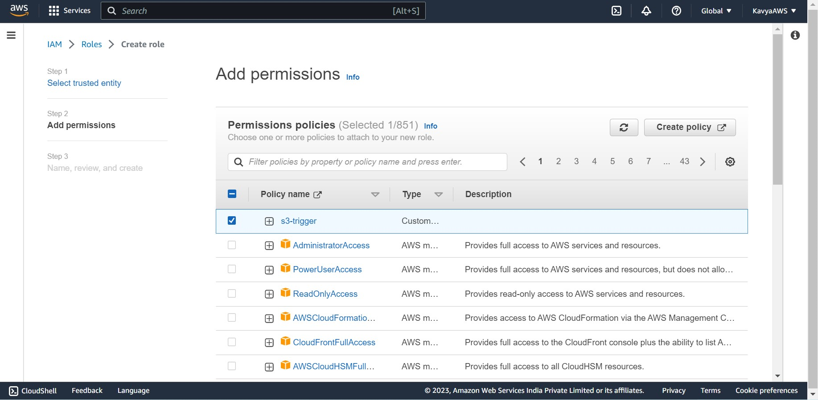

Under **Role details**, for the **Role name**, enter lambda-s3-trigger-role, then choose **Create role**.

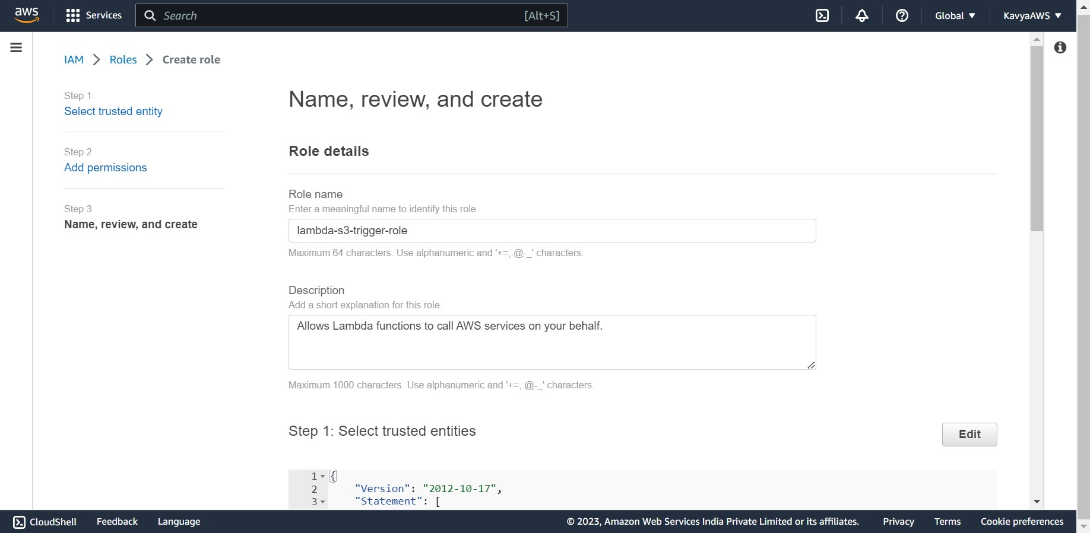 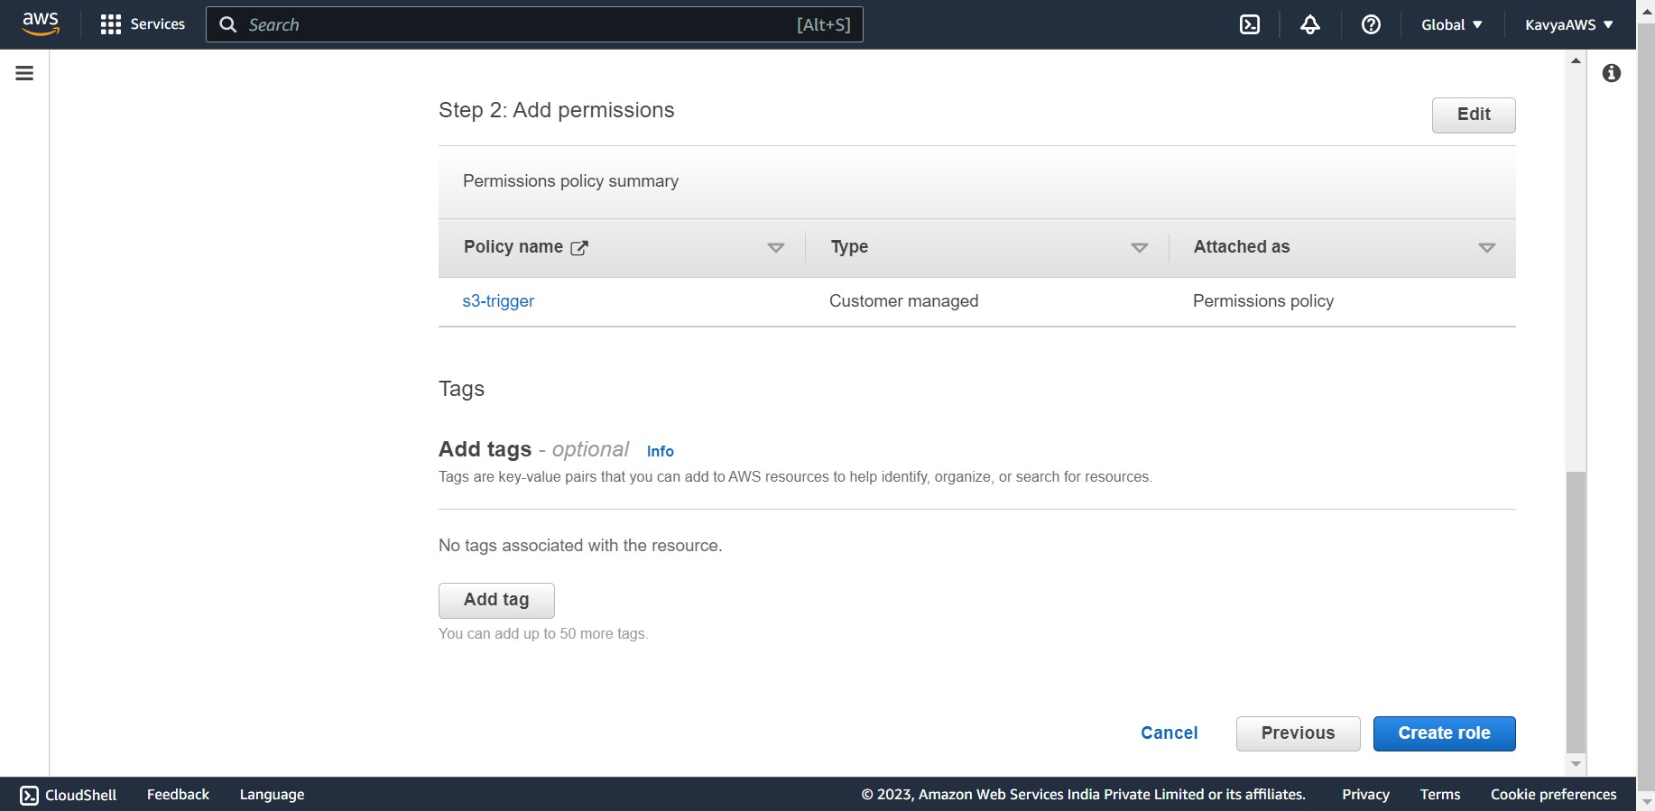

Role lambda-s3-trigger-role created successfully.

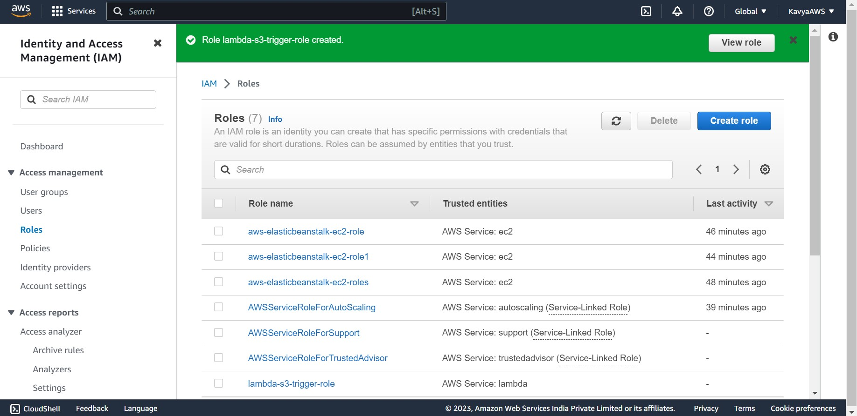

1. **Create the Lambda function.**

Open the function page of the Lambda console.

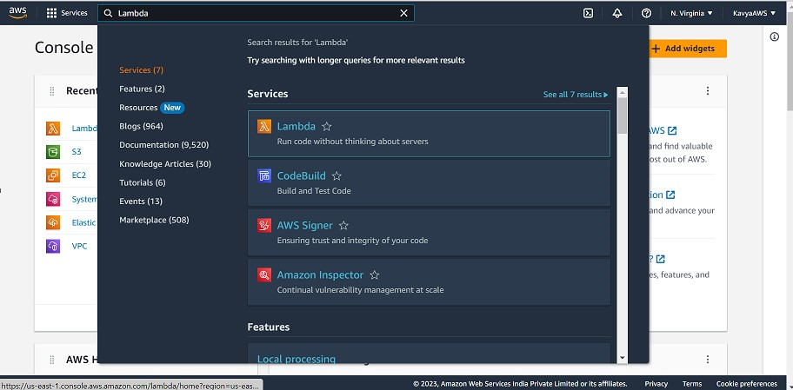

Make sure we are working in the same AWS Region we created the Amazon S3 bucket in. You can change your Region using the drop-down list at the top of the screen.

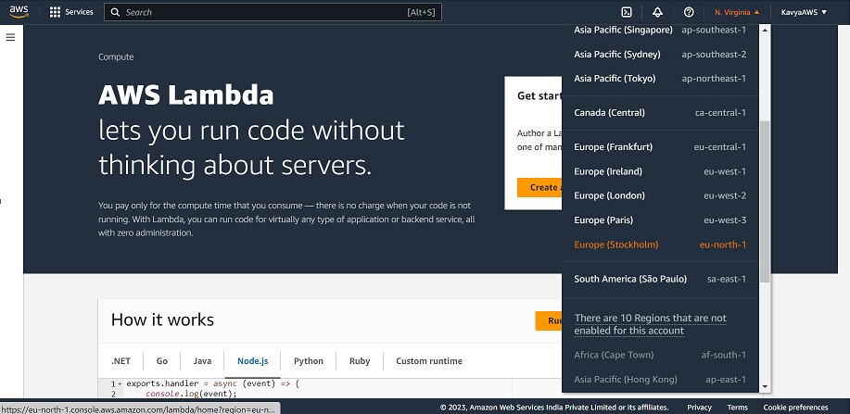

Click on **Create function**.

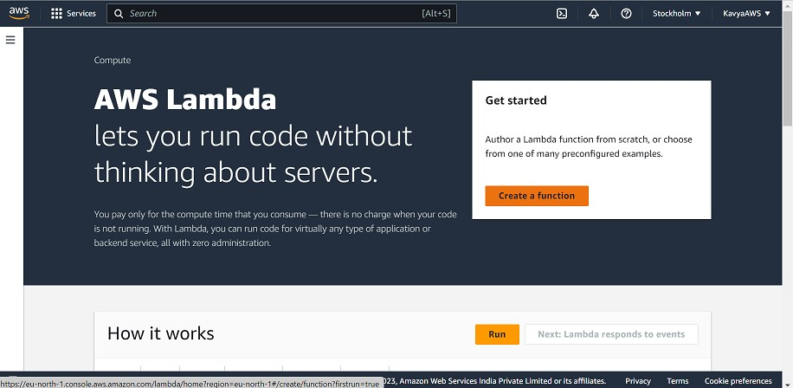

Choose **Author from scratch.**

Under **Basic information**, do the following:

* 1. For **Function name**, enter s3-trigger-tutorial.
  2. For **Runtime**, choose **Node.js 18.x**.
  3. For **Architecture**, choose **x86_64**.

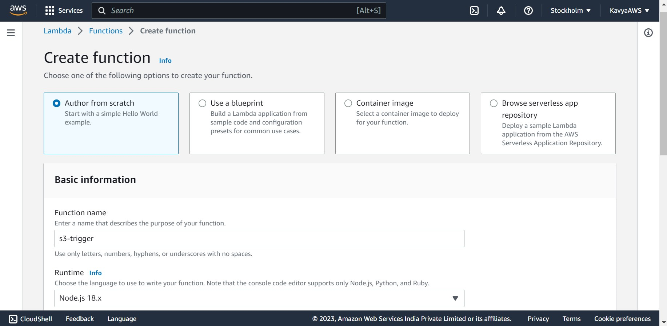 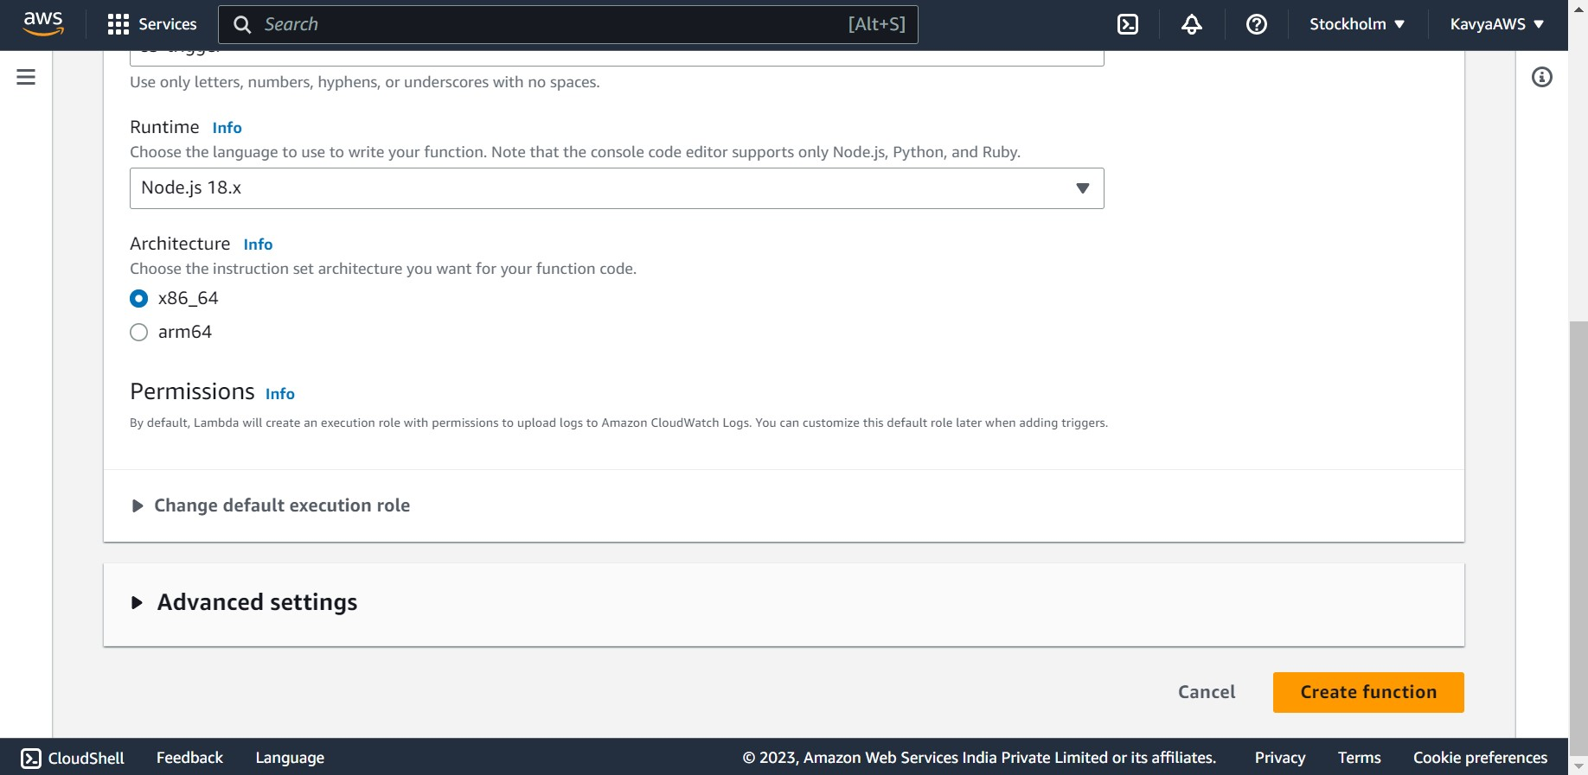

In the **Change default execution role** tab:

* 1. Expand the tab, then choose **Use an existing role**.
  2. Select the lambda-s3-trigger-role we created earlier.

Choose **Create function**.

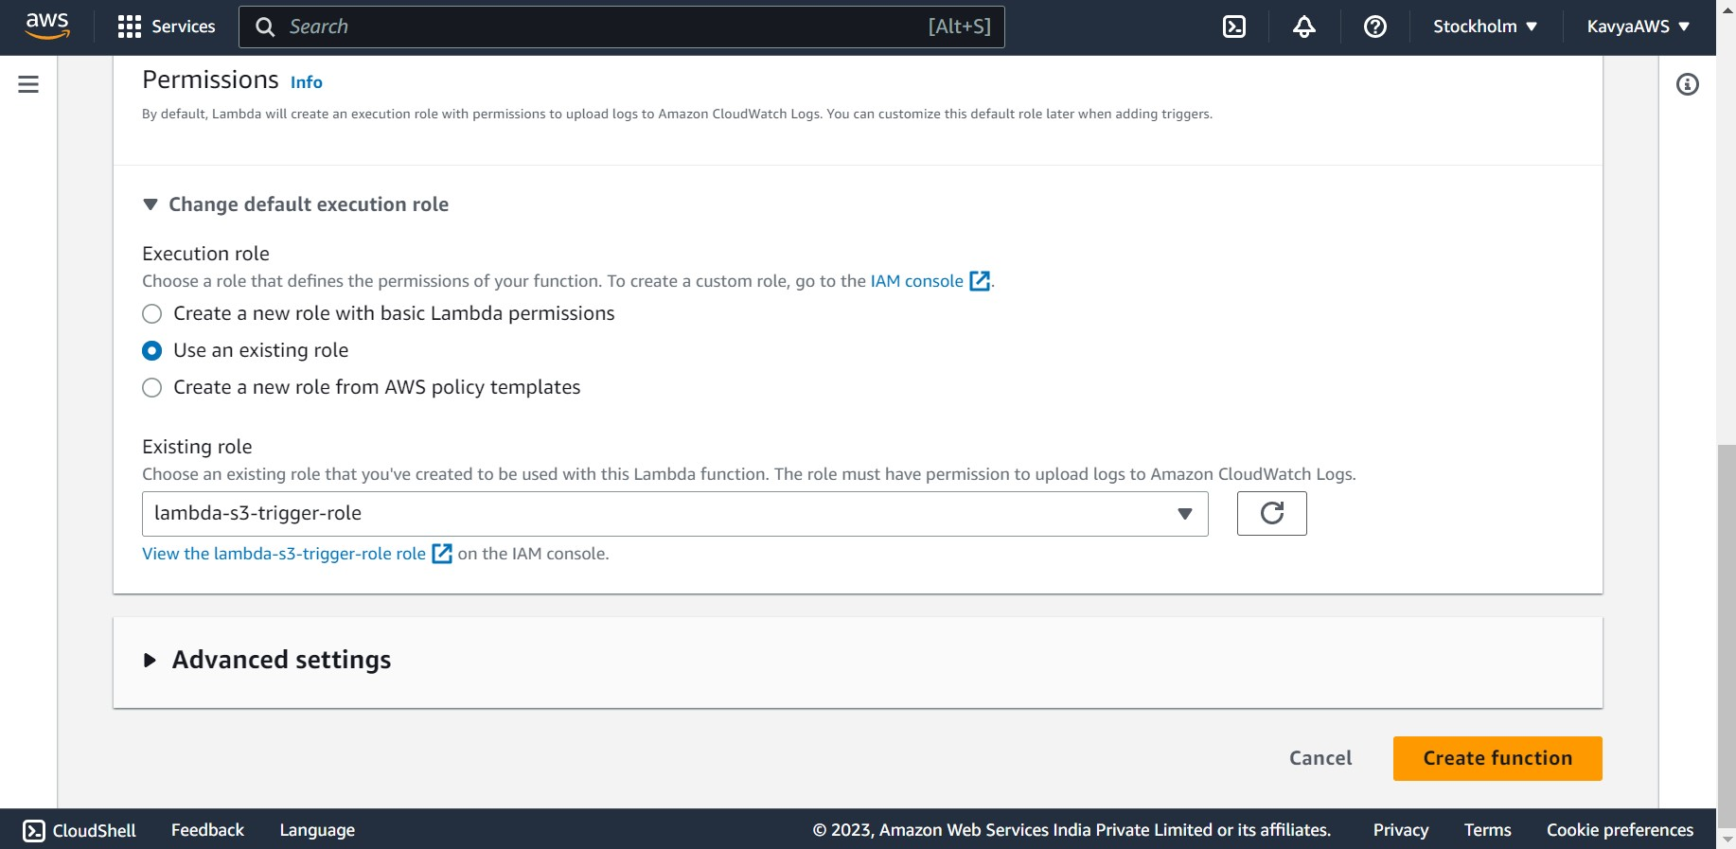

Lambda function s3-trigger is successfully created.

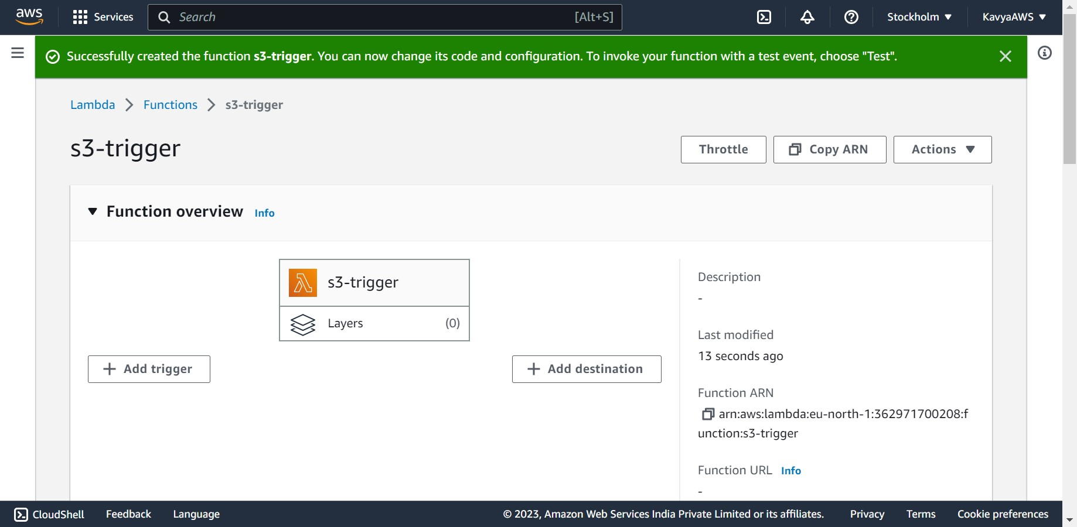

1. **Deploy the function code.**

Open the Functions page of the Lambda console. Choose the function we created in the previous step (s3-trigger).

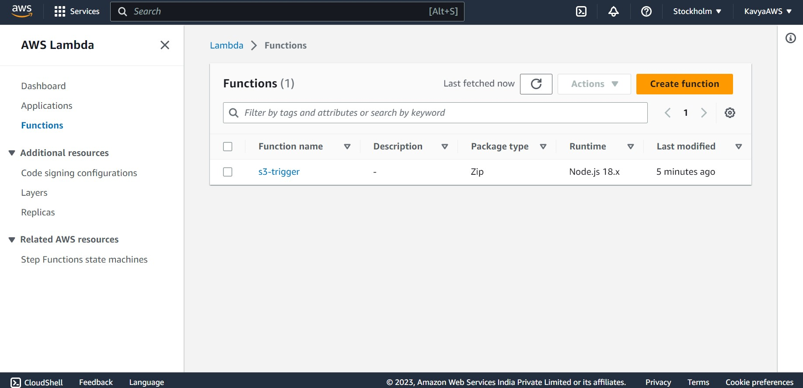

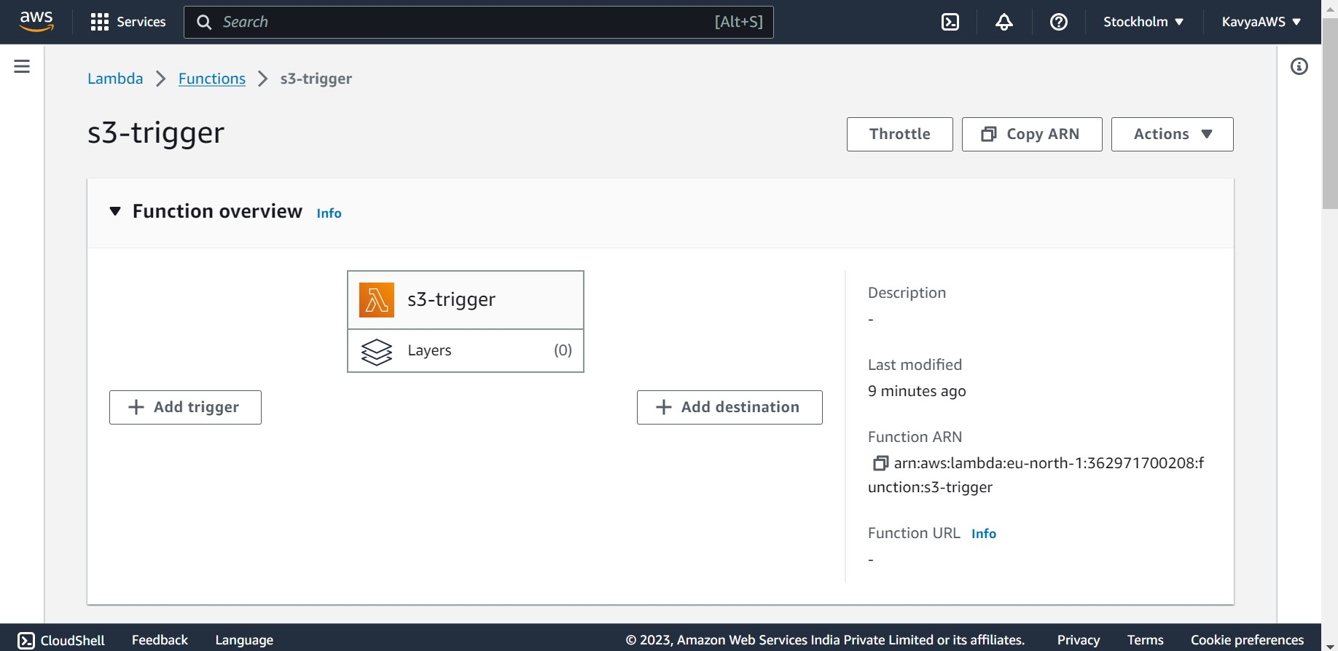

Choose the **Code** tab. Then provide the JavaScript code into the **index.mjs** tab in the **Code source**. And click on **Deploy**.

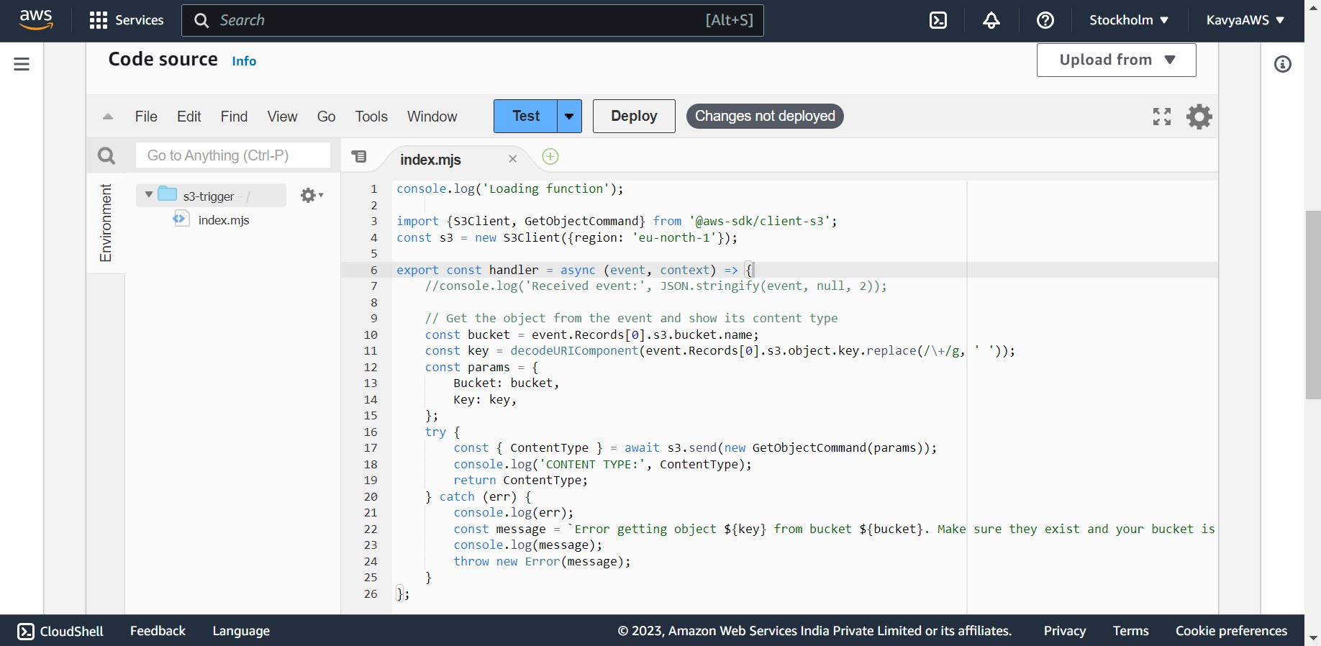

We have successfully updated the lambda function “s3-trigger”.

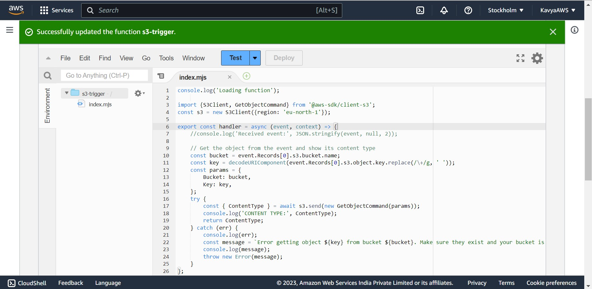

1. **Create Amazon S3 trigger.**

In the **Function overview** of the function’s console page, choose + **Add trigger**.

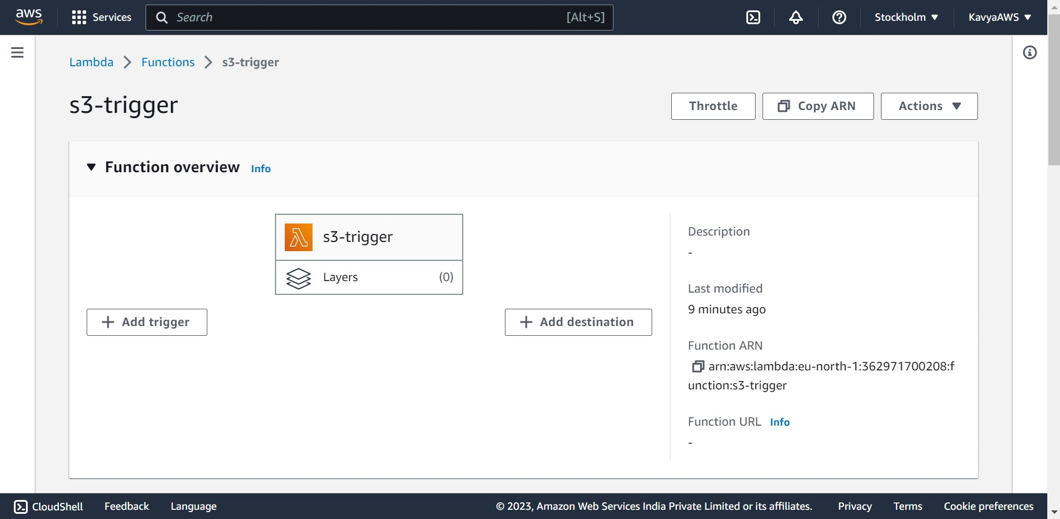

Under Trigger Configuration **Select S3**

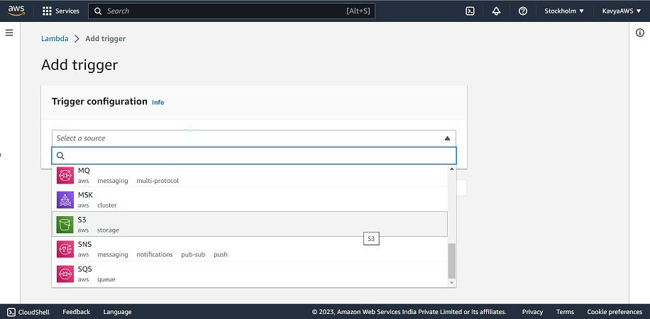

Under **Bucket**, select the bucket we created earlier “first-aws-bucket-01”.

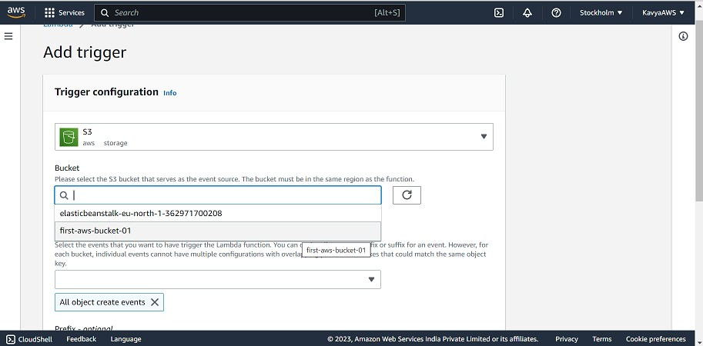

Under **Event types**, select **All object create events.**

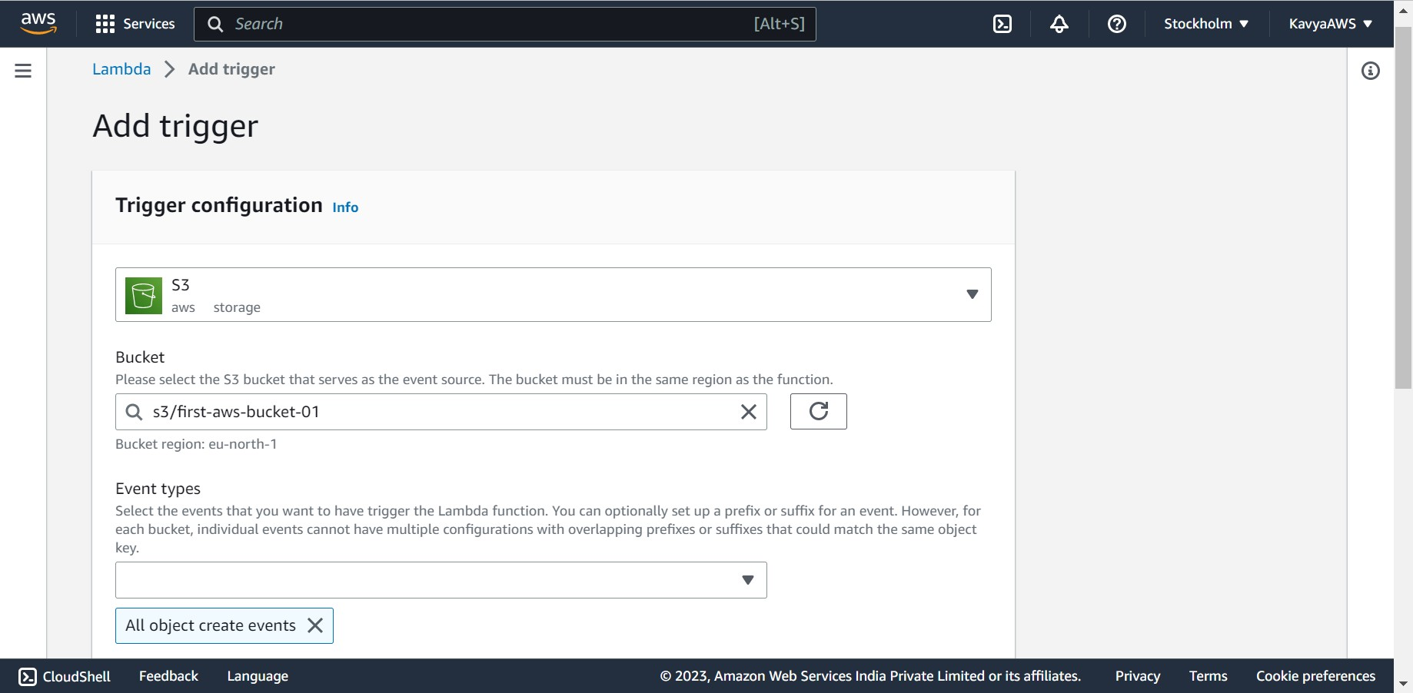

Under **Recursive invocation**, select the check box. Click on **Add**.

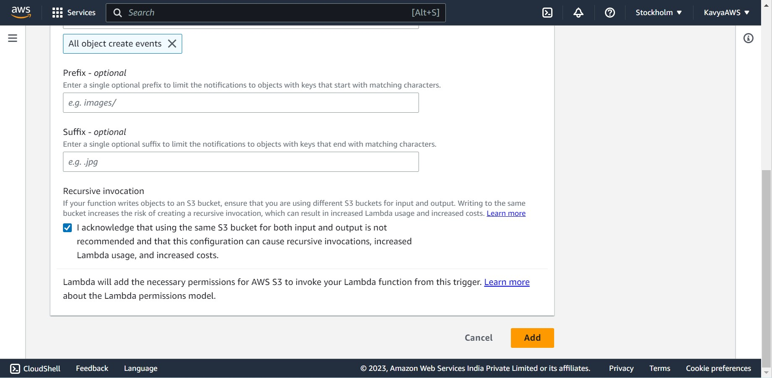

The trigger first-as-bucket-01 was successfully added to function s3-trigger.

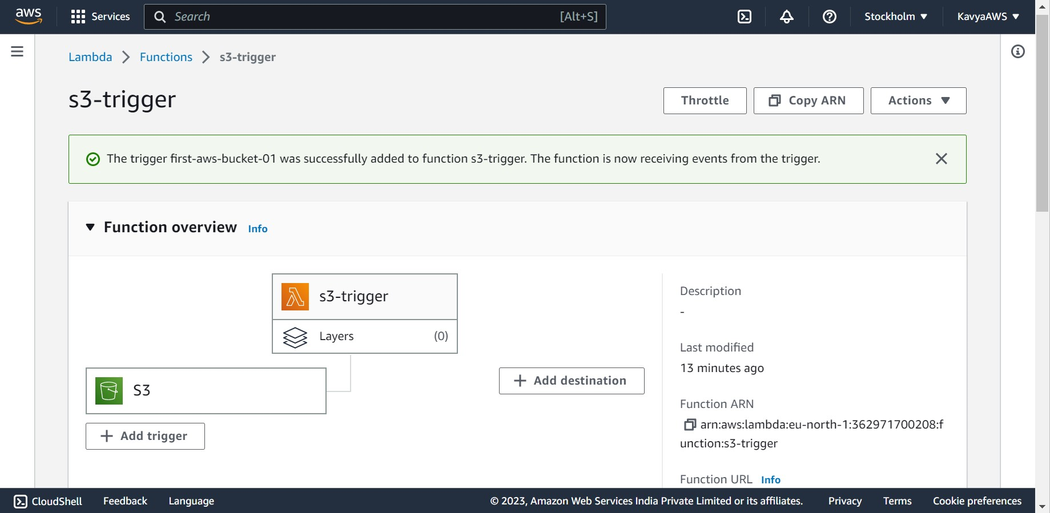

1. **Test the Lambda function with an event.**

In the Lambda console page for the function, choose the **Code** tab.

In the **Code source**, choose **Test**.

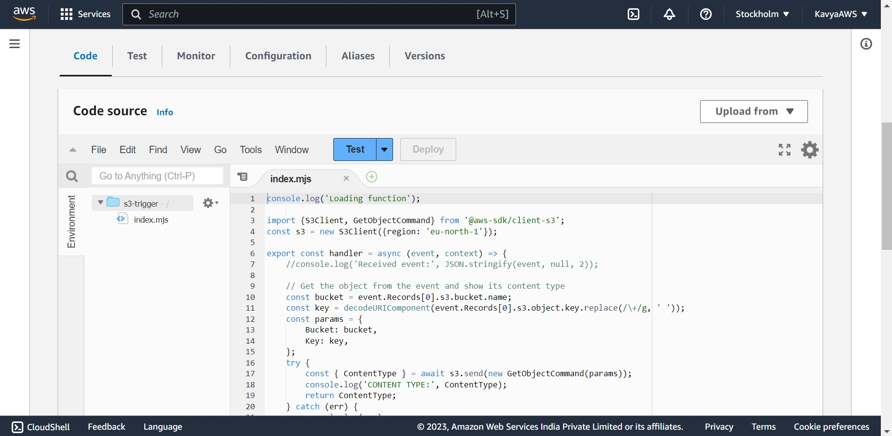

In the **Configure test event** box:

1. For **Event name**, enter MyTestEvent.
2. For **Template**, choose **S3 Put**.
3. In the Event JSON, replace the following values:
   * Replace us-east-1 with the region we created the Amazon S3 bucket in (eu-north-1).
   * Replace both instances of example-bucket with the name of our own Amazon S3 bucket “first-aws-bucket-01”.
   * Replace test%2FKey with the name of the test object we uploaded to your bucket earlier (for example, Nagarro.png).

Click on Save

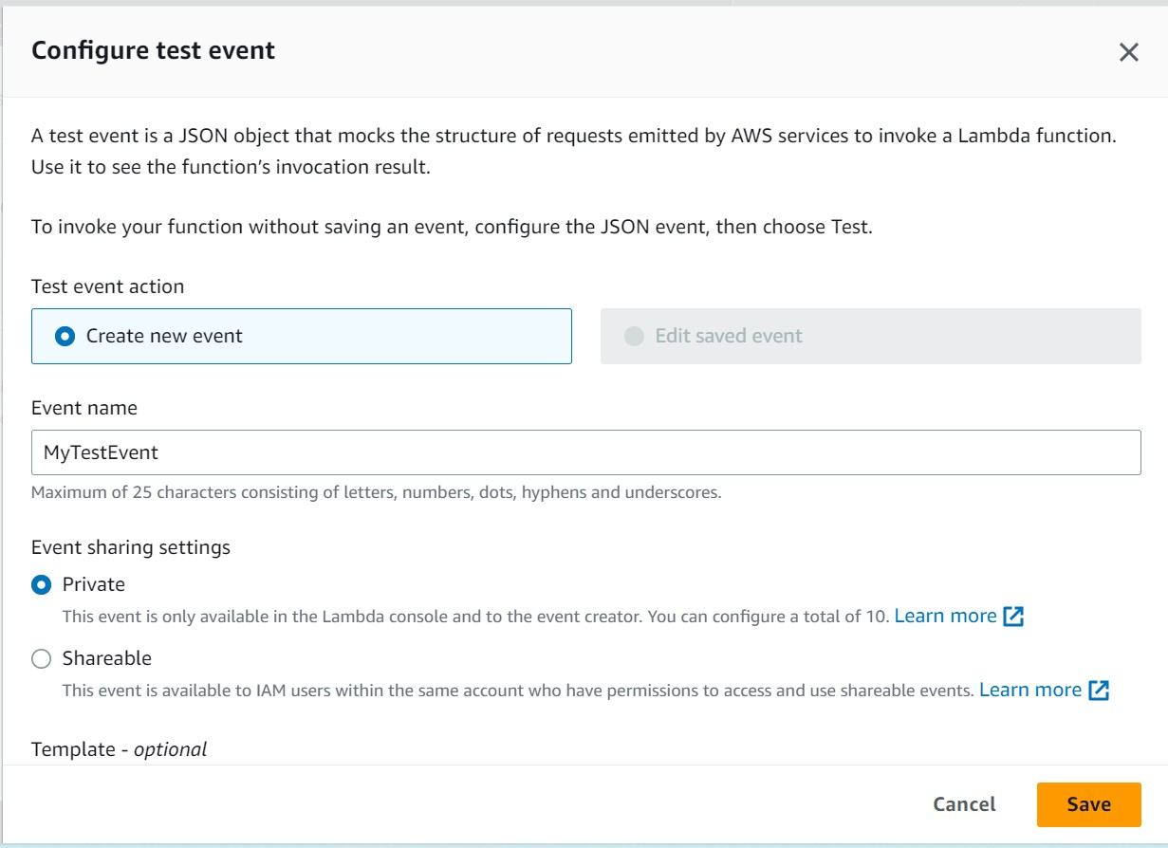 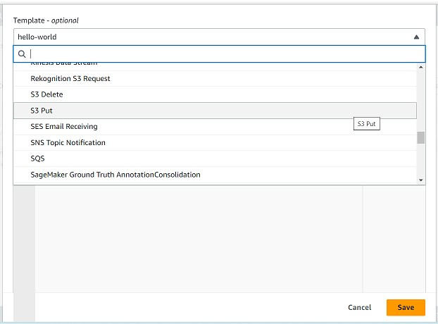

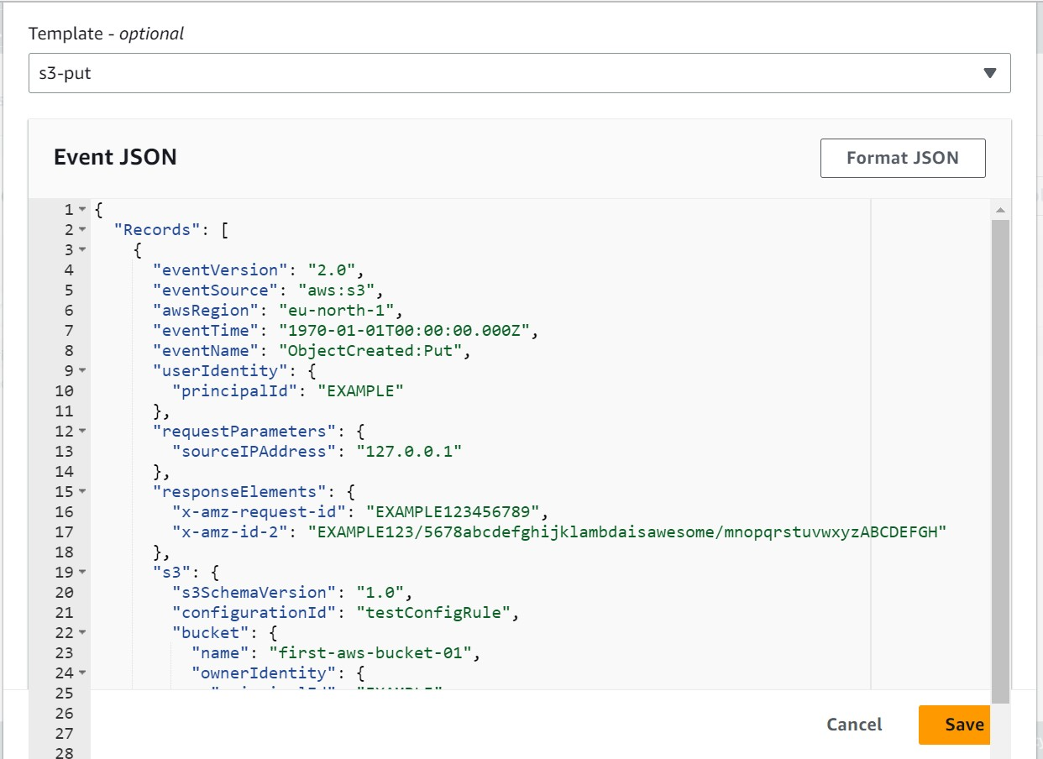 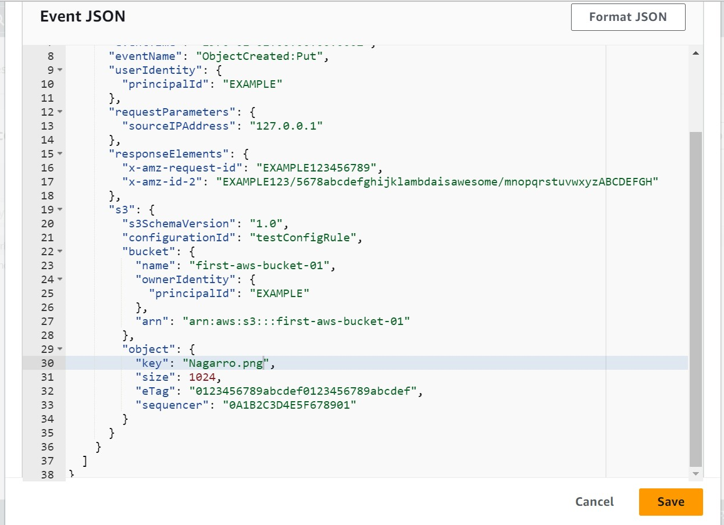

The test event **MyTestEvent** is successfully created.

In the **Code source**, Click on **Test**.

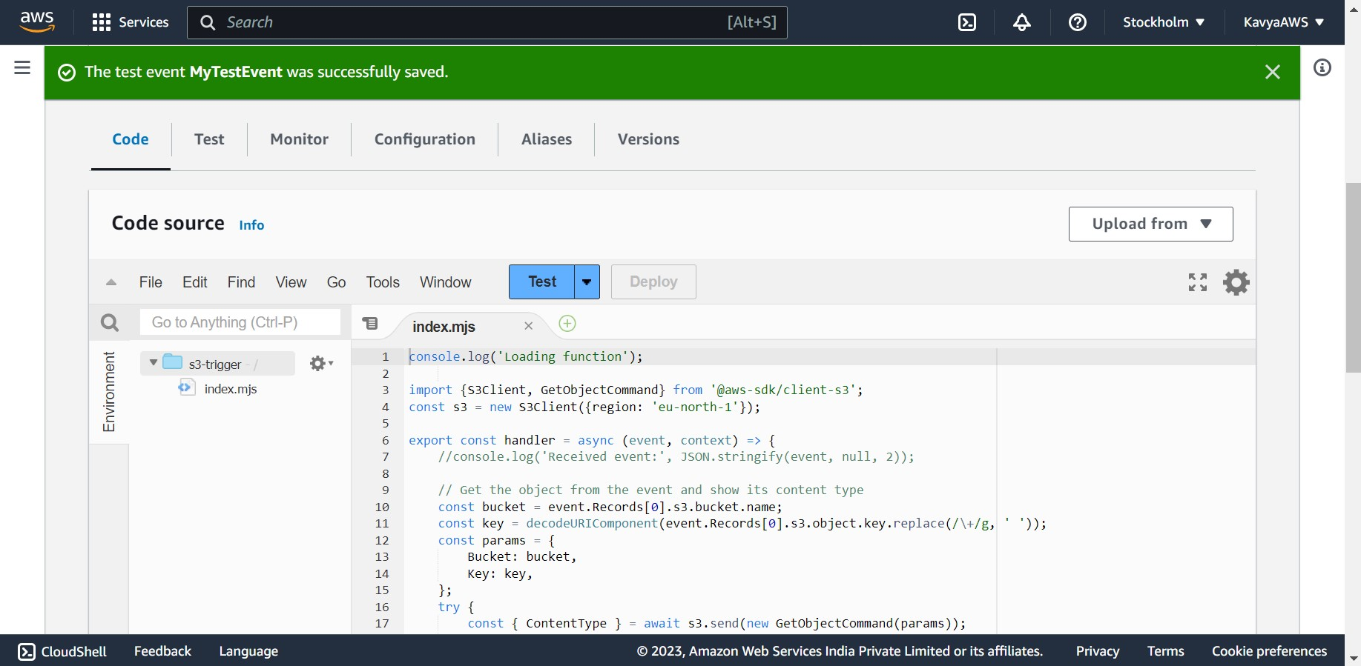

If your function runs successfully, if we see output similar to the following in the **Execution results** tab.

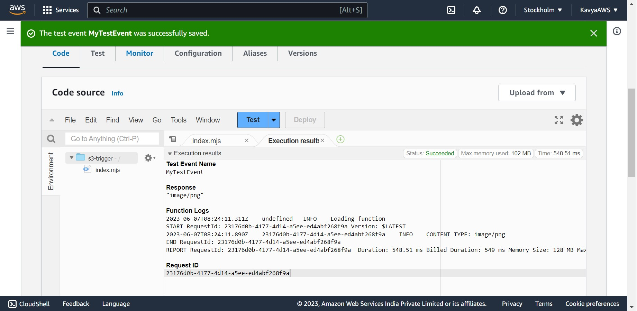

1. **Test the Lambda function with Amazon S3 trigger.**

To upload an object of the Amazon S3 bucket, open the buckets page of Amazon S3 console and choose the bucket we created.

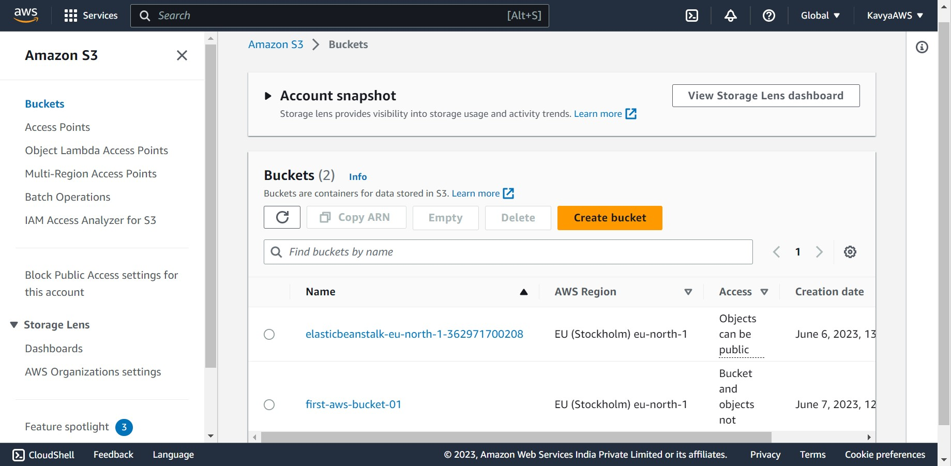

Click on **Upload**.

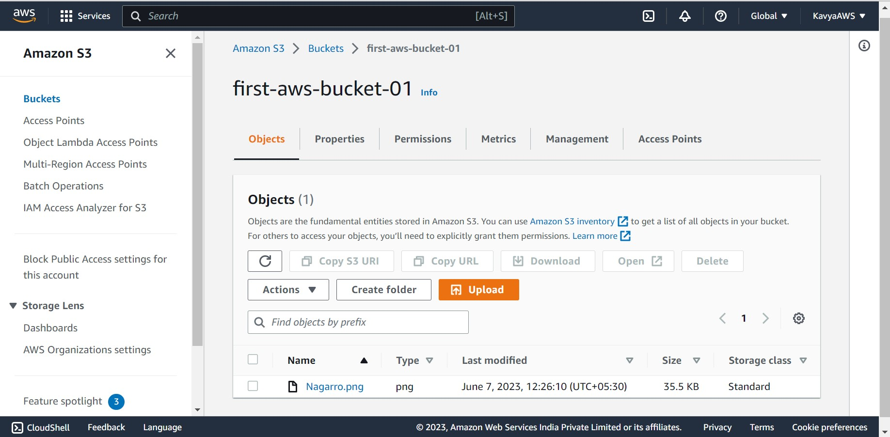

Click on Add files and use the file selector to choose an object we want to upload.

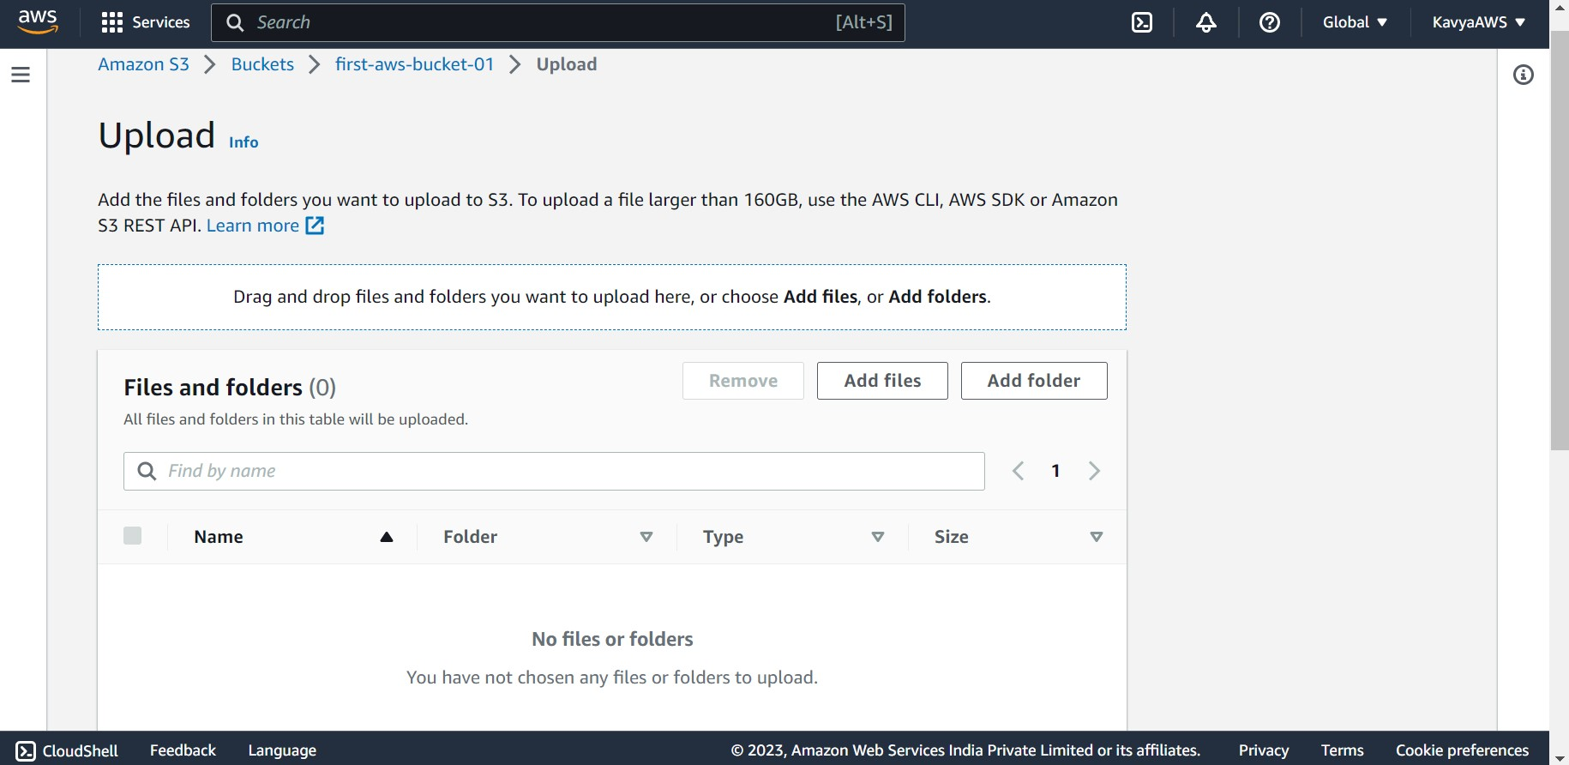

Click on **open** and the choose the file.

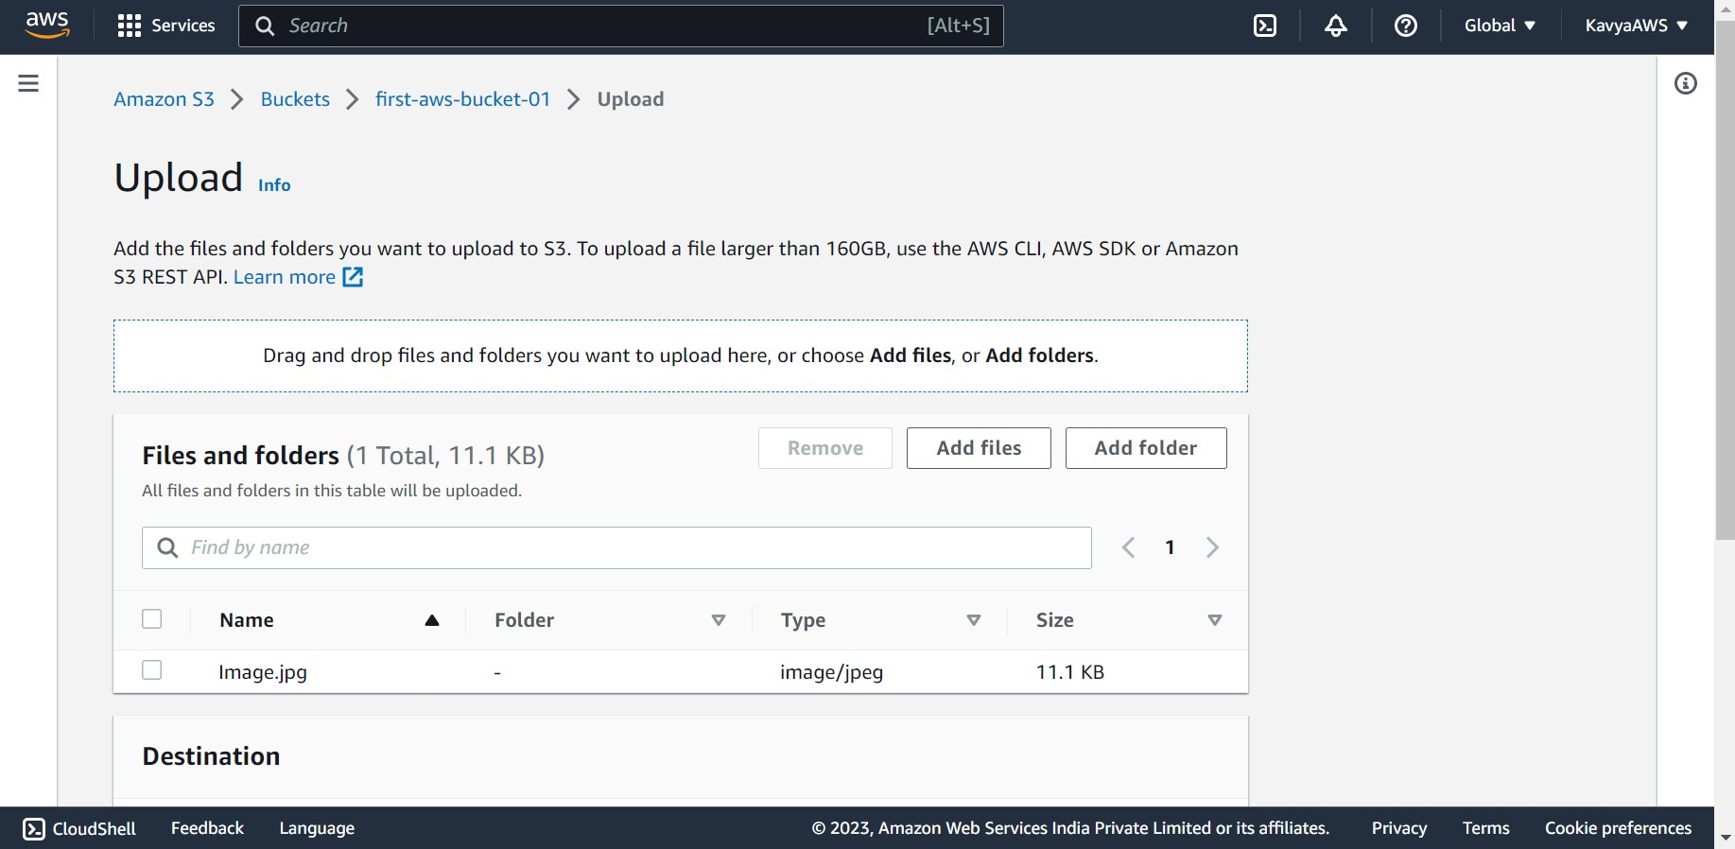

Click on **Upload**.

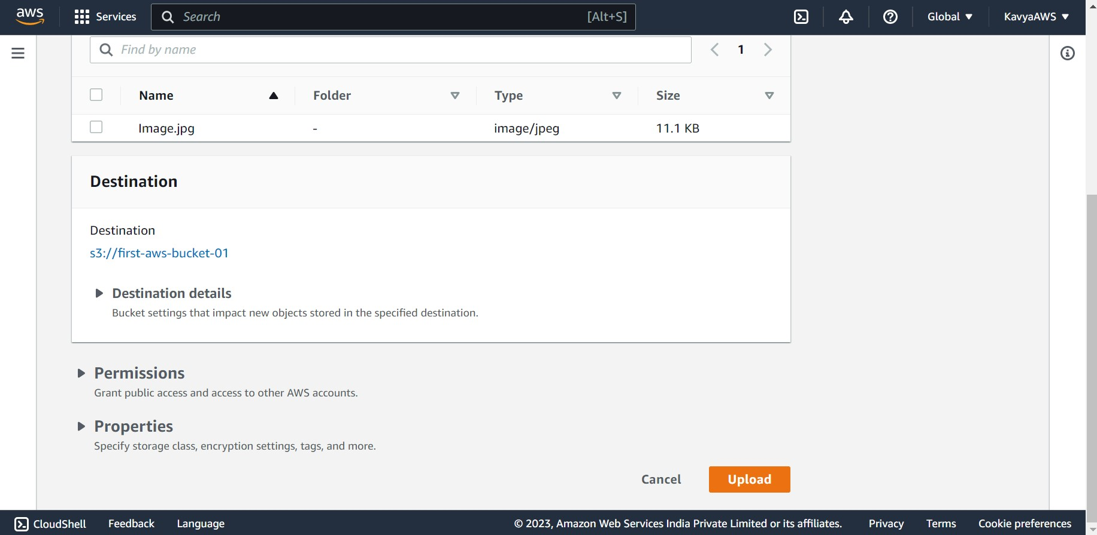

Uploaded the object successfully.

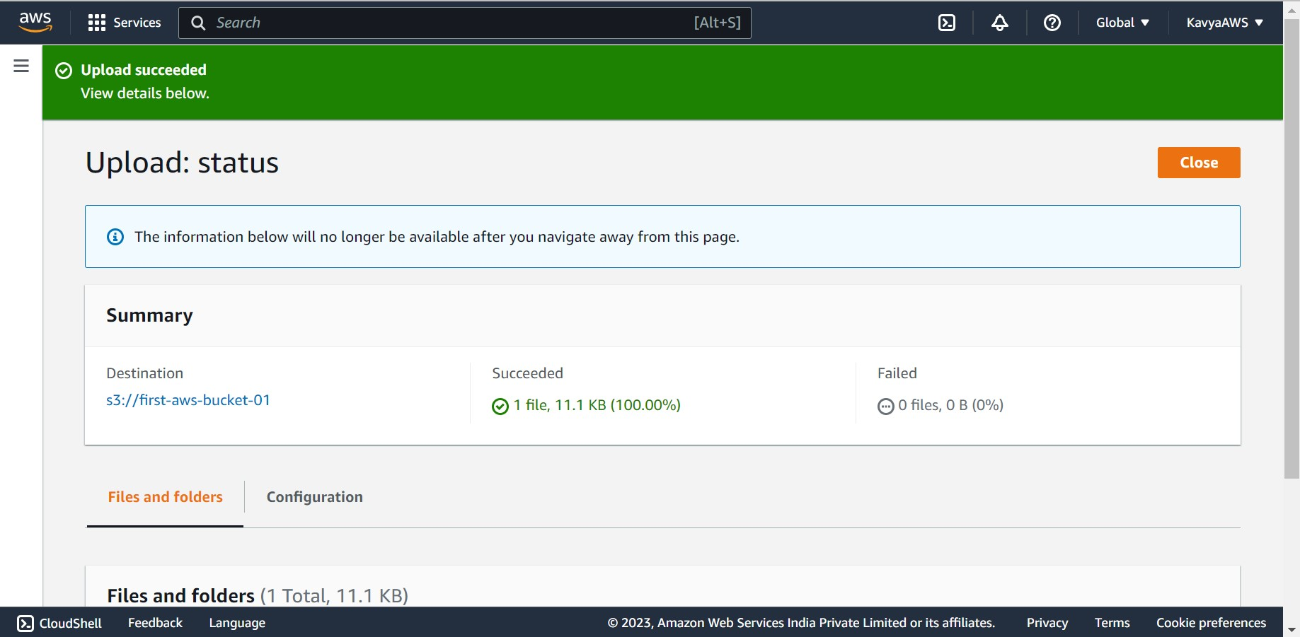 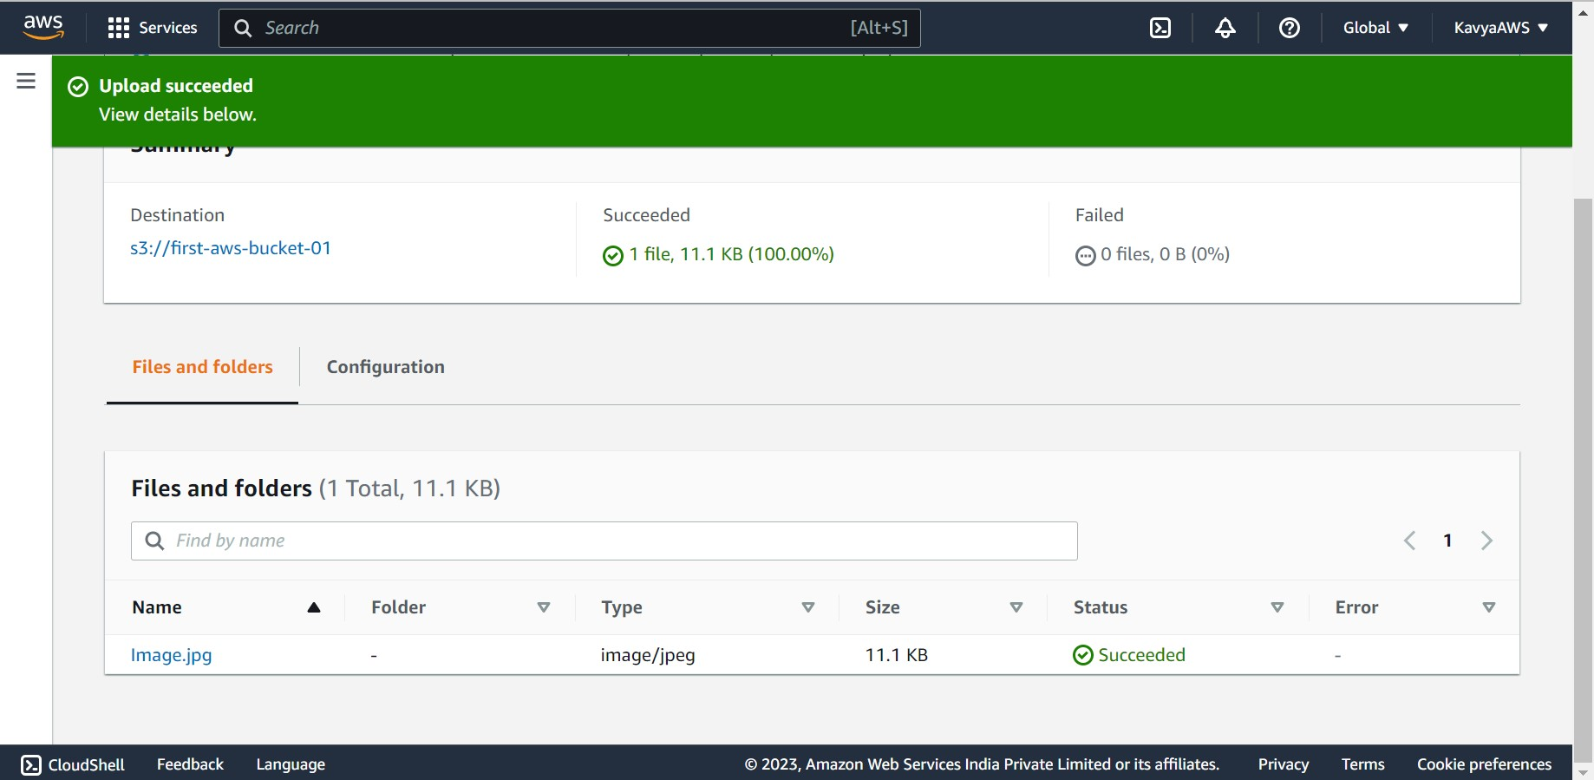

**To verify if the operation is working correctly, use CloudWatch Logs**

Open the CloudWatch console.

Make sure we are working in the same AWS Region we created our Lambda function in. We can change the Region using the drop-down list at the top of the screen.

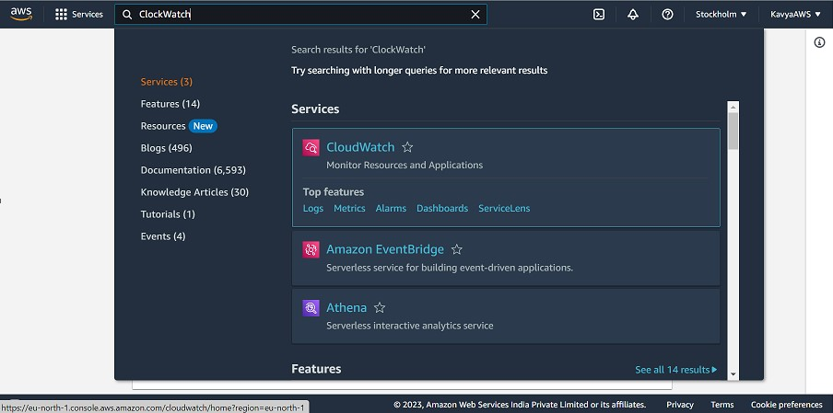

Choose **Logs**, then choose **Log groups**. Choose the log group for the function (/aws/lambda/s3-trigger).

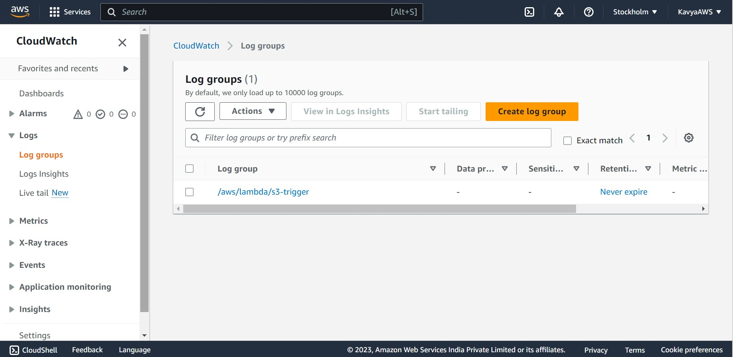

Under **Log streams**, choose the most recent log stream.

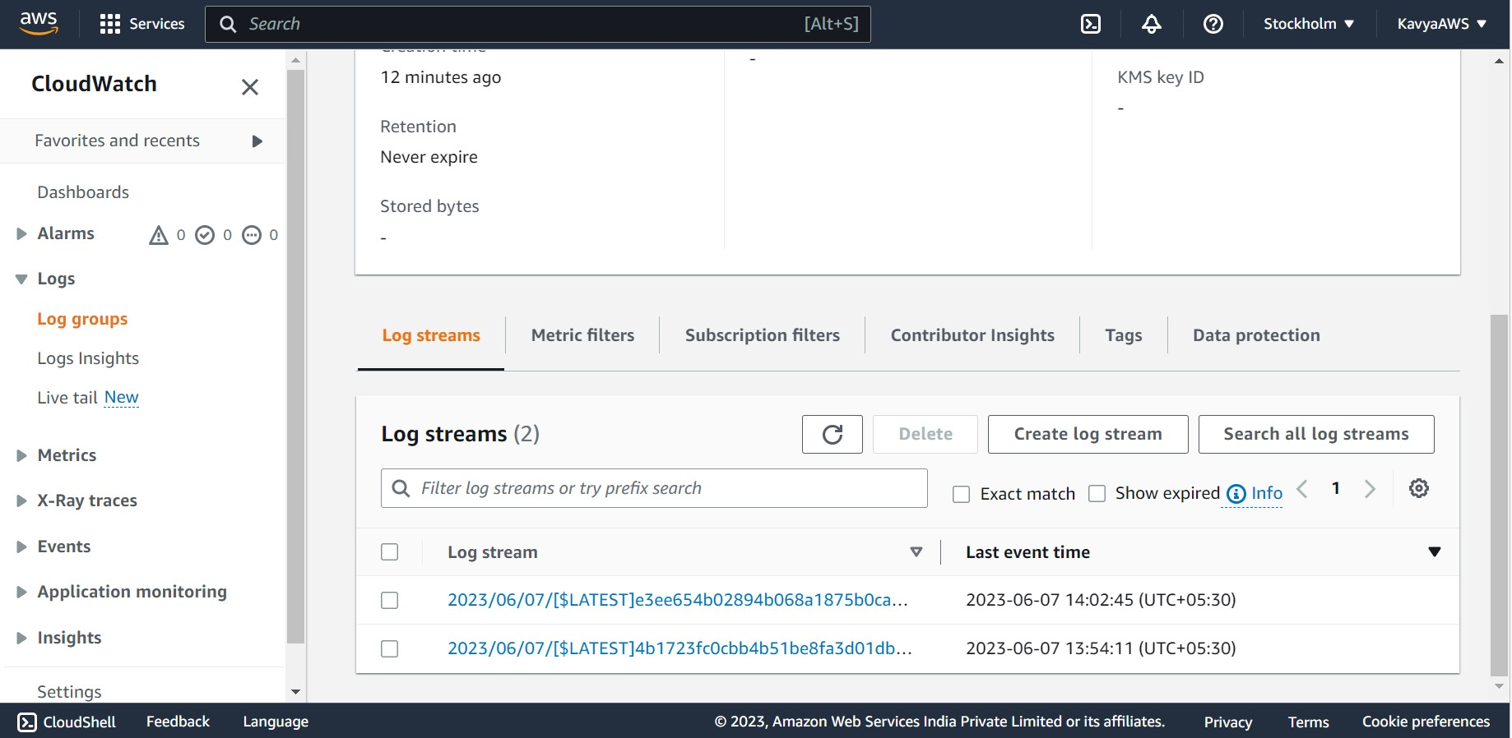

If the function has been invoked correctly in response to the Amazon S3 trigger, we’ll see an output similar to the following. The CONTENT TYPE we see depends on the type of file we uploaded to the bucket.

